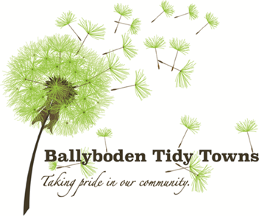

Senior Executive Officer

Forward Planning Section

Land Use Planning & Transportation Department County Hall

Tallaght

Dublin 24

14th September 2021

**Ballyboden Tidy Towns & Glendoher & District Residents Association**

**Submission to the Draft South Dublin County Development Plan 2022 - 2028**

Dear Sir/Madam,

Thank you for this opportunity to make a submission in relation to the Draft South Dublin County Development Plan 2022-2028. We wish to request the following issues are addressed in the Draft Plan.

* Whitechurch Library
* Palmyra, Whitechurch Road, Rathfarnham
* Stocking Lane
* Industrial heritage of the past (rivers and mill races)
* Safeguarding of Green Space/Open Space
* Owendoher River Catchment /Glin River Catchment/ Whitechurch Stream Catchment
* St Catherine’s Gate, Taylors Lane
* Dublin Mountains Area/Upland Areas
* Public Transport Deficiency
* Social and Community Infrastructure
* Data Centres
* Ballyboden Village Plan
* Taylors Lane
* Whitechurch/Edmondstown Lands (SM4 SLO1)
* Appendix 1: Ballyboden Tidy Towns & Glendoher & District Residents Association -

Joint Submission on Biodiversity

**Whitechurch Library – Public Access**

Whitechurch Library is protected under the Planning and Development Acts as follows: the "Carnegie Library, Ballyboden" is referred to in the Council’s Record of Protected Structures (R.P.S.) (Map Ref. No. 299) under the County Development Plan 2016 - 2022 - Schedule 2, Record of Protected Structures, referred to as a *“two storey library (stone and red brick)”.*

The Library was previously in public use until recent times. SDCC has failed to prepare a Long Term Management Plan for this historic building and the short term, medium term and long term use of the Carnegie Library has not been assessed or subject to public consultation. The current occupiers have adopted a policy to restrict access to this building and therefore what was once a public accessible building is no longer so.

The library is identified in the National Inventory of Architectural Heritage (N.I.A.H.) survey of the South Dublin County Area, under Registry Number 11216029. The NIAH rates the structure as being of Regional Rating, and being of architectural, historical, social, and technical interest. The Library is a valuable element of the streetscape, a streetscape which benefits from a sensitive village scale.

**We request that SDCC prepare a Long-Term Management Plan for this historic building and ensure it remains open for public use.**

**Palmyra, Whitechurch Road, Rathfarnham**

We submit that the property referred to as Palmyra on Whitechurch Road is within the attendant grounds of St Marys of the Blessed Virgin Abbey founded in 1139. However, settlement of this site goes back further and through research by local historians and the Rathfarnham Historical Society we are aware the site of Palmyra was within a monastic settlement (one of 15 monastic settlement including Mellifont) run and founded by the Cistercians.

**The site therefore requires protection due to its archaeological and historical significance, either through a listing or other protection method.**

**Stocking Lane**

Stocking Lanes historic importance and role as the gateway to the Dublin and Wicklow Mountains and as part of the historic Military Road. We request that all development respect the original historical boundary treatments ditches/hedgerow systems and seeks to recreate its tree lined spectacle. The Tree lined corridor should be reinstated along Stocking Lane.

**Industrial heritage of the past (rivers and mill races)**

We request that the plan recognises the interconnection between the industrial heritage of the past (rivers and mill races) and the vital role they play in the ecological & hydrological corridors that connect Natura 2000 sites in Dublin Bay and the Uplands. We request that any development that has such milling or such a watercourse is recognised as being part of Natura 2000 Infrastructure and should be assessed as such. The distance of the site to the source of its hydrological connectivity must be identified and assessed in a similar way as if it was located within a Natura 2000 site.

**Safeguarding of Green Space/Open Space**

We view with great concern a recent trend emerging of the council attempting to develop on public open space/green space within existing residential areas. Open Space/Amenity space is a valuable resource which provides numerous health, societal and environmental benefits.

In relation to Zoning Objective ‘OS’: ‘To preserve and provide for open space and recreational amenities’, we request the following:

**Residential is removed from ‘Open for Consideration’ uses in order to preserve and protect open space and green space in the county.**

**Owendoher River/ Glin River/ Whitechurch Stream and Catchments**

We are concerned at the potential impact of development in the area on the Owendoher River, Glin River and Whitechurch Stream and their respective catchments. The Owendoher and Glin Rivers are part of the River Dodder Catchment, connected hydrologically and ecologically to two NATURA 2000 sites. The Owendoher River is itself an important ecological feature in the area, particularly as a trout spawning river for the Dodder. The Dublin City Biodiversity Action Plan (2015 – 2020) notes the survey by Triturus Environmental Ltd indicates the rivers and streams that flow through South Dublin County **were among the top waterways for otter activity – particularly the Dodder and the Owendoher.**

**We request that the Draft Plan and Natura Impact Report should strengthen protections for the Owendoher River and recognise its importance for biodiversity in the area and its hydrological links to Natura 2000 sites.**

There is a pathway from the Owendoher to the Natura 2000 sites in Dublin Bay, via the Ringsend treatment plant and the River Dodder respectively, and therefore development impacting on the Owendoher has broader implications that need to be considered in the Draft Plan and the Natura Impact Report.

**Dublin Mountains Area/Upland Areas**

We support the submission made by the Hellfire Massy Residents Association and wish to see strong objectives included in the plan to enhance and protect the special character of the Dublin Mountains Area, particularly we wish to see strong protections for the Hellfire Club, Massy’s Estate and Orlagh Country House and Estate.

Regarding Orlagh we support the acquisition of Orlagh by SDCC in recognition of the need for greater amenities for the thousands of residents who will live in this area as a result of the SHDs. Orlagh is similar in scale as Marley Park and no change in zoning should take place which would threaten the viability of this site in terms of green infrastructure and heritage deliverables by way of fragmentation of the site for residential or commercial development

We believe that rather than focus on a large scale visitor’s centre SDCC should seek to develop a series of PODs that would assist a more sympathetic footprint in ecological terms and yet offer recreational utilities to tourists and local users.

SDCC should seek to identify buffer zones that would act as a layer of protection around the Natura 2000 sites and those sites such as Massys Wood & Hellfire that act as a gateway to the Natura 2000 sites

Rewilding

That the Manager seeks to identify sites for rewilding and carbon capture including former dumps (both authorise/closed and unauthorised including Section landfill sites)

**SLO for St Catherine’s Gate, Taylors Lane**

**We request an SLO for St Catherine’s Gate, Taylors Lane to retain its public exhibition function and as a focal point for community & heritage gatherings within Ballyboden Village.**

**Public Transport Deficiency/ Bus Connects**

The Ballyboden area is not capable of absorbing high-density residential development having regard to the existing deficiency in public transport serving the area proportionate to the existing, permitted and planned residential developments in the area.

The Transport Strategy for the Greater Dublin Area 2016 – 2035 published by the NTA divides the GDA into corridors. Ballyboden is located within Corridor E. The strategy notes that public transport mode share in Corridor E for all trip purposes is 9%, with the car mode share for all trip purposes at a staggering 73%. The modal share is symptomatic of the deficiency in public transport infrastructure in the area.

The Strategy states ‘*Corridor E is made up of generally suburban residential development and is not defined on the basis of a major transport route, road or public transport service. It presents a challenge in that respect as it is more difficult to serve with high capacity public transport than other corridors’.*

*‘For the Metropolitan parts of this corridor,* ***the performance of the Rathfarnham Quality Bus Corridor is poor relative to others and requires enhancement****. As such, a number of options, including Light Rail, have been examined. However, due to the land use constraints in the corridor and owing to the pressure on the existing road network, a Luas line was not deemed feasible’.*

As noted herein, and outlined by the strategy above, this corridor will never see the benefits of high capacity public transport which allow high density residential development to be absorbed sustainably. As discussed further herein, the residents of Ballyboden will not see any noticeable improvement from the proposed Bus Connects project and indeed there is huge concern amongst residents that the bus service will deteriorate, with routes commencing in Tallaght that are at capacity by the time they reach Ballyboden. The area is comparably poorly served by public transport and deficient in social and community infrastructure and facilities (particularly retail); and is completely incapable of absorbing additional quantum’s of residential development in a sustainable way (having regard also to the quantum of permitted residential development in the area), and in fact will reinforce car dependency.

The area is not proximate to a Dart station, a Luas station, or a commuter rail station. The 15B bus route providing access to Dublin City Centre, whilst frequent, is not a QBC, does not benefit from a dedicated bus lane, and as a consequence shares the lane with commuter car traffic; with the capacity constraints, inevitable delays and slow service inherent in such an arrangement. The orbital bus route on Taylors Lane again shares the lane with general traffic, save for a small stretch of a token dedicated bus lane. The public transport deficiency in the area precludes any possibility that high-density large-scale housing can be absorbed sustainably.

In relation to the proposed Bus Connects project, Core Bus Corridor Route 12 - Rathfarnham to City Centre 12 is intended to terminate at the intersection of Nutgrove Avenue, Grange Road and Rathfarnham Wood; c.2km north of Ballyboden. We note therefore that local existing public transport capacity will remain constrained even with the provision of this potential infrastructure at a future date.

It is considered best practice and preferable to direct high-density development into areas which have excellent public transport, employment, retail, and social/community infrastructure rather than to poorly served and capacity constrained areas such as Ballyboden. None of the ingredients are in place to encourage existing and future residents to increase modal shift away from car use to more sustainable modes of transport and Bus Connects will not address this.

**We request that this deficiency is acknowledged in the Draft Plan and that significant public transport improvement is required as an objective in the Draft Plan prior to any large-scale residential development being permitted in the Ballyboden area going forward.**

**Social and Community Infrastructure**

The proposed SHD development at Taylors Lane currently at Judicial Review stage will incredibly result in an overall net loss in social and community infrastructure in the area. Best practice in sustainable development for residential areas involves a proportionate increase in social and community facilities as population increases. This proposal which will generate an additional population of c.1,339 people results in a net loss of social and community infrastructure as outlined below. The amenity resources on the site set to be lost include a Pitch and Putt Club which served the community for over 40 years, Tennis Courts, Boxing Club, Basketball Court, Youth Centre and Bowls Court.

In addition, and despite previous commitments to the community, St. Josephs Youth Club building and St. Joseph’s Amateur Boxing Club will now be lost to the community. The Augustinians previously indicated that they would build a small community centre to replace the St. Josephs Youth Club building.

The Ballyboden Village Plan states the objective *‘To provide for the continuation of community facilities/ services on or in the vicinity of the Augustinian Lands’.* The SHD currently under Judicial Review ignores this objective and does not provide for continuation of community facilities and services on the lands.

**We request that the Draft Plan seeks to provide additional social and community facilities for the Ballyboden area to replace the net loss in facilities the area has seen in recent times.**

**Data Centres**

Policies restricting further data centre development need to be strengthened in the Draft Plan. They are having a crippling impact on our electricity system and are leading to load shedding for other energy consumers, not to mention how they are completely undermining our progress on achieving our climate action targets.

Data Centres should only be permitted where they can provide 100% on-site renewable energy generation to power the facility. Where on site demand cannot be met permission should be refused. They should be made to contribute more extensively to funding enhanced capacity within the relevant water and wastewater network to accommodate the extra demand they impose.

**Ballyboden Village Plan**

We request the reinstatement of the Ballyboden Village Plan as part of the County Development Plan or failing this we request an updated Village Plan be prepared and an objective for same included in the Draft Plan.

The Plan noted the need for the following community services:

* A Post Office.
* Leisure.
* Sport and Recreation.
* Entertainment.
* Youth Centre.
* Increased library services.

**The Draft Plan should acknowledge the same requirement for services in the Ballyboden area**.

The Ballyboden Village Plan stated:

*‘It is an objective of the Village plan to combine the proposed road improvements with the potential for Ballyboden to develop as a village. Features such as the height and elevations of buildings, textures of pavements, street furniture and public art can contribute to the village character of Taylor’s Lane and offset the impacts of the road realignment and increased width of carriageway’.*

**This vision of Ballyboden developing as a village can still be realised and the Draft Plan should include objectives aimed at achieving this, including in relation to urban form, the public realm and land uses.**

**Taylors Lane**

We request an SLO for Taylors Lane to protect and enhance Ballyboden Village to read as follows:

***“The height and the massing of development on Taylors Lane should respect the established pattern of development in the area, where two storey semi-detached dwellings predominate”.***

**Whitechurch/Edmondstown Lands (SM4 SLO1)**

We oppose the development of large-scale residential development on these lands due to the severe transport and infrastructural constraints in the area. We reject the assertions by Mr Fox and Mr Deane by their respective consultants in relation to these lands that housing can be sustainably provided for on these lands and we strongly contend that development on these lands will exacerbate car dependence and associated environmental impacts.

**Newbrook House**

In recognition of the group significance of Newbrook House and the accompanying Paper Mill buildings and millrace in situ and the ecological significance of the site and the potential community, biodiversity and amenity gain must be secured for future public access as part of any development including coffee shop, community room/gallery and outdoor public realm.

**Stocking Avenue School Site**

We support the Department of Education requirement for a school on this site and reject the claims made in submissions that the school objective should be removed.

**Ballyboden – Poetic Landscape**

We request that Ballyboden is recognised as the poetic landscape of the poem ‘Easter 1916’ by W.B Yeats and that the roads of Taylor’s Lane, Scholarstown Road, Whitechurch Road, Ballyboden Road, Stocking Lane tell a unique story of the 1916 Rising and a Heritage Trail should be created as an educational and heritage tool.

We trust that this submission will be taken into consideration as part of the Draft Plan process and look forward to further positive engagement with South Dublin County Council.

Yours Faithfully,

Angela O’Donoghue

Chairperson

_____________________

Ballyboden Tidy Towns & Glendoher & District Residents Associations

**Appendix 1: Ballyboden Tidy Towns & Glendoher & District Residents Association**

**Joint Submission on Biodiversity**

**Background**

Glendoher & District Residents Association (GDRA) was constituted in 2007 to protect and improve residential amenity and to change the way people think about green spaces. In 2017 a number of resident associations were invited by SDCC to form Ballyboden Tidy Towns Group (BBTT). It was a natural progression as many had been working with each other on planning and ecological projects including the Ballyboden Village Area Masterplan. It allowed the collegiality of these groups to grow and to work with other groups in the area, schools, sports clubs, churches and businesses in the area**.** For the purpose of the Biodiversity Consultation as many of the projects and interests cross over we decided to make a joint submission.

**Introduction**

Biodiversity is many things but for us it is a residential amenity to be protected and improved as per the zoning for our area. Yet for many people, they don’t think it is a zoning issue or a right and for most residents and Councillors, the idea of biodiversity impacting on our lives locally in such fundamental ways would be a revelation to them. What role does Biodiversity have in zoning and planning terms for a sustainable community – we say everything! Land use and Biodiversity are intrinsically linked.

In 2005 following a meeting with SDCC Parks Department, GDRA were invited to come back to SDCC with a Plan for our ‘conditioned open space’. At this time this space was a disused field with an annual bonfire, three drinking dens and serious dumping issues possessing approximately 6 mature trees and very little hedgerow.

So, with the help of An Taisce (Spring Clean) and Conservation Volunteers Ireland we created a plan for ‘A Biodiversity and Amenity Park’. This was before Biodiversity was featured in Development Plans except by a few local authorities and now fifteen years later SDCC are in the process of preparing a Biodiversity Plan for the entire Local Authority.

GDRA AND BBTT are delighted to participate in this public consultation endeavour and hope some of our experiences, initiatives and ideas can be incorporated into this Biodiversity Plan.

However, SDCC face a serious if not impossible obstacle - they are simply understaffed and under-resourced to deliver a Biodiversity Agenda. However, those staff we have encountered, do have tremendous skills – often untapped and are professionally committed to developing the role of biodiversity in our local authority.

Biodiversity is not just an ecological reality it is a public health reality (green prescription) and if nothing else we have learned during these ‘Covid Pandemic times’ is that local biodiversity and local green spaces are essential to our economic and emotional wellbeing.

**Key People are your Parks Department People**

At every step of the way we were supported by the SDCC Parks Department and with them we have increased the ecological value of Glendoher Park and in tandem the amenity value. There is a major lesson for Residents Associations and Tidy Towns Groups to appreciate – Landscape and Biodiversity management of a public space is a different skillset than managing your domestic garden. Some of the most successful ideas, came from us going to the Parks Dept Depot in Rathfarnham with an idea and leaving with a better idea again. They know what will work, they have a genuine interest in people using green spaces and parks, they are open to ideas and are willing to assist to make sure it is a success. They are on the frontline of the Biodiversity crisis and they want you to succeed.

It would be impossible to create another Glendoher Park now because of the lack of personnel available to meet with community groups. It is difficult to get Tidy Towns projects off the ground. There is no doubt that there are staff working in SDCC who have the capability to deliver Biodiversity Objectives, Targets and Actions but there is not enough of them to meet the challenge that South Dublin County Council is facing. We have seen at first hand other groups struggle to initiate another ‘Glendoher Park’ not because of interest and motivation but because they were unable to get a meeting with Parks Dept personnel. So SDCC will continue to fail to capitalise of the available and willing human capital to deliver the green capital in comparison to other local authorities. The current investment in the Biodiversity Resource Structure is incapable of delivering on a Biodiversity Plan in this local authority area and as it stands cannot manage to capitalise on the substantial interest to assist from the community.

The expectation by residents of SDCC to make up for the ‘late to the meeting’ of SDCC’s management response heretofore to the Biodiversity crisis in the local authority area is high. If they can’t meet their Biodiversity Service Agreement then how can SDCC meet their Climate Action Plan Service Agreement. So, a lot depends on the Biodiversity Output for securing SDCC Climate Action Objectives.

So how valuable is our local biodiversity in our local green spaces and parks? SDCC has never calculated such a value on Biodiversity and Parks/Open spaces but London has in a recent report called ‘London Green Spaces Report’.

* London Parks store 5.5 million tonnes of carbon annually and this is valued to be worth £340 million
* for every £1 invested in parks and green spaces Londoners receive a value of £27 back.
* covering almost one fifth of the city, green spaces save London £950mper year in avoided health costs.
* Projected increases in average monthly temperatures show that London is likely to experience a 5-6°C5 increase in summer and winter averages by 2050.
* The natural services parks and green spaces provide help reduce urban temperatures by up to 2°C during heat waves.
* Across London, there are over 3,000 parks of varying sizes designated as ‘public open space’. Together these spaces cover almost 18 per cent of London
* It is estimated that for every £100 the Croydon Borough spends on green spaces, it saves £12 in social care costs
* Early findings from the Parks for Health programme and evidence from the growing number of borough Natural Capital Accounts show the potentially significant economic benefit of offsetting future costs by commissioning parks as public health assets. This approach of reimagining parks and green spaces as an integral part of local health and wellbeing systems is likely, with the support of the NHS, to gain traction across all London boroughs

It simply does not make sense financially and ecologically not to enhance and invest in developing Biodiversity and Amenity Parks and Open Spaces right across the SDCC local authority area.

**Actions:**

1. SDCC need to create a Green Space/Biodiversity Skills Programme for their Workforce and also for Volunteers
2. SDCC need to recruit horticulturists and gardeners
3. SDCC need to recruit a Chief Biodiversity Officer separate from the role of the Heritage Officer
4. SDCC need to have Biodiversity Co-ordinators within the Parks Department to work with local community groups, tidy towns groups and residents’ associations, schools, golf clubs, GAA clubs, business owners
5. SDCC need to create biodiversity expertise in other Departments too e.g. Planning, Housing, Roads, Drainage and Community.
6. SDCC need to recruit an Environmental Lawyer as planning enforcement is a black hole if it is a biodiversity related complaint and the statutory obligations towards protected species are simply not being met currently in the operation of the Planning Process.
7. Environmental Awareness personnel need to be transferred to work out in the Community – there seems to be gridlock in getting educational material out in the community which is regrettable because some of the material and initiatives are really positive. We have a Noticeboard in our Park but we never get issued with Posters etc.,
8. Communication Officer: Biodiversity & environmental information need to communicated to residents but there is no strategic marketing of this information. Despite SDCC having so much Biodiversity Content (mainly positive affirmations, educational facts and good news) there is no active communication on social media etc regarding Parks, Biodiversity etc

**Biodiversity in the Community**

So, Glendoher Park, a ‘conditioned open space’ which was once known as ‘the field’, is not just a Biodiversity & Amenity Park anymore, it is now referred to as the Community Hub of the area and we don’t have a community centre in our area so it is particularly important. During Covid, the pubs, churches, libraries and community centres were all closed but not Glendoher Park. It is not unusual for new residents to meet other residents in our Park and for this experience to be an important part of their introduction to the area and a continued sense of belonging. We have also found that older people, especially during Covid or those with mobility issues are using our Park to overcome social isolation, rehabbing from an injury, operation or illness, enhancing their wellbeing and incorporating exercise in their lifestyle. The take-up by residents and the benefits of this ‘green prescription’ or ‘nature bathing’ have grown exponentially in recent months due to Covid. The frequency and duration of time residents stay in our park has increased also. It is not unusual to have three generations of a family in our Park. So many residents have said thank goodness we had Glendoher Park during the lockdown. The Circular Paths in Glendoher Park, Whitechurch Park and Dolly’s Field in Moyville Estate were the hidden success stories of the Covid experience in our area.

We have found that if you provide opportunities for people to engage with nature and biodiversity they will come. As the saying goes **– *if you build it - they will come*** should be replaced with ***if you plant it - they will come*.**

* Biodiversity is necessary for wellbeing and health
* Biodiversity is necessary for community development & social inclusion
* Biodiversity increases economic value of an area
* Biodiversity is valuable green capital and it needs protection

We submit that every green space which is designated as ‘conditioned open space’ within housing estates has the potential to be as valuable as Glendoher Park is to our area. There are bigger green spaces and certainly ones with a better lay-out, access and better passive supervision than Glendoher Park.

* Why is Glendoher Park busier than any green space around our locality?
* Why is it that people come from estates in Ballyroan, Orlagh, Knocklyon, Whitechurch, Willbrook and Butterfield etc rather than stay on their own green space?
* What are we winning awards for?
* What are we doing differently - our secret?
* More importantly how can this be replicated throughout the local authority area?

It is quite simple we have changed the way people think about our green space simply by incorporating and attracting biodiversity into our green space.

* We have hedgehogs, squirrels, bats, foxes, frogs, and badgers and a variety of birds that contribute a terrific birdsong.
* Buzz Factor border – a border full of pollinator friendly plants
* Buzz Stops - Estates Stones, planters or small bedding areas
* Edible hedgerow raspberry, blackberry, elderflower, hazelnut
* Hedgerow: over 3000 whips of blackthorn, whitethorn, hazel, ash, maple, oak, holly, beech, birch, ash, hawthorn etc. with existing wild roses.
* Creating an arboretum of trees – some trees gifted from residents (grown from local seed), others were from the National Botanic Gardens, some we purchased and others from SDCC
* We have 4 benches equidistant around our Circular Path.
* Our Circular Path is designed to measure a distance - 3 laps equal 1 kilometre

**Glendoher - Time**

There was a time in the early days where GDRA had to put up signage e.g. nettle corner, wildflower meadow. We had to explain the value of nettles and thistles for ladybirds and butterflies etc., Now that we made our case, got the ‘buy-in’ for residents we find the need for signs is not there as it once was.

Inside our circular path we ask the Grass Cutters to cut regularly but outside this circular around the boundary we ask them to cut less regularly – Grow don’t Mow. There are many times in our Park and we list them, here in no particular order but together they offer a food source: dandelion time, daffodil time, snowdrop time, crocus time, woodland anemone time, bluebell time and not to forget bluebell time, buttercup, daisy time and wait for it – nettle time but they also offer a visual expectation of activity – a living park. Therefore, people look out for these flowers etc as they walk around the park and they become a talking point. When we receive calls from residents that are worried that the Grass Cutters may not know that the Snowdrops are about to bloom or that dandelions may be at risk at being mown then you know that Biodiversity has captured the hearts and minds of residents. Many residents who opposed ‘weeds’ are those who are now embracing ‘wild flowers’. Not everybody got what we were trying to do immediately but by explaining to residents the benefits of biodiversity or the connectivity within biodiversity. E.g. Hedgehogs eat snails and slugs who eat our flowers and plants and our hedgehogs are very healthy specimens who are frequently seen in the Park and the flowers bloom.

The problem we face is that other Residents Associations and Groups are regularly asking us to assist them with making their ‘conditioned open space’ like Glendoher Park and we don’t have the resources to do that especially to the degree to which the demand is there. There is no one person they can contact to start the ball rolling besides An Taisce (Spring clean). Many residents have the enthusiasm but they make the fundamental mistake of treating their green space like they would a big domestic garden and that is not sustainable and so things don’t evolve from that. We embrace areas of rough scrubland but we find other groups will regrettably strim them out of existence. Some groups will buy some wildflower seed from e.g. Aldi but will not do a baseline survey of what is actually there to begin with. Without structured engagement with SDCC Parks Dept as we did and to the level we did, they are unlikely going to achieve a Biodiversity and Amenity Park or a Community Hub.

**Actions:**

1. We believe there needs to be a **Green Space Programme** for Existing Estates just like the Natural Playspace Programme whereby in suitable locations a circular path (measured in Kilometres) can be installed on a green space, followed by tree and hedgerow planting followed by benches etc., in stages not overnight - in partnership with the local Parks Dept but in guardianship with local residents, developed in accordance with a Biodiversity & Amenity Plan. In this way substantial amounts of green deserts can be reclaimed and become green nodes of biodiversity activity whilst developing social cohesion.
2. Each Green Space as part of this programme should be assessed like a **BER Rating that is a Biodiversity Environmental Rating** – an assessment and a rate in terms of biodiversity and a

an appropriate plan drawn up to increase that BER and follow-up measurement. This is to overcome the lack of value indicators in respect of Biodiversity in the community. Biodiversity must go mainstream. Biodiversity is important as a utility like Energy – it’s the mindset that changes. We have residents who document the different species of bees, butterflies and other pollinators so results can be measured. We have never had a shortage of people wanting to plant trees or hedgerow – so all this is measurable

1. **Circular Paths** on appropriate green spaces are important tools in getting people to take ownership or guardianship of their local green space and from there - the biodiversity journey begins to grow and gather momentum in the community, in our experience.

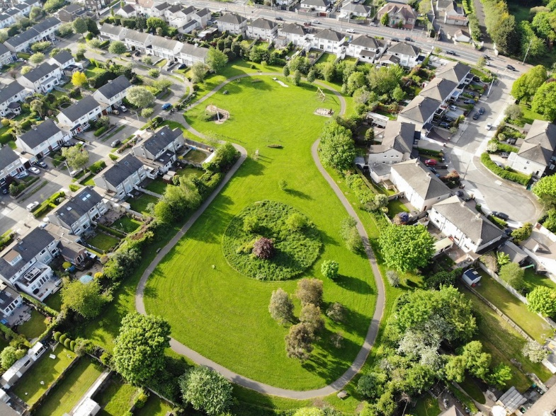 Glendoher Park – 3 laps = 1km

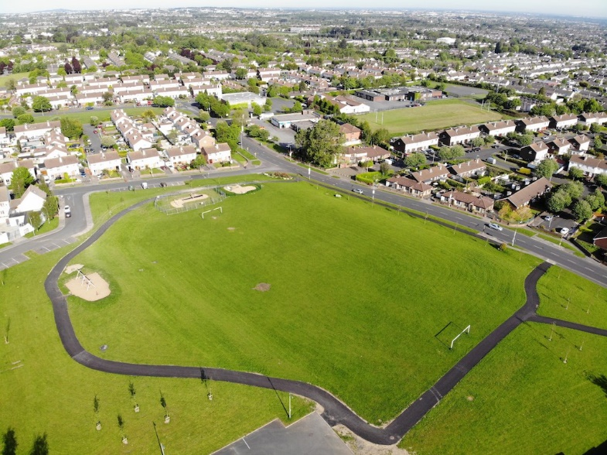 Whitechurch Green – 1 Lap = 1km

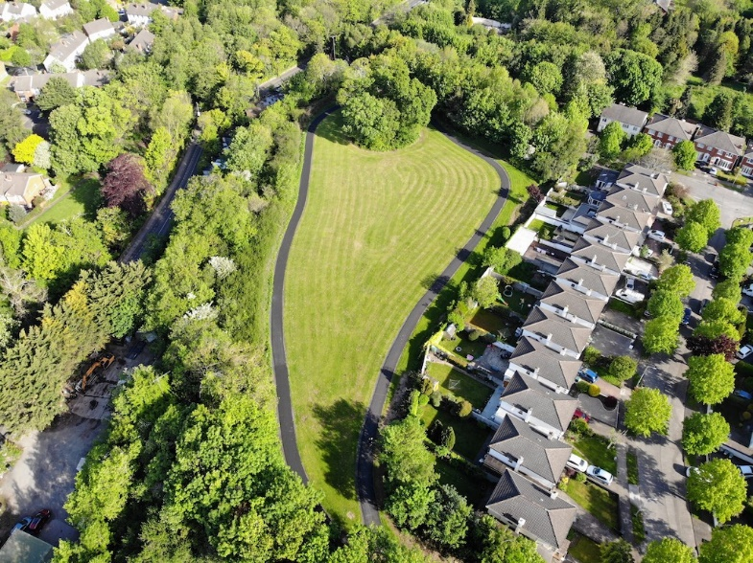 Dolly’s Field – Moyville Estate

4 laps = 1 km

**Ripple Effect & Natural Linkages**



Glendoher Park like other green spaces can act in conjunction with back gardens to create an unlikely but valuable alliance. With a green space you can create a ripple effect within your neighbourhood and community.

Example: E.g. for years we have encouraged residents to collect street leaves and to place them in wire cages in Glendoher Park for leaf mould - to help the local population of earthworms and to keep street footpaths clear. Glendoher Park took the street leaves from within Glendoher Estate but from as far afield as Rathfarnham Village, Willbrook and Ballyroan. Now we have residents creating their own leaf cages in their gardens, in other estates and applying some of the things we do in Glendoher Park into their seasonal routine. When needed our leaves are ‘borrowed’ by Pearse Museum when they host their composting classes in conjunction with Stop Food Waste (EPA). One of the most effective pieces of messaging we have ever done is to advise residents that earthworm have up to 13 hearts. It was surprising the number of residents who stopped using weed killer and ‘Mapex’ (weed suppressant material) and turned to using 2 layers of cardboard/newspaper with 2 inches of mulch on top instead. The second most important piece of messaging for us was – if you don’t have daisies in your lawn then you are the one with the problem not your lawn. So, for us Glendoher Park is an outdoor classroom or a biodiversity lab for communicating ideas and messages.

Glendoher Park cannot exist ecologically on its own and that is where natural linkages and green infrastructure are imperative. The threat of ecological habitat fragmentation poses a real risk to our residential amenity. Our Park is only as good as the Natural Linkages it is connected into. So, we need to work with SDCC to build on our messaging within the community and to do that SDCC need to work on their messaging.

**Actions:**

1. Create a Nature, Parks & Biodiversity publication for every household in SDCC. SDCC has such diverse biodiversity, amazing parks and tremendous knowledge on biodiversity and environmental awareness to share – not to mention places and habitats of interest. This would help break the log-jam we believe there is in the community between the local authority and local communities.
2. Create a wildflower sheet - things to find in your lawn, things to find along an old footpath or old wall.
3. Local Tree Poster in the area that might have a history or simply to identify these tree types
4. Create a YouTube channel full of local talks about biodiversity in our parks, workshops etc
5. Continue to publish articles in Local Newspapers on biodiversity

**Biodiversity, Natural Linkages & Planning**

The first time many of us came across the term Natural Linkages was in a SDCC Ballyboden Village Area Masterplan adopted in July 2006

On page 19 it stated the following text with 2 pictures and a map the following

**5.2.4 Wildlife Corridors and Green Space**

Suburban wildlife requires a habitat in which to survive and thrive.

Watercourses, parks, trees, hedgerows and landscape planting are

valuable urban resources for birds, hedgehogs, squirrels, otters,

badgers and foxes. As the density of urbanisation increases these

green areas become isolated in a grid of buildings, streets and

roads.

Creating linkages, between green spaces and streams, enables the

movement of local wildlife in search of food and life cycle habitats

and enhances the green amenity of the locality as well as sustaining

suburban biodiversity.

 

Linkages can be formed between large open green spaces such as

Glendoher Park, Moyville ‘Pocket Park’, the Augustinian lands and

other smaller green spaces. Trees and shrubs in back gardens can

link green spaces. Linear stands of trees, including street trees and

the Owendoher River and remnant mill races, contribute to wildlife

corridors



Fig. 6 Map showing potential for linkage between green spaces

This one page from a 27page plan that has long since gathered dust in County Hall changed fundamentally how we viewed our area. Somebody in the SDCC Planning department created that ripple effect in our area and our area has benefitted from this inspirational piece. If we could be inspired, just how many other groups, schools and residents could be inspired? We have shown this page to so many residents, groups, shops and schools in our area. It is the easiest tool to use in Biodiversity as it shows the gaps and it shows that everyone can play a part.

GDRA together with BBTT and other residents groups, Men Sheds and TY Students from local secondary schools, sports clubs, Brownies, have used this map and installed our 1916 Heritage Rose Beds as part of the Ballybuzz - Buzz50 project along Taylor’s Lane, Ballyboden Way and soon to be Ballyboden Road, not to mention tree planting that has been undertaken – this has so much potential if only we could work better with SDCC in a structured and planned way.

**Actions:**

1. If Heritage Maps can be produced why can’t Natural Linkage Maps (NLMs) be produced? Some of these hedgerows range from 300-700 years old. We would like to work with SDCC to produce an updated version of this map for our area and see how we can implement the biodiversity potential and ecological connectivity in our area.
2. We believe a Natural Linkage Map would be an effective planning tool for all SDCC Departments and such maps could be replicated throughout the County. If Landscape Character Maps can be incorporated into a County Development Plan then why can’t NLMs?
3. Landscaping Plans of new developments should be assessed how they can contribute to this Natural Linkage Map and potential mitigation measures suggested and adopted. At the moment planning permissions simply concern themselves of the landscaping detail in-situ but not how it can affect ex-situ area or the future potential of ex-situ natural linkages.

**Sites of Interest for Nature Conservation – SINCs**

It seems that if a site is not a Natura 2000 site or a NHA it has no protection and perhaps this is where a more locally nuanced assessment by a planning authority can be identified and recorded in the Development Plan with e.g. the associated Specific Local Objectives and that collectively they can enable the planning system to recognise and thus protect or enhance local areas of substantive nature conservation outside the restrictive Natura 2000. These areas are of importance in Local educational, national linkages and biodiversity terms and where the developer must provide mitigation measures so that there is no loss to that local nature or wider nature network.

**Rivers, Wildlife & their Riparian Vegetation**

There are plenty of weaknesses, risks and threats to the welfare and future of our rivers, habitat and their wildlife in the South Dublin County Council area. It is not just legacy issues but current practices and strategies and inattention by senior management are failing our rivers, wildlife and us. Those risks and threats include:

* We cannot measure the ‘impact with scientific certainty’ of the biodiversity crisis at a local level because SDCC have been irresponsibly slow to meet the obligations in respect their management obligations. The lack of survey work to establish baseline data of species locally in particular species protected under the EU Habitats Directive and the Irish Wildlife Act is an issue that regularly comes up for commentary.
* The failure by Management to resource Biodiversity and specifically in terms of Planning Enforcement and Parks Department are persistent own goals for SDCC.
* What is particularly noticeable is the failure by SDCC to have any baseline data of EU protected species within Natura 2000 sites and Zones of Influence within their local authority area.
* Unauthorised development beside rivers and riverbanks
* legacy issues of inappropriate development e.g. too close to rivers, culverting, bad connections in respect sewerage, septic tanks, spreading slurry by farmers, removal of riverbank, rerouting rivers and in appropriate surface water treatment.
* The impact of Forestry Licenses that did not adhere to EU Law and therefore did not have an Appropriate Assessment and the ecological impact of their Monocultural Commercial Enterprises – their practices and methodologies e.g. soil erosion, soil degradation, silting of rivers, extensive use of weed killer on local vegetation, over-engineering of access roads often without planning permission and the subsequent loss of habitat and wildlife.
* Car washes run-off and other un-regulated run-offs from panel beaters, garages.
* lack of sufficient protection in respect of establishing Specific Local Objectives in the Current Development Plan e.g. Owendoher and Glin are nurseries for the Dodder - yet no Specific Local Objectives to support these rivers exist i.e. to protect and improve them.
* Lack of recognition of heritage millraces and the ecological benefit especially naturalised linkages and ecological connectivity and group significance they represent. SDCC simply have no idea certainly in Ballyboden and Rathfarnham the extent of this connectivity
* Basic protection guidelines and measures that the Inland Fisheries recommend are regularly ignored by Planners when they grant planning permission and/or for Part 8 developments. Surely SDCC should have these guidelines and objectives developed already internally and included in their Development Plan or Biodiversity Plan for specific detailed measures depending on the specific rivers. If the IFI do not submit such a letter to SDCC pertaining to a development, as a prescribed body, it is likely that no measures to protect the river and its riverbank are incorporated into the Grant of Permission
* Inappropriate emphasis on engineered solutions to flood alleviation schemes rather than looking at nature-based solutions especially those available upstream
* dumping by local authorities/state bodies & their contractors (main cause of debris on the Glin was road works debris courtesy of the SDCC Roads Department (or their contractors) and where trees are pruned etc the branches dumped into the river.
* Regrettably the Housing Department have a poor record in our area when it comes to rivers and maintaining Ecological corridors. E.g. The Housing Department culverted a stream in Owendoher Grove and that was not featured in the Part 8 proposal project description or site notice, that was adopted by Councillors. At Kingston Court - by building a wall which was not necessary they blocked off access to a river for wildlife - no mitigation measures were considered E.g. Natural boundary despite it being such a small measure required – it was too small for them to consider and we were simply ignored.
* Illegal dumping not just of garden waste but also of builder’s rubble
* Election Posters
* annexing of riverbanks by residents and businesses receives so little attention that SDCC has no figures for it despite enforcement complaints and at a local level the Glin really has suffered from it on Lower Whitechurch Road yet we reported such instances to SDCC and OPW
* the removal of ditches and hedgerow to facilitate development and their replacement with attenuation tanks
* the reliance on rivers by Irish Water for water supply rather than local aquifers
* the failure by SDCC Senior Management and for staff across a number of departments to understand the Irish Wildlife Act, EU Habitats Directive and the Birds Directive – this is a training issue that is the common denominator for a lot of problems that rivers face.

We have some of the most beautiful rivers in our area the Owendoher River and the Glin River also known as the Whitechurch River and together with various millraces we know the value of a good ecological corridors but the question is do SDCC? SDCC consistently fail to recognise that most rivers in their local authority are hydrologically and therefore ecologically associated with at least one Natura 2000 site and in the case of the Glin and Owendoher two Natura 2000 sites respectively as they both rise in Natura 2000 sites and end up in a Natura 2000 site -Dublin Bay.

Historically, you could build on the river, then we had an exclusion zone of 5 metres from a river and then in the last development plan it was 10m although we had submitted a request for 20 metres. Hopefully in this Biodiversity Plan this can be increased to 30 /50 metres. But even with that Developers can circumvent the planning process by going for retention and getting away with removing a riverbank and culverting it and using it as a drain for their surface water. Then we ask the question why is river quality so poor – after the horse has bolted?

**Example**

In 2008 this is what happened to the Glin River on Whitechurch Road – the applicant had no planning permission to remove the river bank. In fact, it specifically stated in the conditions that the banks were not to be interfered with during construction according to the Inland Fisheries of Ireland and the subsequent grant of permission. We did report this breach in planning conditions to SDCC but no action taken. The message was if it is about the plight of a river and business and despite the presence of otters, badgers and kingfisher and trout and the existence of the EU Habitats Directive it is regrettable to say that SDCC will not adhere to the EU Habitats Directive in our experience of dealing with the Planning Department and we would be shocked if they did adhere with ‘scientific certainty’. So, the entire river has been culverted with a car forecourt with absolutely no mitigation measures for otters or their impact assessed.

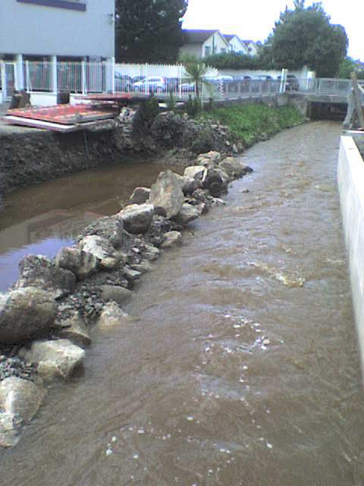 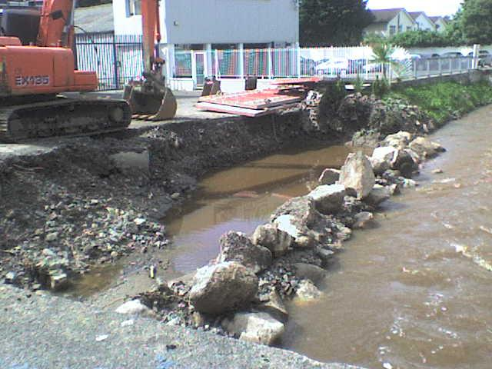

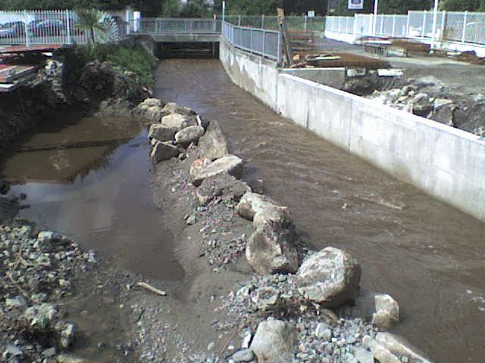 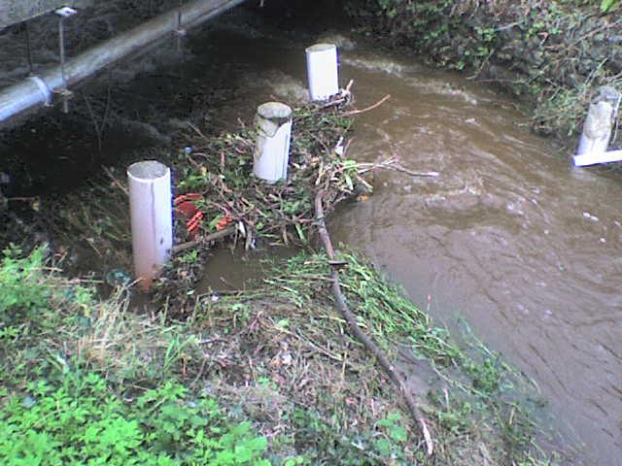

**River Surveys & Neighbourhood Nature Reserves**

In 2012 with the help of the Heritage Officer and SDCC Parks Department we received funding to Prepare a Biodiversity Study of the Owendoher and Glin (Glynn) Rivers also known as the Whitechurch Stream and we engaged Mary Tubridy (ecologist) to project manage it for us as we were involving the local community. Whilst the report was the first of its kind to digitally map invasive species it took until 2016 for SDCC to actually implement and roll out across the County a successful 5year programme to eradicate such invasive species. As monies were limited and our study area covered both the Owendoher and Glin further stages or modules were not completed but notwithstanding that the following important points need to be acknowledged:

1. CFRAMS identified that both the Owendoher and Glin (Glynn) are part of the Dodder Catchment Area but sometime rivers that form part of such large catchments can get lost or overlooked.
2. It is important to note that what happens upstream impacts downstream and rivers such as Owendoher and Glin are nursery rivers and therefore require their own individual river management plan.
3. Whilst both are sourced in two different Natura 2000 sites – two different Mountains that are both part of a SAC. However remarkably they are connected via a naturalised Millrace that flows along Taylor’s Lane. They are both very different rivers in character and waterflow and what might work on one river may not work on another which makes Appropriate Assessments really important for these rivers.
4. We gathered a community of people in the area who were interested in these rivers and who had knowledge of these rivers since they were children and these people came from golf clubs, residents, Dodder Action, Dodder Angler, businesses, Residents Associations.
5. Research from this project fed into subsequent publications e.g. ‘The Rivers Dodder and Poddle’ by Don McEntee and Michael Corcoran and William Hoggs Data base on the Mills of Ireland which is currently being digitised
6. It has also allowed us to make submissions in relation to planning applications that abut these rivers regarding the information we uncovered
7. It identified 18 locations of invasive species in 2012. By 2016 SDCC when they commenced their treatment programme there were 33 locations for the Rathfarnham Ward and it indicated that the Rathfarnham Ward had a far bigger concentration of invasive species than any other SDCC electoral ward and that the Glin and Owendoher had a serious problem compared to other rivers.
8. GDRA, BBTT and Dodder Action commenced in 2018 regular clean-ups of both the Glin and Owendoher Rivers and have identified groups and individuals who are committed to setting up a **Neighbourhood Nature Reserve** for both the Glin and Owendoher from its source in a Natura 2000 site to where these rivers join the Dodder.

**Actions:**

1. We would like to work with SDCC again to review the Study and to complete the other modules of this Biodiversity Study for both the Glin and Owendoher
2. We believe a River Management Map where the riverbank quality or gaps can be identified - where the width of a riverbank from the nearest development is measured – 2m, 5m, 10m
3. Identify historical flood plains and identify those areas that have been built on and the extent of culverting of existing rivers, areas of unauthorised development both reported and unreported – identity the extent of non-compliance of sites abutting rivers
4. Identify those areas and specifically rivers that act as ecological corridors to Natura 2000 sites and to develop policies and objectives that give them greater connectivity & habitat value
5. Identify sites that will enhance the potential of Zones of Influence and Natura 2000 sites
6. Identify sites for the rewilding purposes
7. Consider identifying local sites as Sites of Interest for Nature Conservation - SINCs and having them included in the Development Plan with the appropriate Specific Local Objectives.
8. Setting up Nodes of Communities along the Rivers who are interested in setting up a Neighbourhood Nature Reserve for each of the Owendoher and Glin and working in partnership with SDCC & NPWS on enhancing the ecological habitat value of these beautiful rivers with a view to increasing their connectivity value to their respective Natura 2000 sites

**Wetlands**

As part of the planning permission for the new Ballyboden Reservoir the old reservoir which is a Protected Structure was to be retained and turned into a wetland habitat.

**Actions:**

* Develop a plan for the Ballyboden Reservoir in partnership with Irish Water, Dublin City Council and Ballyboden Tidy Towns
* Another location we would propose to be designated as a wetland would be the Brittas Ponds.
* The Local Authority areas should be scoped to establish a list of wetland habitats.
* Specific Local Objectives should be established to protect and improve such sites for wetland habitat and
* such sites should be identified in the Development Plan as Sites of Interest for Nature Conservation – SINCs

**Grass Verges – taking it to the Grass Roots**

We do know that people want to respond to the plight of pollinators but the enormity of the pollinator, earthworm & insect disaster is intimidating & overwhelming for residents so we often say ‘whatever you do is better than doing nothing at all’. So, we encourage residents to plant e.g. crocuses in their lawn and to celebrate the dandelion, trefoils etc with a ‘Grow don’t Mow’. Some residents mow a small border (like a picture frame) around their grass verge just in case the neighbours think they are lazy. We are also encouraging residents to replace/reduce their grassed verge area with pollinator plants. Even contacting residents to thank them for their efforts even if it is small can often encourage residents to do more. There is leadership required and sometimes investing in grassroots is the only way as every ‘win’ matters, in a biodiversity crisis.

Peer pressure or the power of local influencers has never been examined by SDCC in terms of identifying people or businesses who can help affect change. If one resident on a road edges their grass verge or sweeps up leaves you can bet another and another resident will. It starts with one resident and it can start with one business.

**Actions:**

1. In new developments Grass Verges are endangered and this needs to be looked seriously as front gardens are becoming car ports. Private amenity space and semi-private amenity space need to be provided for and assessed in terms of their contribution to biodiversity.
2. Within new housing estates landscaping plans feature trees being planted but not the eventual size of the root system or the scale of the crown is seldom factored in.
3. Current balcony sizes are not big enough to facilitate a significant biodiversity contribution.
4. Residents Associations and Tidy Towns groups should be offered more than ‘Daffodils not Bonfires’ as daffodils are poor pollinator food source.
5. Prepare a poster/leaflet about ‘My Lawn and me - what it says about me’? Explain in simple terms the power and importance of having trefoils, daisies etc in your lawn.
6. Get people in love with earthworms - they have up to 13 hearts so why not promote the importance of them so that people will not choose to buy weed killer for their cobble lock, lawns and grass verges.
7. Identify key influencers, golf clubs, businesses or groups in communities and ask them to get involved in biodiversity projects

**Street Tree Canopies**

We have also noticed in our area that we have lost a lot of street trees from our grass verges. The rate of replantation has not kept up with the rate of tree removal and this needs to be addressed as a priority. We know that SDCC have developed a very successful ‘Living with Trees’ policy. However, the tree planting levels in the Local Authority area had a low baseline level to begin with, without having to compensate for the level of tree removal in said area. For residents to say it is like a ‘scorched earth policy’ changes need to be made. We submit that before tree removals take place perhaps an agreed number of trees can be planted in anticipation that there will be future tree removals.

It is also obvious that some electoral wards have more trees than others but what is noticeable is that the tree planting can be provided quicker in some areas than others. To the point that some residents’ associations source and plant their own trees in their grass verges. If SDCC are struggling to keep up with the demand for trees to be planted – then they need to invest more resources in their Parks Department. We have residents who have requested trees and have been waiting on them to be planted on their grass verges outside their house for years.

**Actions:**

1. If SDCC can produce figures for the Tree Maintenance schedules & a tree planting schedule then why can’t the Planning Department produce figures for those developments where trees are removed for development, e.g. trees to be retained and what number of trees are to be replanted? We don’t know how many trees were subject to unauthorised removal. We don’t actually know these figures so the Tree Canopy Number for SDCC is not available and it would appear unable to be calculated and mitigation measures designed or implemented for an electoral area let alone countywide.
2. SDCC needs to address the lack of Tree Preservation Orders in the local authority area.
3. SDCC should have their own tree nursery
4. SDCC need to start planting woodlands and retaining existing woodlands e.g. Rathcoole woodlands

**Hedgerows**

Hedgerows appear to have no protection in the SDCC local authority area. You can have Architectural Conservation Areas for buildings that may very well be 100 -200 years old but a developer can rip out an 8th Century Hedgerow on Scholarstown Road with impunity. The planning department will not enforce anything to do with a hedgerow removal. Tree bonds do not cover hedgerows. Protection measures for trees are poorly enforced but for hedgerow non-existent. If you have a planning condition for the retention of a hedgerow – it is meaningless in SDCC in terms of planning enforcement.

The impression in SDCC is Hedgerows should only be in the Parks. They have no value or function outside of this. So, when SDCC Housing Department and the County Architect designed a housing Scheme for a Part 8., Councillors in good faith adopted plans that had 200-year old trees to be retained, as in the case of Owendoher Grove, but where are they in the final delivery of units? No comeback on the Contractor, the County Architect or the Housing Department for unauthorised removal. So, what is the message we send to children who live in SDCC Housing that biodiversity is not a right for them and they should not have that expectation of experiencing nature?

The message we have got from the Housing Department is that they do not do landscaping and they certainly would laugh at you, as they have at us, if you suggest the All Ireland Pollinator Plan as we did in Owendoher Grove.

There is no joined up thinking between a hedgerow system, surface water and flood relief. In Scholarstown Wood we identified over 13 hedgerows (300-700 years old) working effectively as a surface water relief system below the Ballyboden Reservoir and they were replaced by the installation of large attenuation tanks which would be grassed over and calculated as public open space. The problem with that is you can’t plant trees on top of attenuation tanks. In that development the local biodiversity wipe-out was total. There has to be a way to reduce/avoid such local biodiversity loss and to incorporate mitigation measures. It should not just be applicable to Natura 2000 sites that you assess risk, threat and consider mitigation. The loss of birdsong for residents in that area and the wipe-out of bat traffic was considerable but never measured or assessed by SDCC.

**Actions**

1. Hedgerows are often old field and town boundaries and need to be digitally mapped and in conjunction with the SDCC Libraries Local Studies – mapping section so that the age of these hedgerows can be ascertained and recorded.
2. They also need to be identified as Sites of Interest for Nature Conservation (SINCs) in the South Dublin Development Plan and appropriate Specific Local Objectives be associated with them
3. Fragmentation of Hedgerow – is there a policy to avoid that on that in SDCC?
4. The removal of hedgerow should be avoided at all cost in new developments this needs to be reflected in the Development Plan.
5. Landscaping Plans must emphasise that boundary treatments should be where possible a natural based solution

**Buffers zones and Repurposing Dumps & Quarries**

SDCC have a number of old Dumps and Quarries and it is important that they are not left out of the Biodiversity Plan as they may represent Rewilding Opportunities. The Natura 2000 sites and NHAs that are within the South Dublin County Council area are under severe development and agricultural pressures. There is a need to protect those areas known as Zones of Influence (ZOIs) that abut/affect Natura 2000 sites and NHAs. Consideration should be given to create buffer zones in the ZOIs and to identify additional areas to be incorporated into the Natura 2000 site itself or the NHA or to separately identify them as Sites of interest for Nature Conservation (SINCs) in the Development Plan and in this way to Specific Local Objectives can be appropriately applied to protect or improve ecological diversity and habitat connectivity.

**Actions:**

1. Prepare a list of all Dumps and Quarries and identify any suitable sites for rewilding purposes and prepare a feasibility study
2. Prepare a map where all the Zones of Influence around Natura 2000 sites and NHAs can be identified and recorded as potential extensions of NHAs and Natura 2000 sites or SINCs within the Development Plan.
3. Request copies of all the Management Plans of Natura 2000 sites and NHAs

**Parklets & Street Furniture**

This is a perfect opportunity to adopt parklets as a tool for biodiversity which came about as a result of the need to socially distance from each other but not from nature. We would like to see parklets incorporate seating areas, cycle stands within biodiversity hubs – to us these are the ultimate Buzz Stops, functional to our lifestyle but also helpful to address habitat fragmentation for insects and to remind people that biodiversity can enhance a streetscape and increase frequency at a business establishment especially restaurants. SDCC could even use these Parklets at Shows, events or markets or where Public Consultations are required instead of using Libraries.

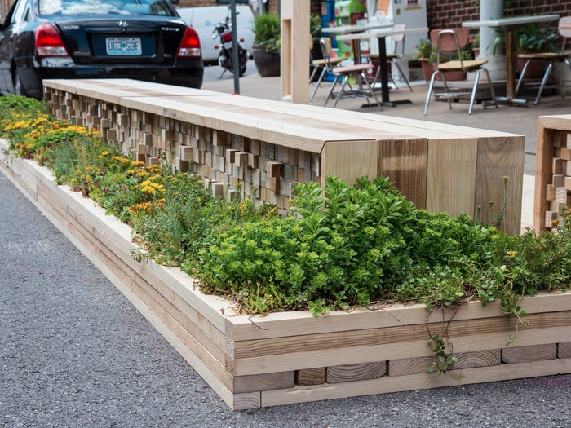 -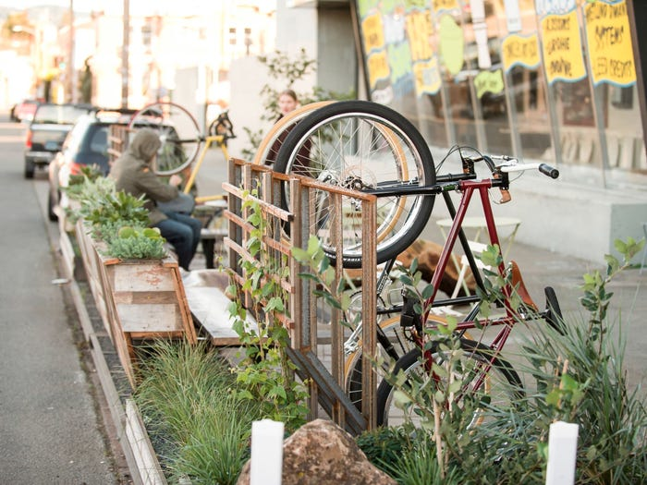 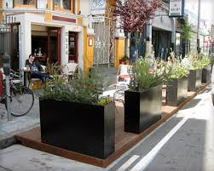 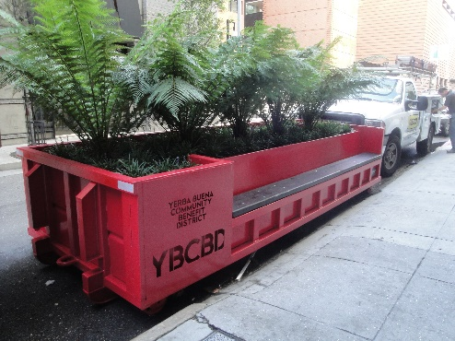

**Actions:**

1. We would like to see these Parklets rolled out in association with the business, community, restaurant and coffee shop owners, office blocks, libraries, shopping centres, churches.
2. Use parklets not just as a tool for village regeneration but also for streetscape regeneration especially when increasing cycling infrastructure and street furniture.
3. Promote the use Parklets within Office Plazas such as at County Hall, Office Blocks, outside Libraries, shopping centres and especially within industrial estates and Parks.
4. Use Parklets for SDCC Public Consultation booths and displays or outdoor exhibition spaces.

**Roundabouts**

One of the depressing messages that SDCC sent out to its residents regarding how they view biodiversity, environmental spaces and their Parks Department personnel is the complete lack of imagination, design and biodiversity incorporated in respect of their Roundabouts with few exceptions.

Despite schemes to attract sponsorship which should have seen an increase in investment in the horticultural design of roundabouts, SDCC Management sought to remind us that their priority was cheap low maintenance ‘yellow-pack’ solutions where to install monotonous, depressing often gravel-like tombstones to biodiversity was the result of their refusal, unlike other local authorities, to recruit gardeners/horticulturists or set aside any monies so that SDCC could take pride in itself and create an appetite for place-making. Instead of contributing to placemaking with a vibrant biodiversity contribution this opportunity was lost on SDCC Management with their addiction to chipping, concrete and tarmac. Good Corporate PR Management would deem Roundabouts as ‘quick wins’ in terms of biodiversity and good PR – providing good educational talking points in the community.

**Actions:**

1. Review the landscaping of Roundabouts and apply the All Ireland Pollinator Plan with the objective to use Roundabouts to be a showcase for SDCC, its staff and a tool for placemaking.
2. Only those roundabouts that comply with the All Ireland Pollinator Plan should be made available for sponsorships.
3. A commitment that any future roundabout design or redesign will avoid concrete and tarmac where possible.

**Roads Department & their Road Verges**

SDCC have already recognised the importance of road verges in terms of biodiversity in small patches throughout the county but it is still the exception than the rule, this is despite the evidence that biodiversity led planting can effectively act as dust, air and noise filters. It is not clear what SDCC targets are in respect of road verges becoming pollinator friendly or places where tree canopy can be increased. It does not appear that such a target or plan is in place and what are the targets. It seems there is an ad hoc approach here in respect of transport infrastructure. In fact, when green infrastructure is referred to in documentation it is often cycling and not biodiversity that is being discussed.

Sometimes it is hard to understand how grass verges are more like putting greens and not a golf course in sight. This old-fashioned approach of ‘tidy edges and tidiness’ needs to change as it is at the core of the problem we want to address within the roads and parks department.

Sometimes where you do see hedgerow planting along road infrastructure you can tell that there was either no budget set aside for landscaping or whatever there was eaten away with construction over runs.

In SDCC there has been an addiction to daffodil planting especially in road verges and whilst it is a spectacle there are other pollinator friendly bulbs and plants that are ignored. In addition, once the Daffodil is over there is no attempt by SDCC to have another plant or flower come into bloom.

**Actions:**

1. Establish targets and measurement indicators for each electoral area so that we can see the progression from’ cut grass verges’ to ‘wilding verges. Acknowledging that in some cases it will be a ‘grow don’t mow’ approach, three/four-week mow frequency as opposed to a fortnightly mow, rather than a wild meadow or natural scrubland. In other there are degrees of wilding up road verges.
2. Ringfence landscaping & biodiversity budgets for roads construction projects. Too many times landscaping pays the price in Roads & Housing projects Taylor’s Lane, Blessington Road
3. Hedgerow planting along roads lacks the diversity in the tree whip selection - in single rows in order to save money.
4. If we are planting daffodils then consider what comes next into seasonal bloom and could those choices be more pollinator friendly?
5. The National Roads Authority, M50 (Bus Connects) need to fully understand their obligations in respect of EU Habitats Directive and how they are going to work with SDCC to deliver Green Infrastructure alongside Transport Infrastructure but also the potential for them to make a massive difference not just in turn of habitat generation, developing strategies to reduce ecological habitat fragmentation but also in terms of education too.
6. The Roads Department need to change their attitude to their landscaping of road infrastructure and the maintenance of it. In our area there is no attempt by the Roads Department to reflect the biodiversity emergency in their road schemes.

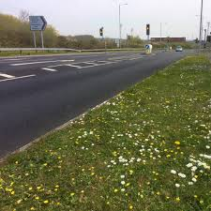

**Green Messaging**

However, we know we are not reaching every resident, business, school etc., with our messaging via social media and that is where our Community Notice Board is invaluable and presents a real opportunity for Biodiversity or Green Messaging’. However, our messaging is dependent on the frequency and quality of the Green messaging coming out of SDCC

The other point is why is SDCC so weak in its social media communications – why is there no account for Biodiversity, Environmental Awareness, Climate Change and Parks Department?

From the content of articles in The Echo about Biodiversity and the presentations given during this current consultation it has become apparent that SDCC has no problem generating biodiversity content but it has no purpose-built communication platforms to promote its activities unlike the Arts Office, the Sports Partnership and the Library Department.

**Actions:**

1. Prepare a Marketing Plan and Communication Strategy for each of the Parks Dept, Environmental Awareness, Climate Action and Biodiversity functions in SDCC within each of those Departments
2. Ensure a social media presence for each of these sections e.g. twitter, Instagram, YouTube, Facebook
3. Develop or collate educational materials for schools, businesses, individuals and community groups
4. Each Park and Natura 2000 site should have its own social media presence
5. Prepare Educational Maps, leaflets and publications on biodiversity
6. In the Council Reviews issued to the Public ensure that Biodiversity, Parks, Climate Action and Environmental Awareness are written about

**Grants**

SDCC have an array of community grants including an Environmental Grant and an Equipment Grant. The Community Department never checks the methodology or the works on which Council monies will be expended. We have seen ‘environmental grants’ used to destroy riverbanks and they have done so whilst Parks Department have been side-lined. Environmental Awareness also have the Local Agenda 21. This was a very important source of seed funding for Biodiversity Projects when none was available elsewhere. Unfortunately, it does not appear to be available or perhaps it has been renamed. There is a need for Biodiversity Grants Programme. If community groups and Tidy Towns are being designated by SDCC to be their agents of change then SDCC need to provide funding for such activities. Tidy Towns funding was not issued in 2020 so far yet biodiversity projects still need materials so it is not clear if Tidy Towns initiative is being continued by SDCC despite referenced in the Biodiversity Plan. Also, Tidy Towns Groups receive the same amount of grant even though the geographical areas might be bigger and be in a different population category.

**Actions:**

1. Greater accountability of Grants when the environment or local biodiversity will be impacted – in other words sign off is required. Environmental or biodiversity themed Grants should be assessed by a suitably qualified biodiversity trained staff member preferably within the Parks Department.
2. A radical rethink is required for Grants for environmental/biodiversity purposes and also who is eligible Community Groups, tidy Towns, Schools, Churches, businesses etc.,
3. Biodiversity grants should be structured across a range of project types and scale – €800 is simply not enough for the scale of some of our projects in our area. The amount of money set aside for Environmental Grants is woefully inadequate for the tasks in hand and the expectation
4. Tidy Towns grants should be based on a scale based on the competition category
5. Clarification as to the future of the Tidy Towns initiative needs to be clarified.