Contents
Rathcoole Woodlands and the Draft County Development Plan 3
Introduction 3
Rathcoole Woodlands 4
Priority Annex I habitat 91E0 Alluvial forests 7
Priority Annex I habitat 7220 Petrifying Springs 8
Annex I habitat 6510 Lowland Hay Meadows 8
Wetland 9
Ecosystem Services and Cultural Value 9
EU Protection for Rathcoole Woodlands and the Annex Habitats 9
Relevant Policies in the Draft County Development Plan 10
Natural, Cultural and Built Heritage (NCBH) 10
Policy NCBH1: Overarching 11
NCBH1 Objective 1: 11
NCBH1 Objective 2: 11
Natural, Cultural and Built Heritage Policy 2: Biodiversity 11
Natural, Cultural and Built Heritage Policy 5: Protection of Habitats and Species Outside of 11
Designated Areas 11
Natural, Cultural and Built Heritage Policy 11: Tree Preservation Orders and other Tree Protections 11
Green Infrastructure 12
GREEN INFRASTRUCTURE (GI) Policy 1 Overarching 13
Green Infrastructure (GI) Policy 2 Biodiversity 13
GREEN INFRASTRUCTURE (GI) Policy 3: Sustainable Water Management 14
GREEN INFRASTRUCTURE (GI) Policy 5: Climate Resilience 14
GREEN INFRASTRUCTURE (GI) Policy 6: Human Health and Wellbeing 14
GREEN INFRASTRUCTURE (GI) Policy 7: Landscape, Natural, Cultural and Built Heritage 15
Proposals for the Protection of Rathcoole Woodlands 15
Core Strategy 15
Amendment to CS10 Rathcoole SLO 1 15
New land use zone - Zoning Objective High Amenity-Camac Valley/Rathcoole Woodlands and environs, ‘HA –CV/ RW’ 18
Natural, Cultural and Built Heritage 18
New Natural, Cultural and Built Heritage Policy 18
Special Amenity Area Order 19
Tree Preservation Order 19
Green Infrastructure Strategy 19
Amendment to GI7 SLO 1 19

Rathcoole Woodlands and the Draft County Development Plan

Introduction
The Four Districts Woodland Group welcomes this opportunity to contribute to the Draft County Development Plan 2022-2028 (Draft CDP 2022-2028). The group appreciates the hard work of the Councillors to agree motions that have resulted in references to Rathcoole Woodlands in the Draft CDP 2022-2028.
The Group appreciate the inclusion of the Core Strategy 10 Rathcoole Specific Local Objective 1 (CS10 Rathcoole SLO1). The Group are pleased to see the councillors agreed amendment to CS10 Rathcoole SLO which saw the insertion of “protecting” and “Biodiversity and the Rathcoole Woodlands” in the Draft County Development Plan. The Group are also pleased to see further reference to Rathcoole Woodlands in Green Infrastructure, under Policy GI7 Objective 3 and 4.
The Group are also pleased that South Dublin County Council recognises the presence of three annex habitats within CS10 SLO1 which includes Rathcoole Woodlands:
- Extensive 91EO Annex 1 Priority Alluvial Woodland
- Springs with an Affinity to Annex 1 Priority 7220 Petrifying Springs
- Extensive 6510 Annex 1 Lowland Hay Meadow

The area within CS10 Rathcoole SLO1 is a biodiversity gem, unique within South Dublin if not nationally and a key candidate for nomination as a green infrastructure core area.
The Group remain concerned that the acknowledged annex habitats are not mentioned in the Draft CDP 2022-2028. The Group are gravely concerned that after three studies undertaken by Brady, Shipman and Martin, the Council has yet to decide what the actual extent of the 91EO Annex 1 Priority Alluvial Woodland is, which includes Rathcoole Woodlands. It is clearly evident from the Councils own presentation of habitat maps, see H14 Major Housing Developments Update that:

(a) Woodland is the majority of the site, and the majority of Woodland is 91EO Annex 1 Priority Alluvial Woodland, Rathcoole Woodland
(b) Grassland /Woodland mosaic, or transitional woodland is the second largest component which no doubt being contiguous with the 91EO Annex 1 Priority Alluvial Woodland will in time become annex habitat ,
(c) Grassland is a small portion of the site of which 1 ha is annex lowland hay meadow

The Group find it unfathomable and inconceivable that in the face of a climate and biodiversity crisis and contrary to their own policy, the Councils shows clear intent to destroy a portion of the Woodland as indicated in their presentation with an Example Development Area outlined. The group are also concerned by the stronger original and still prevalent development emphasis in CS10 SLO1:
“….Following this assessment, and where alternative land use arrangements are identified in line with the proper planning and sustainable development of the area, to bring forward proposals for re-zoning…”
This leaves the status of Rathcoole Woodlands and the three Annex habitats in the area of CS10 SLO1 unclear. Ultimately the decisions regarding CS10 SLO1 will be made during the process to establish rezoning where there is unlikely to be opportunity for public consultation or participation except through councillors and later, should some form of development be proposed, the planning process. This is an unacceptable position for three annex habitats and a naturally rewilded native woodland to be in given our biodiversity and climate crisis.
The group is calling on South Dublin County Council and our Councillors to preserve the entire area of CS10 SLO1 and designate it a High Amenity Area with overarching policies and objectives for protection and preservation.

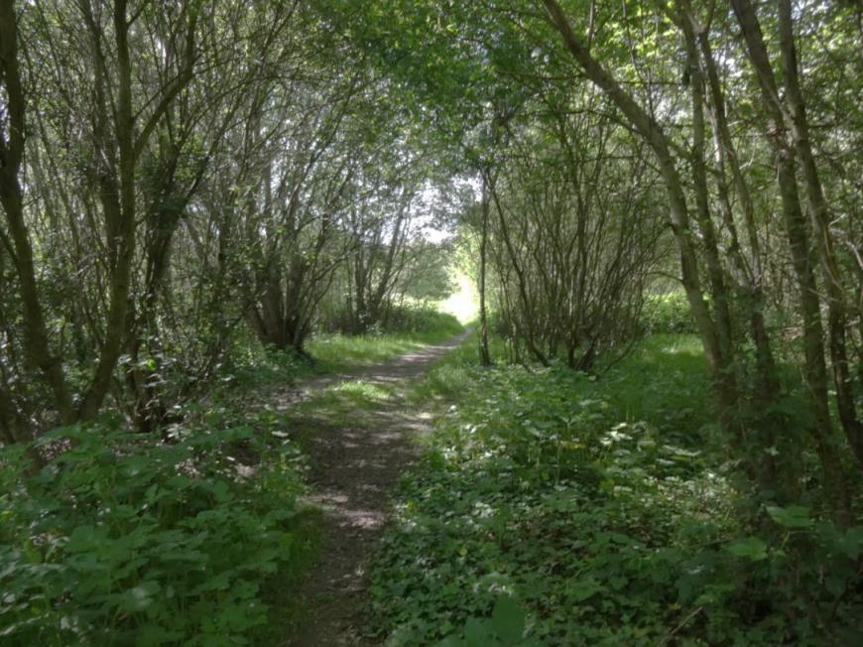
Figure 1 Rathcoole Woodland.

Rathcoole Woodlands
Rathcoole Woodlands is located in South County Dublin, Rathcoole (see here). It is adjacent and directly connected to Rathcoole Park to the east, within 300 m of Rathcoole Village’s Main Street to the north and has agricultural land to the south. It is highly unusual given its juxtaposition between maintained /manicured parkland, agricultural land and an urban environment. Such parcels of land are likely to become increasingly rare with the expansion of the Greater Dublin Area in the future.
Rathcoole Woodland is a prime example of re-wilding and of natural succession in the development of Woodland from abandoned agricultural land. This is a rare phenomenon in South Dublin as most land is never left untouched for 30 years and more.
Land or Woodland such as this usually does not have a qualifying conservation interest such as a particular habitat, plant, animal or water course. However such areas afford wildlife a habitat more in keeping with their needs; food, water, and a refuge from predators. It is also valuable amenity for the people of Rathcoole and the surrounding communities. But this Woodland and the surrounding land is different.
The Woodland within the ownership of SDCC comprises:
- Over 11ha of over 80,000 tress of mostly willow and birch trees
- Over a km of Hedgerows
- Several Springs
- Species rich scrub or wildflower meadow
- Tributary of the Camac, the Crockshane to the south and another, the Coolmine Stream, running west to east in its midst
- Three habitat types - classified according to the Fossitt (2000) habitat classification scheme in Mc Diarmada and Associates Report, unpublished 2020, WEBSITE:
    - WN6 Wet willow-alder-ash woodland
    - WS2 Immature woodland
    - WS1 Scrub

- Two protected habitats - see presentation at the June 14th Council Meeting and report submitted to the Consultation on the Draft County - :
• Extensive 91EO Annex 1 Priority Alluvial Woodland
• Springs with an Affinity to Annex 1 Priority 7220 Petrifying Springs

A Preliminary Ecological Appraisal (Brady Shipman Martin, unpublished 2020, WEBSITE) states:
“Based on the information gathered to date, including a desk review and two ecological surveys, it is considered that the site at Rathcoole is likely to be of Local Importance (Higher Value) as defined by the ecological resource valuations presented in the National Roads Authority/Transport Infrastructure Ireland Guidelines for Assessment of Ecological Impacts of National Road Schemes (NRA/TII, 2009 (Rev. 2)).”
And considers:
“The stream corridors, particularly the stream flowing from south west to north east through the site, with their associated tree lines/hedgerows, are the most significant features. However, by virtue of its rarity in South County Dublin, the early succession willow-dominated scrub and immature woodland, which is present throughout much of the study area but is particularly well-established in the western part, is also of biodiversity value.
In addition to the habitats, the site is also expected to be of Local Importance (Higher Value) for a range of species including badger, bats and breeding birds.”
Observations by Joe Gowran, CEO of Woodlands of Ireland unpublished report WEBSITE (2020):
“……and noted the following:
- Mature coppiced hazel stools on the townland/parish boundary
- New natural regeneration of Birch, Hazel, Guelder rose, Wild cherry (possibly hybrid), Ash and Oak (probably planted by Jays/ Garrulus glandarius / Scréachóg choille)
- Honeysuckle climbing into tree canopy.
- Garden escape species of Cotoneaster, Norway maple and Sycamore
- Water sitting below the root plates of Willow
- Anecdotal account of deer encroachment through the site. “

On Monday the 14th of June, South Dublin County Council Chief Executive Danny McLoughlin, made a presentation at the Council Meeting on the area subject to the Rathcoole Master Plan.This was under Headed item H14 Major Housing Developments Update. He presented the results from the most recent draft report of the ecological studies which included recent surveys. It showed that the Master Plan area including Rathcoole Woodlands has:

- Extensive 91EO Annex 1 Priority Alluvial Woodland
- Springs with an Affinity to Annex 1 Priority 7220 Petrifying Springs
- Extensive Heritage Hedgerow
- Orchid meadows
- Species rich grassland
Following on from Rathcoole Woodland in Rathcoole Park and the adjacent GAA lands is:
• Extensive 6210 Annex 1 Lowland Hay Meadow (note this should be 6510)
• Orchid rich wet grassland
• Locally species rich/orchid rich grassland

Potential ways forward outlined in the presentation:

• The Master Plan as was, is withdrawn.
• South Dublin will consult with National Parks and Wildlife on the ecology and area of protection.
• But South Dublin will also look at the remaining lands outside of ecological sensitive zone; Department of Education and GAA lands.

A comparison of habitat maps (see Annex X) shows there are three main habitat types within the 24 ha of CS10 SLO1:

(a) Woodland is the majority of the site at 14.8 ha, and the majority of Woodland is 12.8 ha of 91EO Annex 1 Priority Alluvial Woodland with the remainder being 2 ha of immature woodland which will in time become annex habitat left to evolve naturally
(b) Grassland /Scrub- transitional woodland mosaic is the second largest component at X ha which no doubt being contiguous with the 91EO Annex 1 Priority Alluvial Woodland, will in time become annex woodland habitat if left to its own devices and some if managed could become lowland hay meadow,
(c) Grassland is a small portion of the site of which 1 ha is annex lowland hay meadow
The location and extent of these broad habitat types are in broad agreement across the habitat maps. There is no definitive line between woodland and scrub- transitional woodland because they are simply different stages of woodland development with each grading into the other. The satellite imagery clearly shows the woodland and scrub- transitional woodland as very distinctive from the grassland components. This is more evident on the ground.

The whole area comprising CS1 SLO10 is a wonderful complex mosaic of annex and non-annex habitats, of woodland, scrub and grassland, hedgerows, streams and springs, each valuable in their own right. The whole area should be preserved and protected with an appropriate management plan put in place. This should be done immediately to prevent loss that can easily happen as illustrated by the loss of the reed and large sedge swamp (Figure 9 and 10).

Priority Annex I habitat 91E0 Alluvial forests
However, habitat in the Woodland corresponds to the ‘Priority Annex I habitat 91E0 Alluvial forests’ as listed under the EU Habitats Directive. A report was submitted to the Consultation on the Draft County Development Plan by an experienced, professional, and well respected ecologist, a Woodland Specialist. In her professional capacity, she has completed many Woodland surveys including on behalf of the National Parks and Wildlife Service (NPWS) . She was on the Woodland Monitoring Survey, of old sessile oak woods and alluvial forests in 2011-2012 . The presentation
Priority habitats are of Community Importance. They are “Priority habitats are those deemed to be in danger of disappearance, in view of the proportion of their natural range within the EU” (Daly, 2020, unpublished). The Habitats Directive lists 45 Priority Habitats considered of particular significance and Ireland possesses 16 of these Priority Habitats. Annex habitat in Rathcoole Woodlands is a very important find. And unusually it is a nascent Alluvial Woodland: “Rathcoole woodland is still in an early successional phase having developed on open habitat within the last twenty years” (Daly, 2020, unpublished). It is likely closer to 30 years old having been the subject of a CPO in the early 1990s.
According to Daly 2020 unpublished: This Priority Annex I habitat is a water dependent habitat; therefore, any activity (within or adjacent to the site) that alters site hydrology could negatively impact the woodland (e.g. species composition change). The presence of this Priority Annex I habitat has implications for any future developments within or adjacent to the Rathcoole woodland site (e.g. SDCC zoned RES-N lands).
Priority habitats are deemed to be in danger of disappearance, in view of the proportion of their natural range within the EU. Habitat 91E0 is a national resource. In the South Dublin County Council jurisdiction there are three Natura 2000 sites:
• the Glenasmole Valley Special Area of Conservation (Site Code 001209)
• a portion of the Wicklow Mountains Special Area of Conservation (Site Code 002122)
• a portion of the Wicklow Mountains Special Protection Area for Birds (Site Code 004040)

None have Priority Annex I habitat 91E0 Alluvial forests identified as a qualifying interest. Article 17 Reporting under the Habitats Directive indicates there are five records of Alluvial Woodland in County Dublin. The location, age and condition of these Alluvial Woodlands are not readily available. However, none is in South Dublin County Council.

Rathcoole Woodlands is a substantial Native Woodland at 11 ha in area given that the National Survey of Native Woodlands found: ‘The majority of surveyed woodlands were small or very small in extent, with 50% of sites being 6 ha or less…, over two thirds (67.8%) of sites were 10 ha or less and only 3.3% of sites surveyed were 50 ha or more, with just ten sites over 100 ha…This reflects the highly fragmented nature of the Irish woodland resource..’
Currently there is 19.644 km² of Alluvial Woodland distributed across 198 10 km² grids. 16.66 km² is in good condition with the remainder not in good condition. The reported over all conservation status is bad due to area loss. 11.31 km² of the area is in SAC of which 9.37 km² has alluvial Woodland as a stated qualifying interest. 2.2 km^{2 is} surveyed over 40 sites and 57.5% of this is in private ownership with seven sites on Coillte lands and five sites are on NPWS lands. Alluvial Woodland is highly fragmented and suffers from edge effects and in some cases could cease to persist related to genetic diversity. There are still areas of unmapped alluvial woodland such as Rathcoole Woodland.

Priority Annex I habitat 7220 Petrifying Springs
The Springs in Rathcoole Woodland are Priority Annex I habitat 7220 Petrifying Springs. A field survey of petrifying springs was conducted island-wide (2011 – 2013): 186 relevés (sample plots, each 4m²) were recorded from 110 springs.
Irish petrifying spring vegetation has been classified into eight plant communities (Lyons and Kelly, 2016).
These groups encompass a broad range of variation within petrifying springs as they occur in Ireland and
Include lowland, upland, wooded, unwooded and coastal springs.

The Monitoring Guidelines for the Assessment of Petrifying Springs in Ireland (Lyons and Kelly, 2016) states that “An important stipulation within the habitats directive manual is that ‘in order to preserve this habitat of very limited expanse in the field, it is essential to preserve its surroundings and the whole hydrological system concerned’. Petrifying springs fall under the remit of the Water Framework Directive (Directive 2000/60/EC) as groundwater-dependent terrestrial ecosystems (Curtis et al. 2009, Kimberley et al. 2013); their ecological significance is recognised under this legislation and there is a legal requirement to maintain or improve the status of the groundwaters with which they are fed.”
The Glenasmole Valley Special Area of Conservation does have Priority Annex I habitat 7220 Petrifying Springs as a qualifying interest. The only other Priority Annex I habitat 7220 Petrifying Springs recognised in Dublin is in the Rye Water Valley/Carton SAC.
The 2019 Article 17 report assessed the overall status of Priority Annex I habitat 7220 Petrifying Springs as Inadequate, which is unchanged since the last reporting period. The trend is assessed as deteriorating and the decline is considered to have been ongoing since before the last assessment.

Annex I habitat 6510 Lowland Hay Meadows
The Annex I habitat 6510 Lowland Hay Meadow in Rathcoole Park is the result of an excellent grass mowing regime by SDCC Parks Department for establishing a wildflower meadow. This is in support of the All Ireland Pollinator Plan which SDCC have signed up to. The distribution of this habitat has reduced drastically over the last fifty years due to a decline in the use of traditional hay meadows in farming systems. The main threats to this habitat are from agricultural intensification and fertilisation. There are no recognised Annex I habitat 6510 Lowland Hay Meadows in County Dublin. The majority of this habitat is located in the centre of the country. It is a rarity on the east coast. And therefore this habitat find is particularly important for South County Dublin.

The 2019 Article 17 report assessed the overall status of Annex I habitat 6510 Lowland Hay Meadows as Bad due “to on-going area losses associated with agricultural intensification (fertiliser application), changes in agricultural practices, and because of significant historical losses in the habitat since the Habitats Directive came into force. The trend is assessed as deteriorating”.

Wetland
This is a Wetland. Wetland habitats occur where the water table is at or near the land surface, or where the land is periodically covered by shallow water. They include a range of different habitat types including marshes, fens, reed beds, bogs and wet woodlands. These areas tend to have high biodiversity value, as well as serving other functions relating to the protection of water quality and protection from flooding. While many protected areas include wetlands, most occur outside protected sites. Works involving the drainage or reclamation of a wetland generally require planning permission and may be subject to Environmental Impact Assessment.

Ecosystem Services and Cultural Value
The Woodland also provides many ecosystem services including carbon sequestration, flood attenuation,
biodiversity, improving air pollution, improving water quality and soil generation to name but a few. It has a rich history having been a Commons (Broadmore) before the Enclosures Act of 1818 which saw the establishment of fields. The Parish Boundary between Saggart/Rathcoole is to the south. A remnant of the Mill Foot Path to Saggart Mills runs along part of its eastern section. A double ditched over 200 year old passage is to the west with the reputed location and possibly remnants of the Rath of Cumhall from which Rathcoole gets its name. In 1948 it was bought and farmed by Nicholas Stassen up until the mid-1990’s.

EU Protection for Rathcoole Woodlands and the Annex Habitats
The Alluvial Woodland habitat, Petrifying Springs and Lowland Hay Meadows are afforded protection under:
- The Habitats Directive which afford protection to all protected habitats both within and outside designated sites. Habitats are assessed on a national basis for area, range, structure and functions and future prospects. 91EO is in unfavourable conservation status. Any further loss or deterioration in area nationally, even outside designated areas, is serious.

- The Water Framework Directive because the alluvial woodland is determined as a ground water dependent terrestrial ecosystem. The Springs are Tufa Springs, another protected habitat. The stream already comes under the remit of the Directive because it is part of a water body and the Liffey Catchment.

- And if damaged, there could be consequences under the Environment Liabilities Directive for unknowingly or wilfully destroying the environment (see new guidelines). Environmental damage under the Environmental Liability Regulations means:
- Water damage that has significant adverse effects on water status under the Water Framework Directive.
- Land damage that creates a significant risk to human health as a result of the direct or indirect introduction, in, on or under land, of substances, preparations, organisms or micro-organisms.
- Damage to protected species and natural habitats.

Relevant Policies in the Draft County Development Plan
Rathcoole Woodlands comes under the following policies (relevant section underlined) in the Draft County Development Plan 2022-2028.
Core Strategy and Settlement Strategy
Policy CS10: Rathcoole
Support the sustainable long-term growth of Rathcoole by focusing development growth along the main street based on local demand and the ability of local services to cater for sustainable growth levels.
CS10 SLO 1:
To investigate the potential for alternative land uses for the lands currently zoned RES-N (To provide for new residential communities in accordance with approved area plans) and OS (To preserve and provide for open space and recreational amenities) as identified by the SLO on the CDP land use zoning map, having
regard to protecting existing habitats, Biodiversity and the Rathcoole Woodlands, the need for social and affordable housing, community infrastructure and access.
Following this assessment, and where alternative land use arrangements are identified in line with the proper planning and sustainable development of the area, to bring forward proposals for re-zoning.

Natural, Cultural and Built Heritage (NCBH)
In this Chapter of the development plan, the Context and Planning Policy Guidance for Natural Heritage is set out. This includes:
National Policy Objectives (NPO) under the National Planning Framework (NPF), 2040
NPO 59 to ‘Enhance the conservation status and improve the management of protected areas and protected species’ and
NPO 60 to ‘Conserve and enhance the rich qualities of natural and cultural heritage of Ireland in a manner appropriate to their significance’.
and
Regional Policy Objectives (RPOs) under the Regional Spatial and Economic Strategy (RSES)
RPO 7.15 states ‘Local authorities shall take opportunities to enhance biodiversity and amenities and to ensure the protection of environmentally sensitive sites and habitats, including where flood risk management measures are planned’.
RPO 7.16 states ‘Support the implementation of the Habitats Directives in achieving an improvement in the conservation status of protected species and habitats in the Region and to ensure alignment between the core objectives of the EU Birds and Habitats Directives and local authority development plans.’

Policy NCBH1: Overarching
Protect, conserve and enhance the County’s natural, cultural and built heritage, supporting its sensitive integration into the development of the County for the benefit of present and future generations.

NCBH1 Objective 1:
To protect, conserve and enhance natural, cultural and built heritage features, seeking opportunities to identify, retain, protect, and incorporate heritage assets into plans and development.

NCBH1 Objective 2:
To support the objectives and actions of the County Heritage Plan and the County Biodiversity Action Plan in the promotion and protection of natural, built and cultural heritage, and to take full cognisance of the County’s Landscape Character Assessment and the County Geological Audit in the sustainable management of development.

Natural, Cultural and Built Heritage Policy 2: Biodiversity
Protect, conserve, and enhance the County’s biodiversity and ecological connectivity having regard to national and EU legislation and Strategies.
NCBH2 Objective 3:
To protect and conserve the natural heritage of the County, and to conserve and manage EU and nationally designated sites and non-designated locally important areas which act as ‘stepping stones’ for the purposes of green infrastructure and Article 10 of the Habitats Directive.

Natural, Cultural and Built Heritage Policy 5: Protection of Habitats and Species Outside of

Designated Areas
Protect and promote the conservation of biodiversity outside of designated areas and ensure that species and habitats that are protected under the Wildlife Acts 1976 to 2018, the Birds Directive 1979 and the Habitats Directive 1992, the Flora (Protection) Order 2015, and wildlife corridors are adequately protected.

Natural, Cultural and Built Heritage Policy 11: Tree Preservation Orders and other Tree Protections

Policy NCBH 11:
Review Tree Preservation Orders (TPO) within the County and maintain the conservation value of trees and groups of trees that are the subject of a Tree Preservation Order while also recognising the value of and protecting trees and hedgerows which are not subject to a TPO.

NCBH 11 Objective 1:
To review Tree Preservation Orders within the County and maintain the conservation value of trees and groups of trees that are the subject of any Tree Preservation Order.

NCBH 11 Objective 2:
To regularly evaluate and identify trees of amenity value within the County with a view to making them the subject of Tree Preservation Orders or otherwise protecting them and further, to furnish information to the public in this regard.

NCBH 11 Objective 3:
To protect and retain existing trees, hedgerows, and woodlands which are of amenity and/or biodiversity and/or carbon sequestration value and/or contribute to landscape character and ensure that proper provision is made for their protection and management taking into account Living with Trees: South
Dublin County Council’s Tree Management Policy (2015-2020) or any superseding document and to ensure that where retention is not possible that a high value biodiversity provision is secured as part of the phasing of any development to protect the amenity of the area.

NCBH 11 Objective 4:
To protect the hedgerows of the County, acknowledging their role as wildlife habitats, biodiversity corridors, links within the County’s green infrastructure network, their visual amenity and landscape character value and their significance as demarcations of historic field patterns and townland boundaries. (Refer also to Chapter 4, Green Infrastructure).

Policy NCBH 13:
Manage development in a manner that protects and conserves the Archaeological Heritage of the County and avoids adverse impacts on sites, monuments, features or objects of significant historical or archaeological interest.

NCBH 13 Objective 1:
To favour the preservation in-situ of all sites, monuments and features of significant historical or
archaeological interest in accordance with the recommendations of the Framework and Principles for
the Protection of Archaeological Heritage, DAHGI (1999), or any superseding national policy document.

NCBH 13 Objective 2:
To ensure that development is designed to avoid impacting on archaeological heritage that is of
significant interest including previously unknown sites, features and objects.

NCBH 13 Objective 3:
To protect and enhance sites listed in the Record of Monuments and Places and ensure that development in the vicinity of a Recorded Monument or Area of Archaeological Potential does not detract from the setting of the site, monument, feature or object and is sited and designed appropriately.

Green Infrastructure
This chapter provides a planning context:
National Policy Objectives (NPO) under the National Planning Framework (NPF), 2040
NPO 59 requires that Local Authorities ‘Enhance the conservation status and improve the management of protected areas and protected species’
NPO 60 requires that policy ‘Conserve and enhance the rich qualities of natural and cultural heritage of Ireland in manner appropriate to their significance’
and
Regional Policy Objectives (RPOs) under the Regional Spatial and Economic Strategy (RSES)
RPO 7.16 ‘Support the implementation of the Habitats Directive in achieving an improvement in the conservation status of protected species and habitats in the region and ensure alignment between the core objectives of the EU birds and Habitats Directives and local authority development plans’

GREEN INFRASTRUCTURE (GI) Policy 1 Overarching
Protect, enhance and further develop a multifunctional GI network, using an ecosystem services
approach, protecting, enhancing and further developing the identified interconnected network of parks, open spaces, natural features, protected areas, and rivers and streams that provide a shared space for amenity and recreation, biodiversity protection, water quality, flood management and adaptation to climate change.

GI 1 Objective 1:
To establish a coherent, integrated and evolving GI Network across South Dublin County with parks, open spaces, hedgerows, trees including public street trees and native mini woodlands (Miyawaki-Style), grasslands, protected areas and rivers and streams and other green and blue assets forming strategic
links and to integrate and incorporate the objectives of the GI Strategy throughout all relevant land use plans and development in the County.

GI 1 Objective 2:
To implement and monitor the South Dublin County GI Strategy during the lifetime of this plan and
develop a fit for purpose GI scoring for the County which will support ongoing identification, protection, enhancement and management of GI in the County and which will enable the assessment and monitoring of GI interventions in the County.

GI 1 Objective 3
To facilitate the development and enhancement of sensitive access to and connectivity between areas of interest for residents, wildlife and biodiversity, and other distinctive landscapes as focal features for linkages between natural, semi natural and formalised green spaces where feasible and ensuring that there is no adverse impact (directly, indirectly or cumulatively) on the conservation objectives of Natura 2000 sites and protected habitats outside of Natura 2000 sites.

Green Infrastructure (GI) Policy 2 Biodiversity
Strengthen the existing GI network and ensure all new developments contribute towards GI, in order to protect and enhance biodiversity across the County as part of South Dublin County Council’s
commitment to the National Biodiversity Action Plan 2021- 2025 and the South Dublin County Council Biodiversity Action Plan, 2020-2026, the National Planning Framework (NPF) and the East Region Spatial and Economic Strategy (RSES).

GI 2 Objective 1
To reduce fragmentation and enhance South Dublin’s GI network by strengthening ecological links
between urban areas, Natura 2000 sites, proposed Natural Heritage Areas, parks and open spaces and the wider regional network by connecting all new developments into the wider GI Network.

GI 2 Objective 2
To protect and enhance the biodiversity and ecological value of the existing GI network by protecting where feasible (and mitigating where removal is unavoidable) existing ecological features including tree stands, woodlands, hedgerows and watercourses in all new developments as an essential part of the design and construction process.

GI 2 Objective 5
To protect and enhance the County’s hedgerow network, in particular hedgerows that form townland, parish and barony boundaries recognising their historic and cultural importance in addition to their ecological importance and increase hedgerow coverage using locally native species including a commitment for no net loss of hedgerows on any development site.

GI 2 Objective 6
To continue to support and expand the County Pollinator Plan through the management and monitoring of the County’s pollinator protection sites as part of the Council’s commitment to the provisions of the National Polinator Plan 2021-2025.

GREEN INFRASTRUCTURE (GI) Policy 3: Sustainable Water Management
Protect and enhance the natural, historical, amenity and biodiversity value of the County’s watercourses. Require the long-term management and protection of these watercourses as significant elements of the County’s and Regions Green Infrastructure Network.

Accommodate flood waters as far as possible during extreme flooding events and enhance biodiversity and amenity through the designation of riparian corridors and the application of appropriate restrictions to development within these corridors.

GREEN INFRASTRUCTURE (GI) Policy 5: Climate Resilience
Strengthen the County’s GI in both urban and rural areas to improve resilience against future shocks and disruptions arising from a changing climate.

GI 5 Objective 1
Protect and enhance the rich biodiversity and eco-systems in accordance with the ecosystem services approach to development enabling mitigation of climate change impacts, by absorbing excess flood water, providing a buffer against extreme weather events, absorbing carbon emissions and filtering pollution.

GI 5 Objective 2
To protect and enhance the natural regime of the watercourses of the County to more efficiently capture their flood resilience value.

GI 5 Objective 3
To ensure compliance with the South Dublin Climate Change Action Plan and the provisions of the Council’s Tree Management Strategy;
- Increase the County’s tree canopy cover by promoting annual planting, maintenance, preservation and enhancement of trees, woodlands and hedgerows within the County using locally native species and supporting their integration into new development.
- Identify suitable sites for new urban trees including Miyawaki style mini woodlands, where feasible.
- Support the implementation of a co-ordinated regional approach to the maintenance of trees and support the work of the Regional Steering Group on Tree Management to which South Dublin County Council is a participant.
- Promote the establishment of tree trails in public parks across the County.
- promote the planting of new woodlands and forestry within appropriate open space and park locations within the County.

GI 5 Objective 5
To promote positive land and soil protection measures to avoid degradation or loss of natural soil resources, to minimise sealing of soils and to remediate contaminated land.

GREEN INFRASTRUCTURE (GI) Policy 6: Human Health and Wellbeing
Improve the accessibility and recreational amenity of the County’s GI in order to enhance human
health and wellbeing while protecting the natural environment within which the recreation occurs.

GI 6 Objective 3
To provide accessible, attractive and safe routes linking settlements to the GI network of the County.

GI 6 Objective 5
To support the provision of new walkways and cycleways in suitable locations to improve the
recreational amenity of GI corridors in a manner that does not compromise the ecological functions of the corridors.

GI 6 Objective 7
To enhance publicly owned open spaces with further appropriate GI including nature-based interventions to improve and diversify the services they provide.

GREEN INFRASTRUCTURE (GI) Policy 7: Landscape, Natural, Cultural and Built Heritage

GI7 Objective 3
To work in collaboration with the owners of lands along the perimeter of Rathcoole Woodlands for its protection and that of the wildlife using it and the ecological services it provides.

GI7 Objective 4
To develop Rathcoole Woodlands as part of a wider nature/ walking trail from Saggart to Lugg Woods subject to the protection of its biodiversity, wildlife and ecological value which is of primary importance.

Proposals for the Protection of Rathcoole Woodlands

Core Strategy

Amendment to CS10 Rathcoole SLO 1
The Draft County Development Plan which is currently out for consultation has a Core Strategy 10 Specific Rathcoole Local Objective 1 (CS10 SLO 1):
To investigate the potential for alternative land uses for the lands currently zoned RES-N (To provide for new residential communities in accordance with approved area plans) and OS (To preserve and provide for open space and recreational amenities) as identified by the SLO on the CDP land use zoning map, having regard to protecting existing habitats, Biodiversity and the Rathcoole Woodlands, the need for social and affordable housing, community infrastructure and access. Following this assessment, and where alternative land use arrangements are identified in line with the proper planning and sustainable development of the area, to bring forward proposals for re-zoning.
The SLO is outlined in black on the CDP land use zoning map (Figure 2).
The Group proposes an amendment to CS10 Rathcoole SLO 1 outlined in red bold below:

To investigate the potential for alternative land uses for the lands currently zoned RES-N (To provide for new residential communities in accordance with approved area plans) and OS (To preserve and provide for open space and recreational amenities) as identified by the SLO on the CDP land use zoning map, having regard to protecting existing annex habitats of Alluvial Woodland, Lowland Hay Meadow, Petrifying Springs and biodiversity rich non-annex habitats of orchid rich and species rich grasslands, and heritage hedgerows, Biodiversity and the Rathcoole Woodlands, GI7 Objective 3 and 4, the need for social and affordable housing, community infrastructure and access. Following this assessment, and where alternative land use arrangements are identified in line with the proper planning and sustainable development of the area, to bring forward proposals for re-zoning including the establishment of a new land use zoning High Amenity-Camac Valley/Rathcoole Woodlands, ‘HA – RW’ if deemed appropriate within the lifetime of this plan.
This is in recognition of the three annex habitats in the area outlined for the CS10 Rathcoole SLO 1:
- Extensive 91EO Annex 1 Priority Alluvial Woodland
- Springs with an Affinity to Annex 1 Priority 7220 Petrifying Springs
- Extensive 6210 Annex 1 Lowland Hay Meadow (note this should be 6510)

The area covered by CS10 Rathcoole SLO 1 also has:
- Extensive Heritage Hedgerow
- Orchid meadow
- Species rich grassland
- Two rivers

Figure 2 CS10 Rathcoole SLO 1 area outlined in black from the CDP land use zoning map.
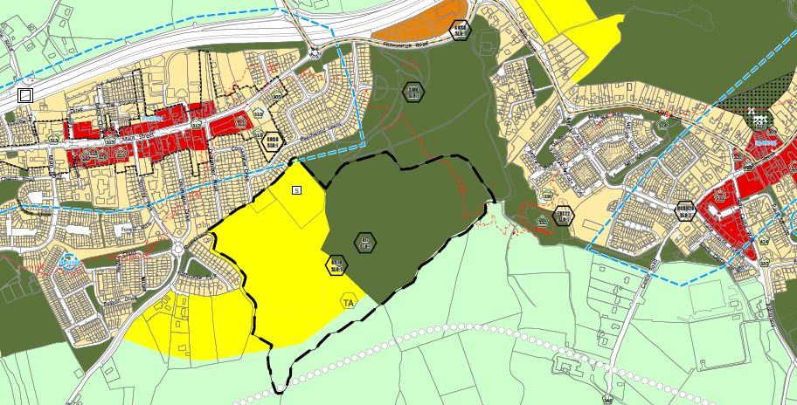

The Woodland Group naturally consider in light of the June 14th presentation that all of the area covered by CS10 SLO1 should be protected and preserved (Figure 2) because of the extent of Woodland shown, the number of protected annex habitats and their location, and the variety of biodiversity rich non-annex habitats. The group is calling on South Dublin County Council and our Councillors to preserve the entire area of CS10 SLO1 and designate it a High Amenity Area with overarching policies and objectives for protection and preservation as set out in sections below.
At the very least, the group would like to see the proposals outlined in the following sections implemented should it prove that none or only a small area can be developed “in line with the proper planning and sustainable development of the area” in the 2022-2028 County Development Plan or within its lifetime.

Figure 3 CS 10 Rathcoole SLO 1 including Rathcoole Woodlands – screenshot from South Dublin County Council Maps facility.
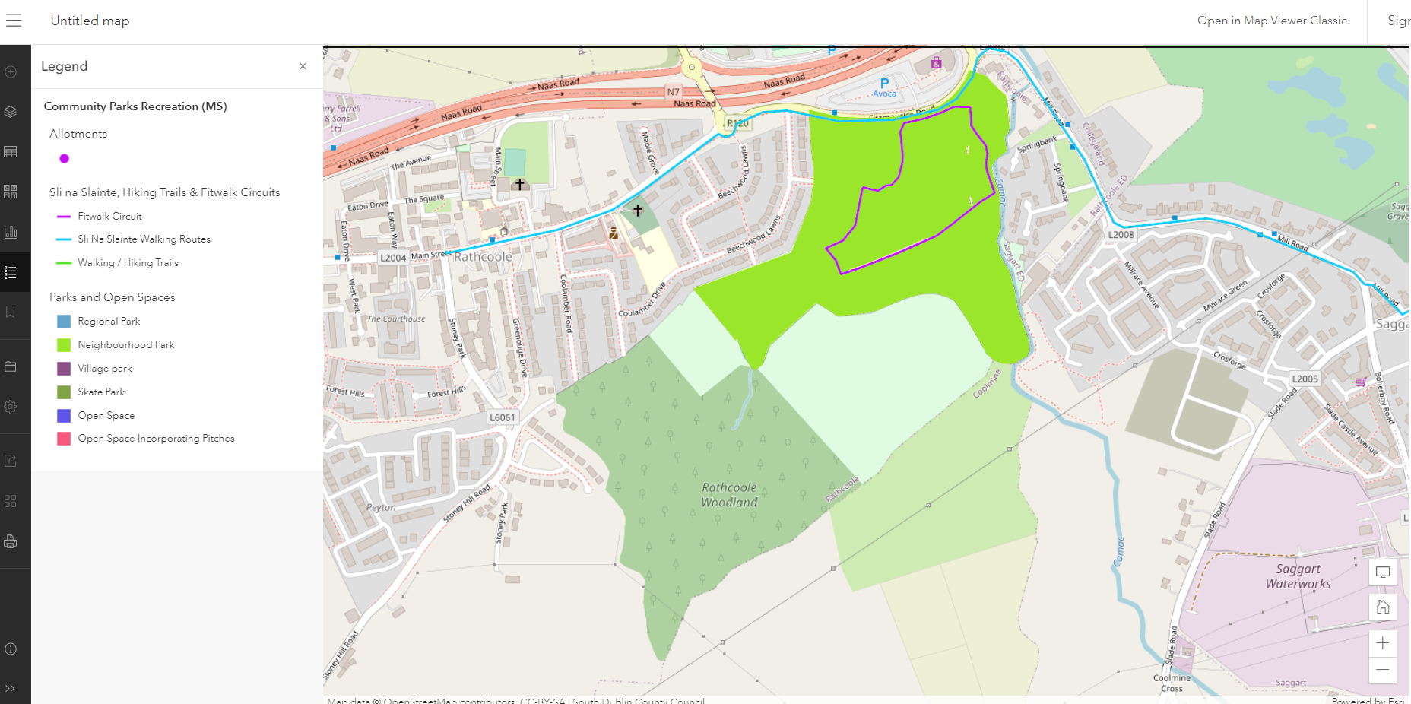

Figure 4 Satellite image of CS 10 Rathcoole SLO 1 including Rathcoole Woodlands.
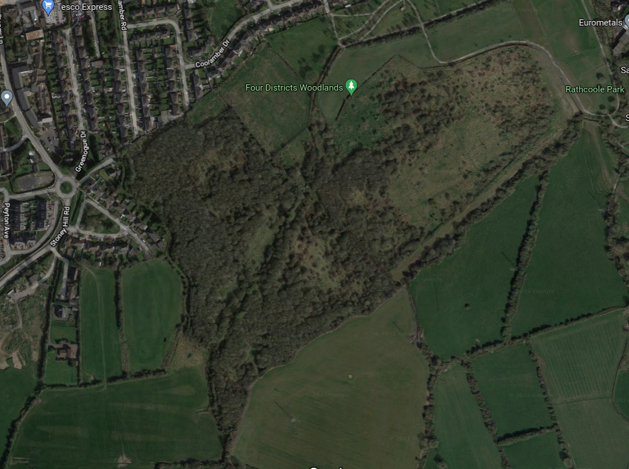

New land use zone - Zoning Objective High Amenity-Camac Valley/Rathcoole Woodlands and environs, ‘HA –CV/ RW’
There are 3 land use zones designated High Amenity areas the aim of which is to protect and enhance the outstanding natural character of those areas:
High Amenity – Dublin Mountains (Objective HA-DM);
High Amenity – Dodder Valley (Objective HA-DM); Proposed Natural Heritage Area, 000991
High Amenity – Liffey Valley (Objective HA-DM); Proposed Natural Heritage Area, 000128

The protection of rural landscapes and of high amenity and environmentally sensitive areas is a top priority of the Development Plan…..The policy of the Council, therefore, is to restrict the spread of urban generated
dwellings into rural and high amenity areas.

The Camac River Valley is similar to the Dodder River Valley extending in a north-easterly direction from the Dublin Mountains at Mount Seskin, passing through the urban environment of South Dublin County and Dublin City, before the Liffey Valley at Heuston Station. In effect, the River Camac like the Dodder connects the High Amenity area of the Dublin Mountains to Dublin Bay, creating a corridor of regional importance through the city of Dublin for key species and habitats and for the residents of Dublin City. Its particular importance lies from its source to the M7 at Rathcoole where it runs relatively free of extensive human disturbance and morphological alteration and has a rich historical significance.

The Group propose the setting of a new zoning objective; Zoning Objective High Amenity-Camac Valley/Rathcoole Woodlands and environs, ‘HA –CV/ RW’:

to protect and enhance the outstanding natural character and amenity of the Camac Valley and Rathcoole Woodlands and environs, including its landscape, visual, recreational, ecological, educational and historical heritage value, as a key element of the County’s Green Infrastructure network and implement specific objectives developed in line with preserving and protecting Rathcoole Woodlands recognising the priority annex habitats and its high biodiversity value within the lifetime of this Plan.

This requires the setting of objectives in relating to its protection and preservation in recognition of its Native Woodland status from rewilding, its biodiversity value and ecosystems services provision including:

- To protect and preserve Rathcoole Woodland for present and future generations by seeking:
    - its designation as a Nature Reserve
    - obtaining a Special Amenity Area Order
    - and if appropriate to nominate it as a candidate Special Area of Conservation
    - or as a Natural Heritage Area
The setting of a new land use zone, “High Amenity-Camac Valley/Rathcoole Woodlands” requires the provision of overarching policy and supporting policies for the preservation and protection of Rathcoole Woodlands by incorporating the following into the County Development Plan:

Natural, Cultural and Built Heritage

New Natural, Cultural and Built Heritage Policy
The Group proposes the setting of a Natural, Cultural and Built Heritage (NCBH) policy for Rathcoole Woodlands and its environs: to protect and enhance the outstanding natural character and amenity of Rathcoole Woodlands and its environs, including its landscape, visual, recreational, ecological, educational and historical heritage value, as a key element of the County’s Green Infrastructure network.

- To designate Rathcoole Woodlands and its environs as a space for Nature and Biodiversity

- To extend the public owned lands containing Rathcoole Woodlands, either by direct purchase or land swap to incorporate the Woodland in adjacent land, the historical 170 year old double hedged passage to the west, and transitional zone from Woodland to managed park land to the east.

These objectives are similar to objectives set for the Liffey Valley Special Amenity Area:

NCBH7 Objective 6:
To actively pursue the extension of publicly owned lands, either by direct purchase or land swap within and adjacent to the Liffey Valley Special Amenity Area to create a linked series of park land and open spaces.

NCBH7 Objective 7:
To work in collaboration with the owners of lands along the length of the river to seek to provide appropriate public access.

Special Amenity Area Order
An SAAO is primarily used to protect areas of outstanding natural beauty or areas with special recreational value, having regard to any benefits for nature conservation.

A Special Amenity Area Order (SAAO) was made for the Liffey Valley by Dublin County Council in 1990 and now straddles the administrative boundaries of South Dublin County Council and Fingal County Council. The extent of the area covered by the SAAO is from Lucan Bridge to Chapelizod; the area within the County is identified on the County Development Plan Land-Use Zoning maps that accompany this written
statement. provisions of the Liffey Valley Special Amenity Area Order (SAAO).

Tree Preservation Order
There are only 4 Tree Protection Orders in the County made in 1973, 1987, 1990 and 2015. The group are asking for:
- A Tree Protection Order on Rathcoole Woodlands, including the annex and non-annex habitat trees. A TPO would be a forerunner to applying for SAC designation or as a nature reserve, whichever is the more appropriate.

Green Infrastructure Strategy

Amendment to GI7 SLO 1
There are two references to Rathcoole Woodlands under Green Infrastructure (GI) in the Draft CDP 2022-2028:

GI7 Objective 3:
To work in collaboration with the owners of lands along the perimeter of Rathcoole Woodlands for its protection and that of the wildlife using it and the ecological services it provides.

GI7 Objective 4:
To develop Rathcoole Woodlands as part of a wider nature/ walking trail from Saggart to Lugg Woods subject to the protection of its biodiversity, wildlife and ecological value which is of primary importance.

CS10 Rathcoole SLO 1 is also stated for ease of reference which is welcomed. It is not really clear why it is referenced except that it refers to Rathcoole Woodlands as do GI7 Objective 3 and 4.
A simple Amendment to GI7 SLO 1 as proposed in green bold text below would strengthen the connection:
The current green wildlife corridor between Saggart and Rathcoole be maintained and the need to preserve this wildlife corridor be incorporated into the design and development plans for Rathcoole park and is considered in the outcome from CS10 Rathcoole SLO 1 and Rathcoole Woodlands.

To incorporate all of Rathcoole Woodlands and its environs as is, into the Green Infrastructure Strategy as a pivotal GI Core with Rathcoole Park along the Camac Valley GI Corridor linking to Slade Valley and Crooksling Glen pNHA, Lugg Woods and the Rural Fringe Corridor.
“GI Cores serve as anchors within the network. They are ecological resources of regional / national importance, and / or high levels of outstanding amenity and act as points of origin / destination for wildlife at which essential ecological processes occur”. (Council presentation)

http://www.sdublincoco.ie/Meetings/Agenda/2059?p=1,
https://consult.sdublincoco.ie/en/submission/sd-c147-43 https://consult.sdublincoco.ie/en/system/files/materials/4493/4996/RATHCOOLE_SDCC_DRAFT_DEVELOPMENT_PLAN.pdf
http://www.sdublincoco.ie/Meetings/Agenda/2059?p=1
https://consult.sdublincoco.ie/en/submission/sd-c147-43 https://consult.sdublincoco.ie/en/system/files/materials/4493/4996/RATHCOOLE_SDCC_DRAFT_DEVELOPMENT_PLAN.pdf
Perrin, P.M. & Daly, O.H. (2010) A provisional inventory of ancient and long‐established woodland in Ireland. Irish Wildlife Manuals, No. 46. National Parks and Wildlife Service, Department of the Environment, Heritage and Local Government, Dublin, Ireland. Daly, O.H., O’Neill, F.H. & Perrin, P.M. (2019) Resurvey of long-term ecological monitoring transects at the People’s Millennium Forests 2019. Report submitted to Woodlands of Ireland, Suite 2, Wicklow Enterprise Park, The Murrough, Co. Wicklow.
http://www.botanicalenvironmental.com/wp-content/uploads/2014/01/PRJ33-Woodlands-monitoring-survey_IWM71.pdf
https://eunis.eea.europa.eu/habitats/10150
Lyons, M.D. & Kelly, D.L. (2016) Monitoring guidelines for the assessment of petrifying springs in Ireland. Irish Wildlife Manuals, No. 94. National Parks and Wildlife Service, Department of Arts, Heritage, Regional, Rural and Gaeltacht Affairs, Ireland.
https://www.npws.ie/publications/article-17-reports/article-17-reports-2019
https://www.corkcoco.ie/sites/default/files/2017-04/biodiversity%20and%20planning%20process.pdf
https://eur-lex.europa.eu/legal-content/EN/TXT/PDF/?uri=CELEX:01992L0043-20130701&from=EN
https://www.epa.ie/pubs/reports/research/water/ERC_12_Kilroy_GWTDE_web.pdf
http://www.irishstatutebook.ie/eli/2008/si/547/made/en/print
https://eur-lex.europa.eu/legal-content/EN/TXT/?uri=CELEX%3A52021XC0407%2801%29&qid=1617956961808
https://www.epa.ie/enforcement/liab/
https://sdublincoco.maps.arcgis.com/apps/mapviewer/index.html?layers=2687cc2b62924d5b9ebc392c54edc549

