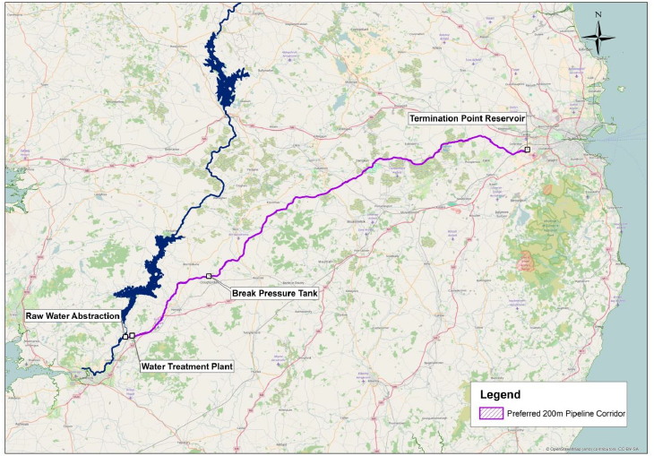
WSP - Preferred Scheme.
Illustration taken from Final Options Appraisal Report (2016), which has been subject to public consultation.

