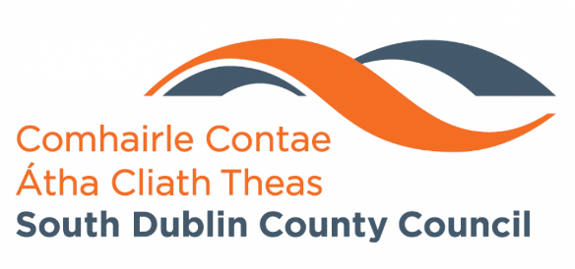

Carrigmore Park Upgrade,
Citywest, Dublin 24

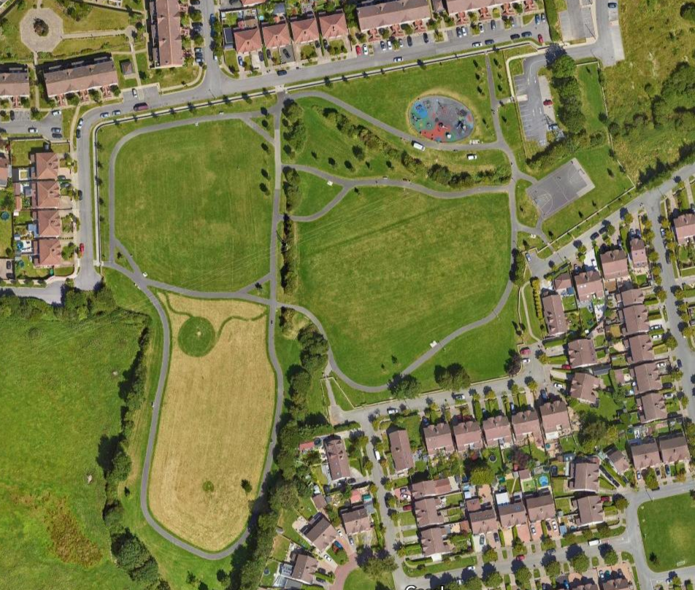
Part 8: Design Report
October 2023

Contents
Contents 2
1. PROJECT INTRODUCTION 3
1.1 Main Purpose 3
1.2 Site Location 4
2. PLANNING CONTEXT 5
1.1 National Policy 5
2.2 Regional Policy 5
2.3 Local Policy 5
3. NATURE AND EXTENT OF THE PROPOSED DEVELOPMENT 8
3.1 The existing situation 8
3.1.1 Land use Zoning 8
3.1.2 The Area 9
3.1.3 Landscape: 10
3.1.4 Access and Movement 10
3.1.5 Recreation. 11
3.1.6 Street Lighting and CCTV. 11
3.2 Masterplan Development. 11
3.2.1 Masterplan Proposals 11
3.3 Anticipated Benefits 12
3.2.2 Ecological Impact Assessment. 15
3.2.3 Appropriate Assessment (AA). 15
3.2.4 Arboricultural Report. 16
3.2.5 Traffic. 16
3.2.6 Cultural Heritage and Archaeology. 16
3.2.7 Flood Risk 16
3.2.8 Waste 17
4. Conclusion 17

PROJECT INTRODUCTION

1.1 Main Purpose

The purpose of this report, in accordance with the requirements of the Planning and Development Regulations 2001 (as amended), is to describe the nature and extent of the proposed development and principal features therein. A brief overview of proposed plans is listed as follows:
- Provision of a pump track and calisthenics area.
- Provision of an active age area.
- Upgrading of existing footpaths, to involve the removal and realignment of existing paths.
- Installation of goal posts onto existing soccer pitch.
- The provision of a new sports pitch area (65m x 40m).
- Retaining existing entrances and upgrading where required.
- Provision of a new pedestrian entrance.
- Provision for new entrances to the development lands to the west.
- Renovation of existing hedgerows.
- Planting new trees, hedgerows, and other planting.
- Removal of 12 trees (as per arborists recommendation).
- Planting of trees along the verge outside of park.
- Provision of 2 wetland attenuation areas to provide drainage for pitch and enhance biodiversity.
- Planting of a mini woodland for enhanced biodiversity.
- Planting of pleached Tilia trees along existing basketball court.
- All associated landscape works including furniture and planting.
- All ancillary works.

Carrigmore Park (approx. 4.2 hectares) is located within the townland of Fortunestown. The park borders two housing estates and its southern end feeds into a series of fields that extend to the Dublin mountains, adding ecological and amenity value.

The focus of this upgrade is to create a new space that reflects and caters to the needs of the surrounding community. The goal is to create a safe and welcoming environment for the community, free from anti-social behaviour and open for all ages to meet, exercise and enjoy nature. The proposed upgrade also aims to further amplify the natural dimensions of the park through the provision of tree planting and rewilding areas. This builds upon the park’s connection with the county’s wider green infrastructure network as outlined in the County’s Development Plan.

1.2 Site Location
The existing park is located within the townland of Fortunestown, Dublin 24 and is approximately 4.2 hectares in area.
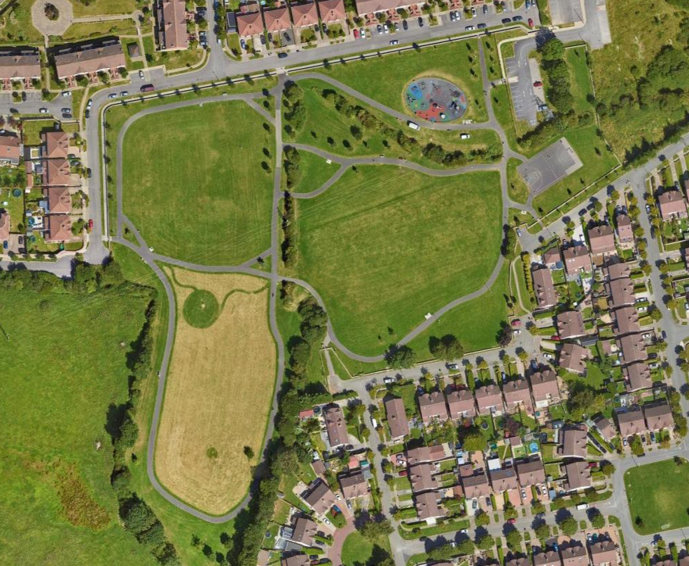
Figure 1.Aerial View of Park
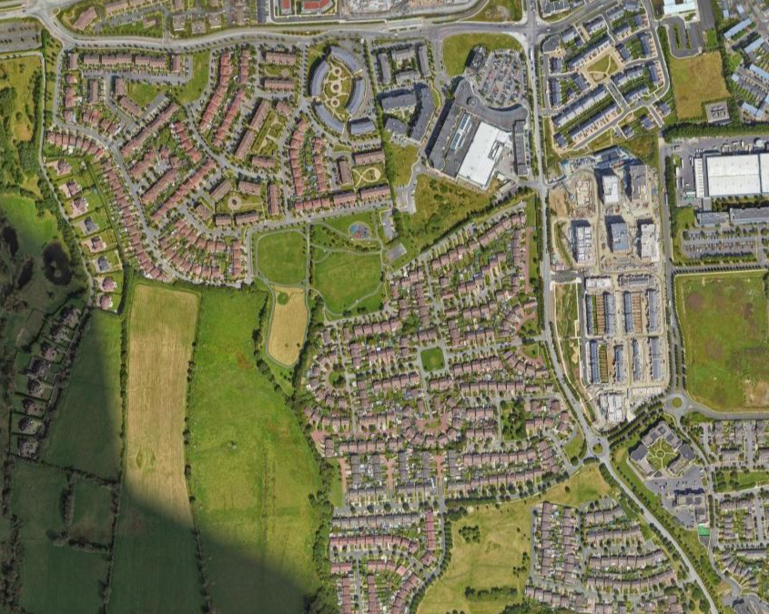
Figure 2. Wider Aerial View of Park

2. PLANNING CONTEXT

National Policy

The masterplan proposals have been developed in the context of:
- Project Ireland 2040: National Planning Framework.
- National Development Plan 2021-2030.
- All Ireland Pollinator Plan 2021-2025.

2.2 Regional Policy
The masterplan proposals have been developed in the context of:
- Regional Spatial and Economic Strategy – Eastern Midland Regional Assembly

2.3 Local Policy
    - South Dublin County Development Plan (2022-2028)

The new South Dublin County Development Plan sets out the framework to guide future development where a focus is placed on the places we live, the places we work, and how we interact and move between these places while protecting our environment. The aim is to progress to a more sustainable development pattern for South Dublin in the immediate and long-term future up to 2040 and beyond.

Chapter 8.7 ‘Parks and Public Open Space’ deals with the function, hierarchy, quality and quantity of parks and public open space in the County. As set out in the Plan, the overarching aim of the Council in the provision of parks and open space is to encourage the development of a well-connected and integrated public open space network that contributes towards achieving a broad range of policy objectives, including:

- Improving community, health, and wellbeing – Parks and open spaces provide a valuable role as a sanctuary for the community; the benefits of engaging with the natural world are now widely understood to be particularly beneficial to mental and physical health.
- Enhancing visual amenity – Parks and open spaces form an attractive green and open setting which enhances the character of urban neighbourhoods in particular.
- Promoting sustainable development – Parks and open spaces contribute to sustainable development objectives where they are appropriately located and accessible by walking, cycling and public transport.
- Promoting climate change adaption and mitigation – Parks and open spaces provide opportunities for sustainable drainage while trees and plants perform a vital role by capturing and storing carbon.
- Reinforcing Green Infrastructure – Parks and open spaces are core elements in the County’s green infrastructure network.
- Promotion of biodiversity – Parks and open spaces offer opportunities to conserve and restore biodiversity and ecosystems. They are often focused on natural environments such as river valleys which support valuable wildlife habitats; parks also offer opportunities to increase pollinator-friendly planting.
- Supporting culture and heritage – Parks and open spaces often contain heritage elements and play host to many outdoor community, arts, and cultural events.
- Supporting the local economy, including tourism – Many parks and open spaces contain facilities such as cafes, heritage features and other attractions that are valuable visitor amenities.

It is the policy of the Plan that a hierarchical network of high-quality open space is available to those who live, work, and visit the County, providing for both passive and active recreation, and that the resource offered by public open spaces, parks and playing fields is maximised through effective management.
The hierarchy of open space is a key element of the green infrastructure network, which connects and forms green corridor linkages across the County.
Objective 1 of the Green Infrastructure strategy (GI6) of the Plan is: To support a hierarchy of accessible open spaces and recreational facilities, appropriate for neighbourhood size and catchment area, which are adaptable and capable of accommodating multiple uses.
The Public Open Space Hierarchy outlined in Table 8.1 sets out the rationale for the existing and planned parks and open space network for the County, identifying the range of functions at each level in the hierarchy. Carrigmore Park falls within the hierarchical category of ‘Local Park’, which is defined in the Plan (Table 8.1: Public Open Space Hierarchy) as:
‘Local parks range in size from between 2 to 20ha. They provide mostly for amenity and passive recreation, although some may have playing pitches and play equipment; they are located in close proximity to homes and thereby easily accessible by pedestrians and cyclists. Examples of local parks in South Dublin County are Vessey and Hermitage Parks in Lucan, Ballycragh Park, Firhouse Community Centre Park and Quarryvale Park. Local Parks serve a local population within a 400m catchment.
These parks primarily consist of improved grassland but offer considerable opportunities for contributing to the local level GI network through enhancement schemes that include native trees, small woodlands, hedgerows, meadows, and other planting’.

The Plan stresses that the provision of high quality public open space that is appropriately designed, located, and maintained is a key element of placemaking. Public open space should have active and passive recreational value and should enhance the identity and amenity of an area. The key objectives of particular relevance to Carrigmore park are:
COS5 Objective 8: To ensure the design of parks and public open space areas is of high quality; to provide a pleasant setting, accommodate use by people of all ages and abilities, to support life-long activity and good health and well-being by the provision of a balanced mix of active and passive recreation and access to, or view of, nature, ensuring that the design considers:
- Provision of an appropriate mix of hard and soft surfaced areas.
- Enhancement of biodiversity and existing trees and hedgerows.
- Incorporation of water courses, other natural features, and existing built heritage into the design of parks and open spaces as appropriate.
- Provision of new planting, landscape features and appropriate site furniture including a variety of accessible, well located, and designed seating.

COS5 Objective 9: To ensure that parks and public open space are appropriately located within the County and within development sites, to facilitate and support its multifunctional role.
COS5 Objective 10: To support and facilitate the key role of parks and open spaces in relation to green infrastructure including sustainable drainage systems (SuDS), flood management, biodiversity, and carbon absorption and to promote connections between public open spaces and the wider GI network.
COS5 Objective 11: To promote the role of parks and open spaces in conserving and restoring biodiversity and ecosystems in accordance with the objectives of the National Biodiversity Action Plan (2017-2021) and the All-Ireland Pollinator Plan 20212025, the Council’s Biodiversity Action Plan 2020-2026, or any superseding plans. In the development of individual management plans for parks the requirements of the aforementioned biodiversity and pollinator plans will be taken into consideration and will form a part of the management requirements for the park. The development of individual management plans for parks will include consultation with local stakeholders.
COS5 Objective 12: To ensure that proposed SuDS measures are only accepted as an element of public open space where they are natural in form and integrate well into the open space landscape supporting a wider amenity and biodiversity value.
COS5 Objective 13: To ensure that parks and open spaces provide for a wide range of recreational and amenity activities that are easily accessible to all in the community, irrespective of age or ability.
Objective 14: To ensure that public open space and associated recreational facilities are accessible by walking, cycling and public transport, as appropriate to their position within the open space hierarchy set out in Table 8.1.
COS5 Objective 15: To support the development of passive recreation within open spaces, such as walking trails, seating provision and areas which provide for passive amenity/ hobbies, and visual interest.
COS5 Objective 16: To ensure that parks and public open spaces are carefully designed as safe spaces, by implementing the following measures:
- Providing active frontages and maximising passive surveillance from adjacent housing and/or public thoroughfares.
- Eliminating buildings which back-on or gable-front public open spaces.
- Designing corner units with active frontage
- Encouraging increased use through improved access and quality of facilities
- Careful location, design and choice of surface materials and site furniture.
COS5 Objective 17: To ensure that incidental areas of open space which do not function as useable open space and/or are not clearly visible from the public realm, are designed out of a proposed scheme.

NATURE AND EXTENT OF THE PROPOSED DEVELOPMENT

  - The existing situation.

Land use Zoning
Carrigmore Park is zoned in the South Dublin County Development Plan 2022-2028 as Objective OS, “To preserve and provide for open space and recreational amenities”.
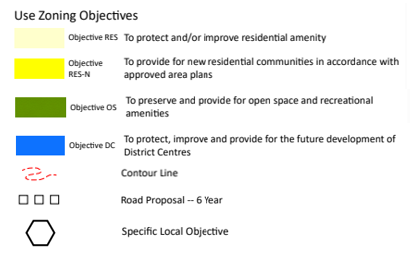
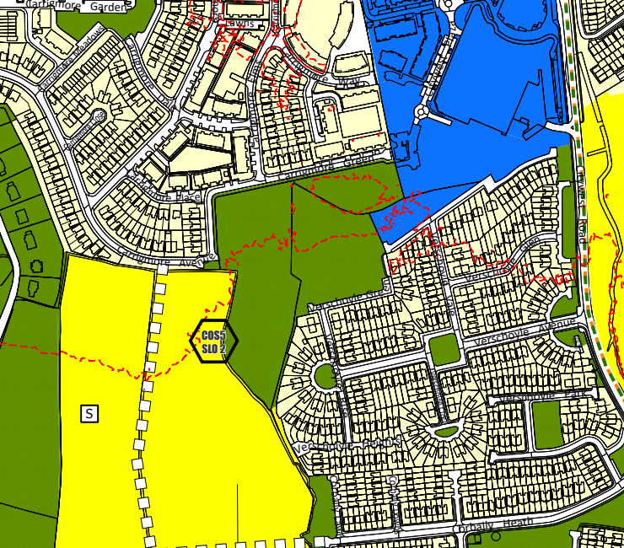
Figure 3. South Dublin Development Plan (2022-2028)

The Area
Carrigmore is a local park located within the Townland of Fortunestown and is approximately 4.2 hectares in area. The park is located just 200m from Citywest shopping centre and is also in close proximity to a Luas line leading into the city centre. The park is enclosed on 2 sides by a number of housing estates and on its Northwestern side there is currently development for residential units. The southern side of the park provides views of the Dublin Mountains. The field touching the southern of the field “Boherboy” is to provide for future residential communities however, the LRD initial process stage has begun.
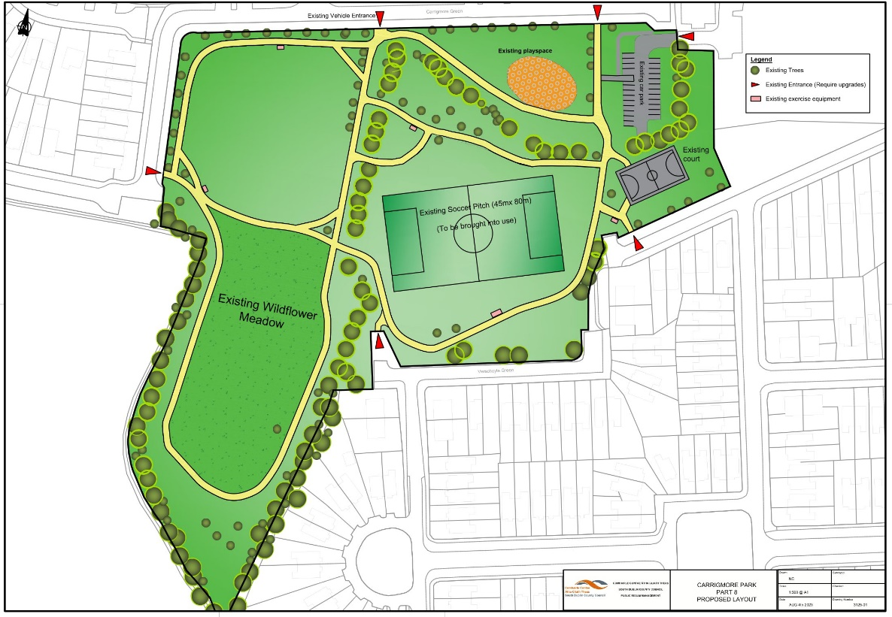
Figure 4. Existing conditions of Carrigmore Park

Landscape:

- The southern side of the park generally slopes downward to the northern side. Where the proposed soccer pitch is to be installed, there is also a slight slope used for drainage toward the north side.
- The park mainly consists of low biodiversity grass, however there is an existing wildflower meadow at the south of the park. Also, along the boundaries on the north side walls there has been bulb planting and reduced mowing.
- There are mature rows of hedgerows and trees which border the southern side of the park and also run along and across the park. These hedgerows are generally in good condition, however there are gaps in some areas.
- The park is not immediately connected to other parks, however its forms part of a wider corridor with its connection to number of fields and hedgerows on its southern side and this in turn contributes to the county’s wider green infrastructure network.

Access and Movement

- The park is mostly enclosed by approx. 50cm high stone walls. Pedestrian access is made through 5 k-frame barriers and one kissing gate. The park also has a car park and a vehicle access gate.
- Within the park a series of tarmac paths stretch around the perimeter and sperate the park into different areas. Generally, the paths provide good access around the park, however, in some places they can fragment the green spaces.
- From a wider context the park is quite accessible. The park is only a 5-minute walk from the nearest Luas top and the N82 runs nearby.

Recreation.

- The park consists of a basketball court approximately 520m² in size.
- A soccer pitch has been provided but is not currently in use.
- An enclosed playground 550m² in size.
- 5 outdoor exercise machines.
- There are currently roughly a 1km of footpaths that are well used by walkers/joggers.

3.2 Masterplan Development.

3.2.1 Masterplan Proposals

The proposed plans for the upgrade of the park are in response to site appraisals keep the communities’ best interests in mind. They are described below:
- Provision of a pump track and calisthenics area.
- Provision of a boules court/active age area.
- Upgrading of existing footpaths, to involve the removal and realignment of existing paths.
- Installation of goal posts onto existing soccer pitch.
- The provision of a new sports pitch area (65m x 40m).
- Retaining existing entrances and upgrading where required.
- Provision of a new pedestrian entrance.
- Provision for new entrances to the development lands to the west.
- Renovation of existing hedgerows.
- Planting new trees, hedgerows, and other planting.
- Removal of 12 trees.
- Planting of trees along the verge outside of park.
- Provision of 2 wetland attenuation areas to provide drainage for pitch and enhance biodiversity.
- Planting of a mini woodland for enhanced biodiversity.
- Planting of pleached Tilia trees along existing basketball court.
- All associated landscape works including furniture and planting.
- All ancillary works.

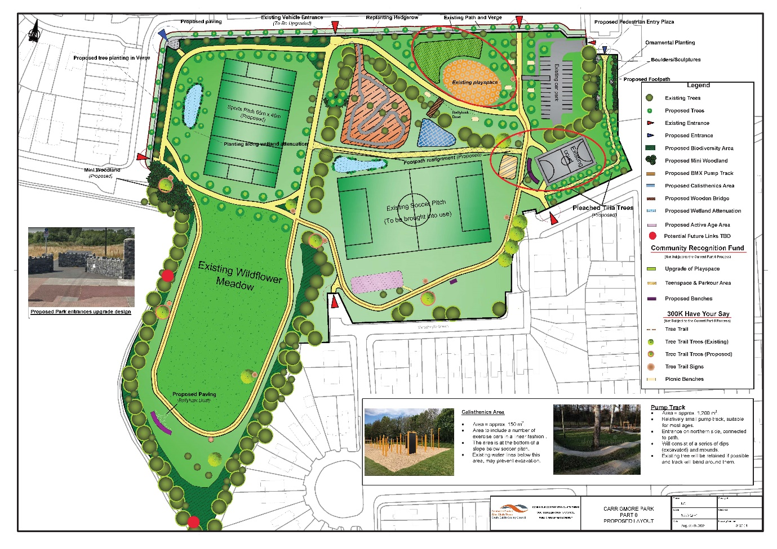
Figure 5. Proposed redevelopment plans

In consideration of the overall up-grade potential of Carrigmore Park, and the aspirations of the local community for developing a meaningful open space for all age groups and abilities, further consideration may need to be given to prioritising the masterplan proposals and to possible implementation in phases according to available resources and funding opportunities. The delivery of the up-grade proposals will continue to be reviewed by the Council through ongoing engagement with all interested parties.

3.3 Anticipated Benefits

South Dublin County Council is proposing an upgrade of Carrigmore Park to better meet the needs of the expanding local population. The existing playground is being retained and will be expand to meet increase in demand through the Community Recognition Fund. The only recreational area for teenagers is the existing basketball court and there are no other areas where teens can socialize, a teenspace will also be provided through the Community Recognition Fund. The Part 8 proposals include new recreational and active areas for multigeneration use. The biodiversity value of the park will also be improved, with hedgerow maintenance, woodland planting, proposed wetlands, and retention of the existing meadow area.
The up-grade proposals for Carrigmore Park will provide a renewed focus for the communities that surround it as well as contributing the county’s wider green infrastructure network.
The benefit of the proposed plan are as follows:
- Improved access and Sense of Security.
- The introduction of new recreational facilities will encourage use of the park by a wide range of age groups and abilities.
- The proposed pedestrian entrances would increase the permeability of the park and the entrance plaza would create a stronger and more welcoming presence of the park.
- The provision and realignments of footpaths within the park will improve access throughout the park.
- The overall up-grade of the park should become a source of pride for the local community and a place they feel ownership of.

- Enhanced range of Recreational Facilities.
- Bringing the soccer pitch into use and providing a new sports pitch will encourage local sports clubs to play in the park and would also invite community games and open field activities.
- The provision of the natural play area with the Community Recognition Fund will encourage creative and active play for the children that use them and enhance their connection with nature.
- The provision of the calisthenics area would provide an area for exercise for the community.
- Following from the success of the pump track in Dodder Valley Park in Firhouse, the provision of a pump track in Carrigmore would provide a unique recreational facility for the area, promoting physical activity.
- The provision of a parkour area using the Community Recognition Fund, provides an avenue for physical activity and social interactions among teens.
- The provision of an active age area provides a recreational spot for visitors of all ages.
• Enhanced Landscape and Biodiversity
- The proposal includes the planting of a number of tree species throughout the park and also along the verge on the park boundary. This will improve the overall landscape aesthetic of the park while also increasing its biodiversity value.
- The existing hedgerows provide some biodiversity value to the park, these will be enhanced.
- Rows of pleached trees with clear stems will be planted surrounding the existing basketball court which allows views beneath the canopies. This will create a clear path indicating the entrance and exit.
- Retaining and enhancing wildflower meadows throughout the park will also maintain the parks biodiversity value in line with the Councils Biodiversity Action Plan (2020-2026) and the All-Ireland Pollinator Plan (2021-2025)
- The creation of a mini woodland within the park will increase the aesthetic value of the park whilst providing additional habitats.
- The provision of 2 wetland attenuation areas will not only provide valuable drainage areas but will also create new habitats and improve the overall aesthetic of the park.

- Minimal Environmental Impact
- The proposals have been screened for EIA and AA.
- The characteristics of the proposed development are not considered likely to result in a significant impact on the environment by virtue of its size, nature, or operational activities.
- Once operational, the proposed development is expected to be low in environmental impact, with largely positive impacts.
- The development will provide an important recreational resource for the local community and will bring positive impacts on amenity value and biodiversity, in line with the Parks and Public Open Space policies and objectives of the County Development Plan.

  - Overview of Environmental Impacts.
The proposal has undergone Appropriate Assessment Screening under the Habitats Directive (92/43/EEC) and screening for Environmental Impact Assessment. The Planning Authority has made a preliminary examination of the nature, size, and location of the proposed development, and concluded that there is no real likelihood of significant effects on the environment arising from the proposed development, and a determination has been made that an Environmental Impact Assessment (EIA) is not required.
    - Environmental Impact Assessment Report Screening (EIARS)
The EIA Screening Report states “It was determined that the proposed development does not fall under Schedule 5 (Parts 1 and 2) of the Act. As such, an EIAR has not been automatically triggered. To determine whether the development may fall under the category of Sub-threshold development, with the potential to give rise to significant environmental effects, a screening exercise was undertaken”.
During construction, typical impacts such as noise, dust, traffic disruption, and the generation of small amounts of waste are to be expected. These are typical construction phase impacts and will be mitigated against by environmental operating plans devised by the on-site contractor, following best practice guidance.
The Screening has been carried out in accordance with the EIA Directive and to the relevant Annexes of that Directive, which sets out requirements for mandatory and sub-threshold EIA. In the case of the subject development, it can be seen on preliminary examination that the characteristics of the proposed development are not considered likely to result in a significant impact on the environment by virtue of its size, nature, or operational activities. It has been concluded that the proposed development does not fall under the category of sub-threshold development, and thus an EIAR is not required.

Ecological Impact Assessment.
While the proposed development project could potentially impact a number of different habitats with high local importance, the specific proposals ensure that these impacts will not arise. The habitats with high local importance include; dry meadows and grassy verges; hedgerow, treelines, eroding/upland rivers and drainage ditches, and faunal groups such as; ground-dwelling mammals; bats; breeding birds and amphibians.
Based upon the information supplied, regarding the site layout, drainage and landscape plans, and provided that the development is constructed in accordance with the mitigation measures outlined in the proposals, there will be no significant impacts alone or in-combination with other projects and plans, as result of the development and associated works on the ecology and local species of the area and on any designated conservation sites.
Given the scale of this development and its suitable landscape plan, the local ecology, including mammals, bats, birds, and invertebrate species, will benefit from the maintained ecological function of the site (enhancement of tree and shrub habitats, implementation of wetland habitats and installation of bat boxes) associated with the operational phase of this project.

Appropriate Assessment (AA).
The stage one screening for AA of the proposed works at Carrigmore Park, Fortunestown, Dublin 24 demonstrates that the proposed development is not likely to have significant effects on any European site. The AA screening process has considered potential effects which may arise during the construction and operational phases as a result of the implementation of the project. Through an assessment of the pathways for effects and an evaluation of the project characteristics, taking account of the processes involved and the distance of separation from European sites, it has been evaluated that there are no likely significant adverse effects on the qualifying interests, special conservation interests or the conservation objectives of any designated European site.
Given the nature of the proposed development works to Carrigmore Park, the scale of the proposed works, the site context, and the localised and temporary nature of the potential effects, the proposed project will not lead to any significant adverse effects in- combination with effects arising from any other plans or projects.
The AA Screening Report completed by JBA for the proposed development determined that no likely significant impacts are expected as a result of the proposed development. This is due to the small size of the development and the distance and lack of pathways to Natura 2000 sites.

Arboricultural Report.
Carrigmore Park is a well-used, high occupancy public open space, popular with dog walkers and young families enjoying informal recreation within a busy residential area. It consists of an open landscape of amenity grassland with mature hedgerows and pockets of scrub. Mature tree cover is limited to a number of larger ash specimens within the hedgerows adjacent to residential properties and agricultural lands to the south west and the park car park. There has been a significant amount of planting of young trees in recent years along the northern boundary, predominately of oak and cherry. No high-risk trees were identified during the survey, the majority of the works focused around managing the ash population and recommending pro-active works for younger semi-mature trees.
Tree Removals - Some young trees have been vandalised or are in such poor health or form that removing and replanting would be the most pragmatic option. Ash Dieback (Hymenoscyphus fraxineus) is present and those specimens displaying intermediate to advanced symptoms should be removed. It is recommended to remove 12 trees in total throughout Carrigmore Park.

Traffic.
Carrigmore Park is accessible by car via local estate roads. There is an existing carpark within the park. The park is very accessible by foot, by cycling or by public transport.
During the construction phase of this plan, the level of traffic may increase slightly in the area. All construction access to the site will be on pre-existing roads.

Cultural Heritage and Archaeology.
There are no Protected Structures or Recorded Monuments located within or adjoining the open space.

Flood Risk
Extract from SDCC County Development Plan 2022-2028
“12.11.1 Water Management
(i) Flood Risk Assessment Flood risk management will be carried out in accordance with the Flood Risk Management Guidelines for Planning Authorities, DOECLG (2009) and Circular PL2 / 2014.
The Dodder CFRAMS, Eastern CFRAMS (Catchment and Flood Risk Assessment and Management) and the South Dublin Strategic Flood Risk Assessment (2021) provide information in relation to known flood risk in South Dublin County (see Development Plan Map 14, Strategic Flood Risk).”
“Development proposals on lands that may be at risk of flooding should be subject to a flood risk assessment, prepared by an appropriately qualified Chartered Engineer, in accordance with the Flood Risk Management Guidelines.”
The map below shows the lands that are deemed to be at risk of flooding in this area; the map shows Carrigmore Park outside of designated Flood Zones. Therefore a flood risk assessment is not required at this stage:
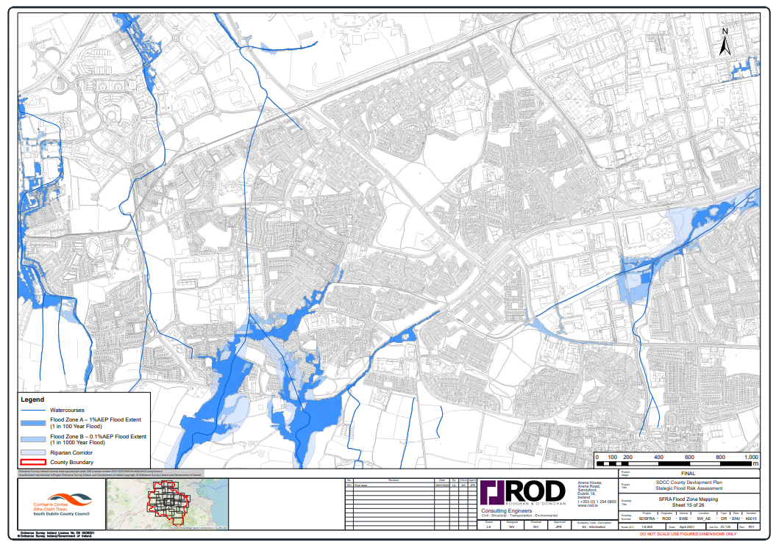
Figure 6. Strategic Flood Risk Assessment from SDCC County Development Plan: (SFRA Flood Zone mapping Sheet 15 of 26).

Waste
During construction, the proposed development will generate a small amount of typical construction waste. This will be disposed of following best practice guidance implemented by operating plans to be devised by the appointed contractor.

Conclusion

In conclusion, this Part 8 proposal aims at providing an enhanced public open space experience at Carrigmore Park. This will be achieved through a number of integrated measures including a pump track, a calisthenics unit, an active age area, reinstating the existing soccer pitch, the provision of a new soccer pitch, enhancement of the existing park entrances, as well as the installation of a new main park entrance, enhancing and adding to the existing park planting with trees and hedgerows, planting of a mini woodland, and the two wetland attenuation areas. These additions along with the Community Recognition Fund upgrades to the existing playspace and the creation of a teenspace area around the existing basketball court, and the 300k have your say upgrades with the picnic benches, tree trail and additional seating, will offer an enhanced visitor experience and create an all-season destination for events and recreation.
The design of the proposal has been informed by an understanding of the site context and the requirement to comply with planning and environmental legislation and policy. The scheme remains fully supportive of all relevant Policy Objectives of the South Dublin County Development Plan 2022-2028. The proposal is in full compliance with all Statutory Zoning and Policy provisions.
Inputs from appointed consultants accompany this Planning Report which will further inform, explain, and detail the intention of South Dublin County Council in this Part 8 Application.

