COUNTY ARCHITECTS REPORT  South Dublin County Council- Proposed Development of a Traveller Accommodation Group Housing Scheme consisting of 7 units on undeveloped lands/site at Fonthill Road, Co. Dublin.  The proposed development shall consist of:  - 5 No. 4 Bedroom 2 storey houses (detached)  - 1 No. 4 Bedroom 2 storey house (semi- detached)  - 1 No. 3 Bedroom 2 storey house (semi- detached)  The works include Landscaping works to boundaries and all necessary associated ancillary works on the site and to adjacent areas including all carpark spaces within the curtilage.  PLANNING & DEVELOPMENT ACT 2000 (AS AMENDED) PUBLIC CONSULTATION PROCEDURE UNDER PART 8 OF THE LOCAL GOVERNMENT (PLANNING & DEVELOPMENT) REGULATIONS 2001 (AS AMENDED).  Consultation Process stage.  This is an advisory report. The full report will be issued following the conclusion of the Consultation Process.  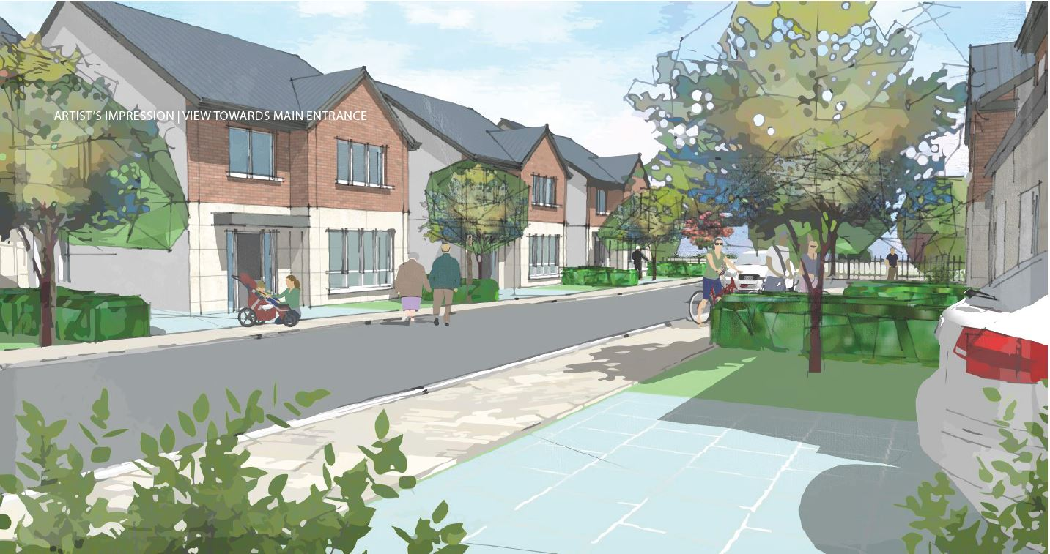  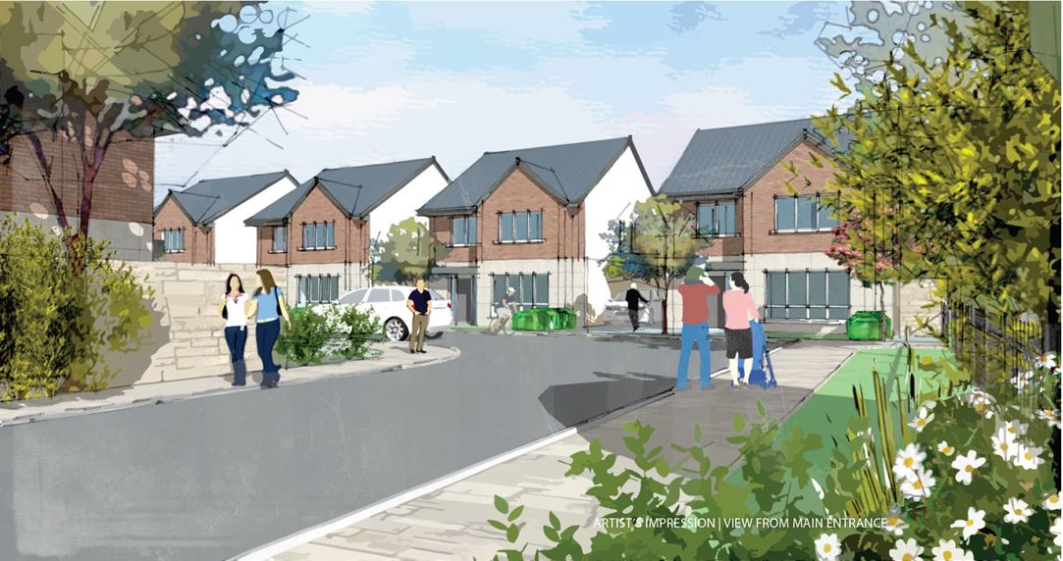 |  |  | 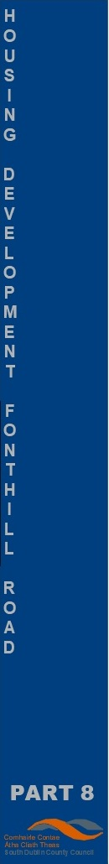
 |  | COUNTY ARCHITECTS REPORT – Part 8 – display / consultation
 | Project Title: | Development of Traveller Accomodation Group-housing scheme of 7 houses on undeveloped lands/site at Fonthill Road , Co. Dublin.
 | County Architect:  :  Architects: | Eddie Conroy FRIAI, Architectural Services Department, South Dublin County Council  McCrossan ORourke Architects.
 | Public Notice: | South Dublin County Council  Proposed Development  Proposed Development of a Traveller Accommodation Group Housing Scheme consisting of 7 units on undeveloped lands/site at Fonthill Road, Co. Dublin.  PLANNING & DEVELOPMENT ACT 2000 (AS AMENDED) PUBLIC CONSULTATION PROCEDURE UNDER PART 8 OF THE LOCAL GOVERNMENT (PLANNING & DEVELOPMENT) REGULATIONS 2001 (AS AMENDED).  Pursuant to the requirements of the above, notice is hereby given that South Dublin County Council proposes to modify a previously approved Traveller Accommodation Development with 7 no. group houses and all necessary associated works on a site area of approx. 0.36 Hectare at Fonthill Road, Co. Dublin.  The proposed development shall consist of:  - 5 No. 4 Bedroom 2 storey houses (detached)  - 1 No. 4 Bedroom 2 storey house (semi- detached)  - 1 No. 3 Bedroom 2 storey house (semi- detached)  The works include Landscaping works to boundaries and all necessary associated ancillary works on the site and to adjacent areas including all carpark spaces within the curtilage.  The proposed Scheme has undergone Appropriate Assessment Screening under the Habitats Directive (92/43/EEC) and a preliminary examination for Environmental Impact Assessment. The Planning Authority has concluded that there will be no real likelihood of significant effects on the environment arising from the proposed development and therefore an Environmental Impact Assessment is not required.  Any person may, within 4 weeks from the date of this notice, apply to An Bord Pleanála for a screening determination as to whether the proposed development would be likely to have significant effects on the environment.  Plans and particulars of the proposed scheme will be available for inspection or purchase at a fee not exceeding the reasonable cost of making a copy for a period of four weeks from Thursday 14thApril 2022 at the offices of South Dublin County Council, County Hall, Tallaght, Dublin 24 and Clondalkin Civic Offices, Dublin 22, and available online on the Consultation Portal.  Submissions:  Submissions or observations in relation to the proposed development, dealing with the proper planning and sustainable development of the area in which the development would be situated, may be made as follows:  Online at https://consult.sdublincoco.ie up to 11.59 p.m. on Tuesday 31st May 2022.  Or  Written submissions not later than 4.00pm, on Tuesday 31st May 2022.  Please address your submission to:  Senior Executive Officer,  Traveller Accommodation Unit,  Housing Department,  South Dublin County Council,  County Hall,  Tallaght,  Dublin 24.  NOTE: Please make your submission by one medium only.  Only submissions received by/on Tuesday 31st May 2022 and addressed as set out above, will be considered.  Submissions cannot be accepted in any other format or to any other postal address. Submissions and observations should state the name, address, and, where relevant, details of any organisation, community group or company etc. which you represent.  It should be noted that the Freedom of Information Act applies to all records held by South Dublin County Council. South Dublin County Council’s Personal Data Privacy Statements can be viewed at www.sdcc.ie and all personal data will be retained in line with statutory requirements
 | Brief explanation of Part 8 Process carried out under Part 8 of the Planning and Development Regulations 2001 (as amended) | Part 8 (Public Consultation Schemes)  Developments by a local authority are subject to a public consultation process as set out in the Planning & Development Regulations, 2001 (as amended). This procedure requires that notice of the proposed development be given in the public press and that a site notice be erected. If any submissions or observations are received, a report is presented to the members of the Council. This report contains a list of the objector's names along with a summary of the points made by them and the Local Authority's response.  Arising from consideration of the representations, the report sets out whether or not it is proposed to proceed as originally planned or to proceed with a modified proposal.  Development by a Local Authority: 'Part 8'  From time to time the Local Authority may carry out development within its administrative area, such as the construction of houses, roads, swimming pools, public toilets etc.  Development carried out by a Local Authority is often referred to as a 'Part 8':- this is reference to Part 8 of the Planning and Development Regulations 2001 (as amended) which sets out the procedure for carrying out such developments.  Public consultation is an intrinsic part of the 'Part 8' process. This is achieved by public notices, public display of the proposal, observations by members of the public, reportage on observations received and a recommendation that considers all internal and public observations. The consultation may extend to advisory consultation meetings with local community and interest groups dependant on the particular circumstances and impact of the proposal, though such meetings are not proscribed under the legislation. The primary purpose of the process is to notify the public of the proposal and incorporate any observations validly submitted into a report to inform the Council on its decision to recommend the proposal.  Comments and observations on Proposed Developments by a Local Authority can only be received in writing between certain dates. The public notices should be referred to in this regard to ascertain the final date of receipt for observations.  Part 8 of the Planning and Development Regulations 2001 (as amended) refers to requirements in respect of specified development by, on behalf of, or in partnership with Local Authorities. Part 8 applications are generally lodged by the proposing department within the Council. Article 80 of the Planning and Development Regulations 2001 (as amended) sets out a list of the types of development prescribed for the purposes of the act.  The process is as follows:  Public Notices of the proposed development must be placed in an approved newspaper. A site notice (or notices) must be erected on the land on which the proposed development is situated – Article 81(1)(a)(b) of the Planning and Development Regulations 2001 (as amended) provides guidance on the requirements.  The application, which must be submitted on the same date as the newspaper notice, must include a cover letter / report, a copy of the newspaper notice and site notice and public display of the proposal in a designated public area accessible to the public during normal office hours – normally County Hall. Drawings can be made available to the public on request.  There is no fee payable on a Part 8 application.  The application is referred to internal works Departments in the Council – (Roads, Water, and Drainage).  In the case of protected structures the application is referred to the Conservation Section, An Taisce, DHPLG and the Heritage Council.  The timeframe for third party Observations/Submissions on the Part 8 application is eight weeks from the date of lodgement. This date is specified in the public notices. There is no fee charged for observations/submissions on a Part 8.  The proposing Department completes a report for the attention of the Executive Manager of the Planning Department. The Executive Manager will make a recommendation to the proposing department on foot of this report.  A report will then be compiled for a meeting of the Council. Following consideration of this report by the Council, the proposed development may be recommended, unless the local authority, by resolution, decides to vary or modify the development, otherwise than as recommended in the report, or decides not to proceed with the development’ – as per Section 179(4)(b) of the Planning and Development Act 2000 (as amended).  For a part 8 application the period for observations/submissions is 6 weeks.  There are 5 weeks allowed for a normal planning application.  The making of a decision on a Part 8 application is a reserved function of Council, while for a normal planning application this is an executive function.  The above is a summary of the Part 8 requirement for consultation. It is intended for guidance only. The Planning Acts set out the requirements in full.
 | Context: | The site is accessed off the Slip-road to N4/Fonthill Road, Co. Dublin  The site adjoins an informal Traveller accommodation cluster which will be replaced by this group-housing scheme for families resident on the site.  The site is served by local public transport, schools, and local facilities.  The site is undeveloped, and relatively free of onsite services constricting development on the site.  The established western boundary consists of a high blockwork wall.  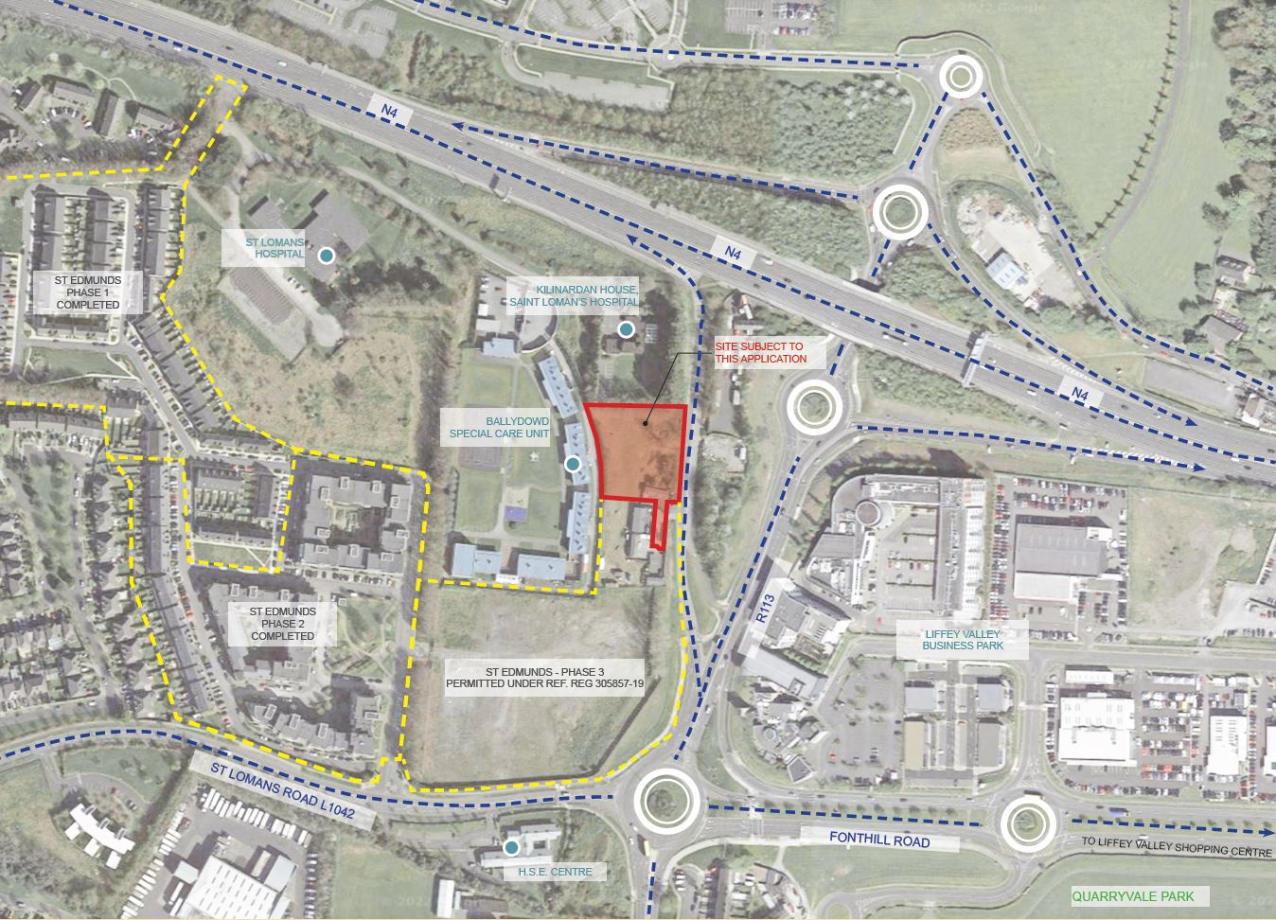  Aerial View of Site  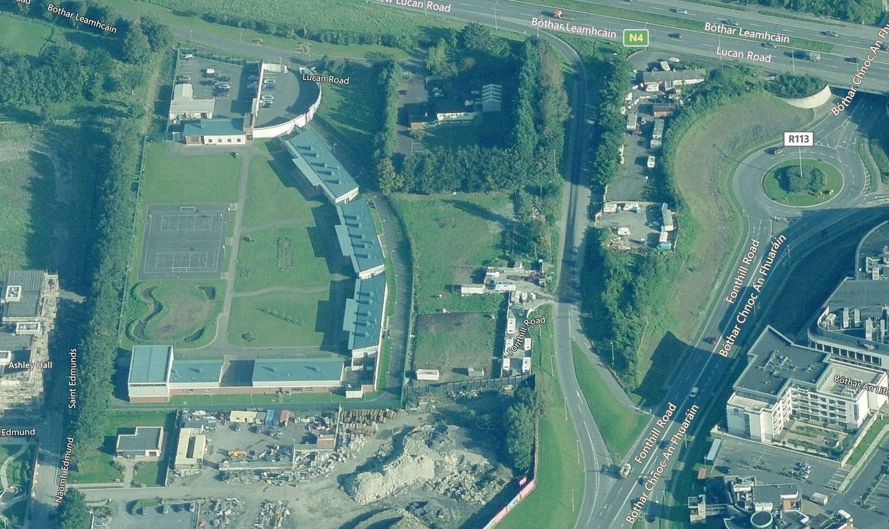  Aerial view 1  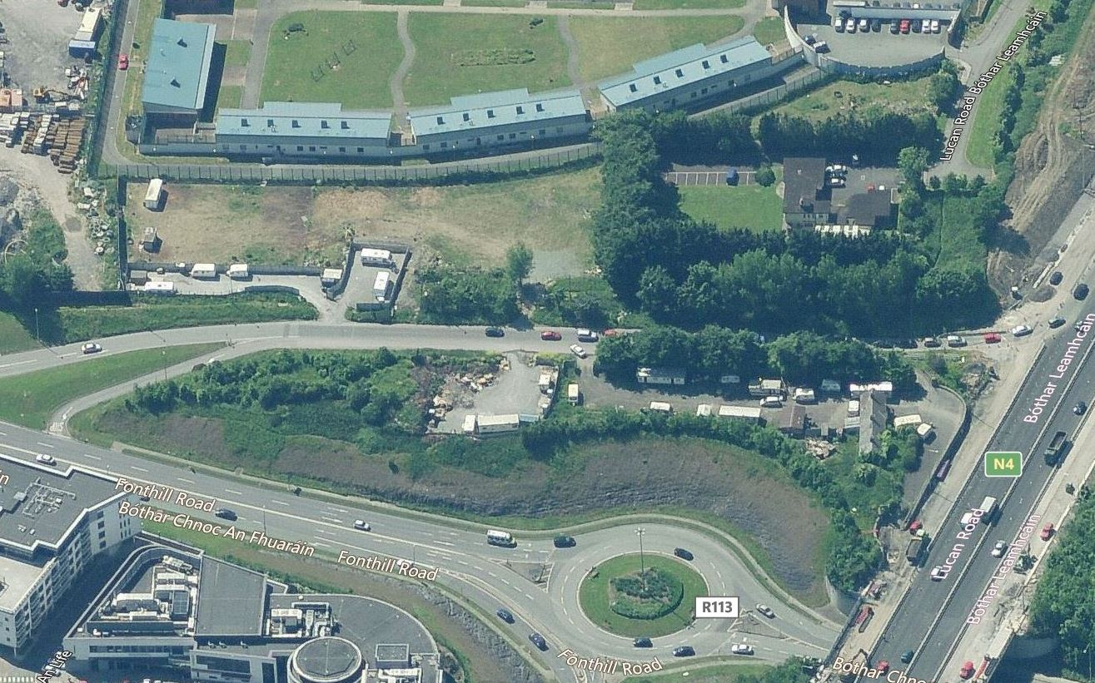  Aerial view 2  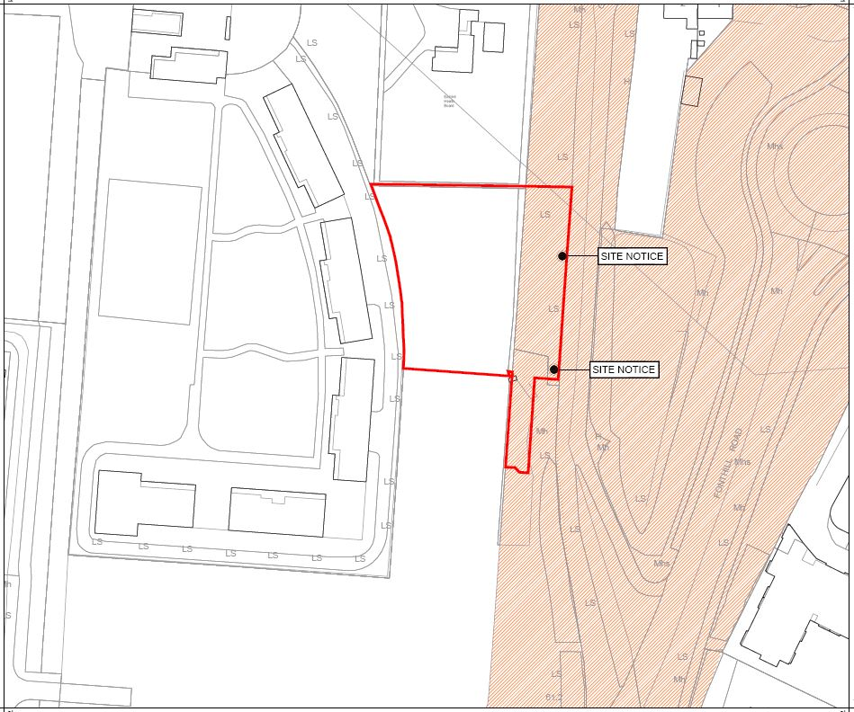  Site Location:  Site Location and Extent – local facilities including Liffey Valley Shopping Centre are within 10 minutes walk.  The proposal for housing is part of mixed-use neighbourhood with extensive retail and commercial facilities. Primary and secondary schools are within easy travel distance with existing community and sport-facilities in the adjoining Quarryvale and Greenfort estates. Facilities are growing in the area and require supplementing as part of the overall area development.  Housing Need in the area:  There is an established housing need for Traveller families in this area. Sites for development are not readily available, and the council owns very little significant land holdings in the area. This land holding will be utilized effectively by the layout proposed and as designed will create a good-quality residential environment for the existing families affected.
 | Planning / Zoning for the site | Planning / Zoning  The lands are zoned – South Dublin County Council Development Plan  Zoning Objective ‘RES’: ‘To Protect and/or Improve residential amenity’  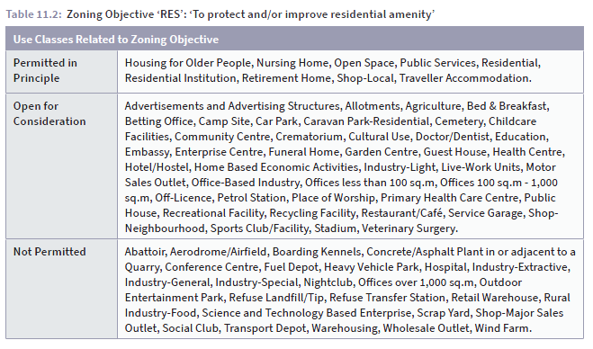  The zoning of the site supports a housing development and the criteria as applicable from the Development Plan supports the design proposed. The proposed development complies with the relevant Development plan polices.  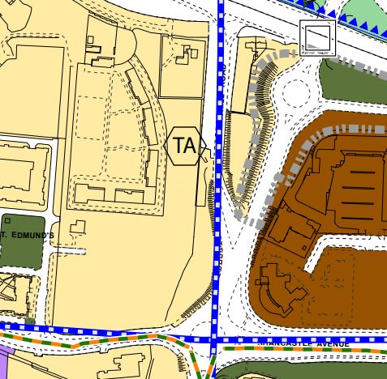  Zoning map for Area  The development plan policies that affect the site directly - proposed residential use Zoning Objective ‘RES’ - are the following :  There is a Specific Local Objective in the current ( 2016-2022) Development Plan and the new Draft Development Plan to develop this site for Traveller Accomodation.  HOUSING (H) Policy 17 Residential Consolidation  It is the policy of the Council to support residential consolidation and sustainable intensification at appropriate locations, to support ongoing viability of social and physical infrastructure and services and meet the future housing needs of the County.  11 IMPLEMENTATION  11.3.2 RESIDENTIAL CONSOLIDATION  Infill residential development can take many forms, including development on infill sites, corner or side garden sites, back land sites and institutional lands.  (i) Infill Sites  Development on infill sites should meet the following criteria:  - Be guided by the Sustainable Residential Development in Urban Areas – Guidelines for Planning Authorities DEHLG, 2009 and the companion Urban Design Manual.  - A site analysis that addresses the scale, siting and layout of new development taking account of the local context should accompany all proposals for infill development. On smaller sites of approximately 0.5 hectares or less a degree of architectural integration with the surrounding built form will be required, through density, features such as roof forms, fenestration patterns and materials and finishes. Larger sites will have more flexibility to define an independent character.  - Significant site features, such as boundary treatments, pillars, gateways and vegetation should be retained, in so far as possible, but not to the detriment of providing an active interface with the street.  - Where the proposed height is greater than that of the surrounding area a transition should be provided (see Section 11.2.7 Building Height).  IMPLEMENTATION  - Subject to appropriate safeguards to protect residential amenity, reduced open space and car parking standards may be considered for infill development, dwelling sub-division, or where the development is intended for a specific group such as older people or students. Public open space provision will be examined in the context of the quality and quantum of private open space and the proximity of a public park. Courtyard type development for independent living in relation to housing for older people is promoted at appropriate locations. Car parking will be examined in the context of public transport provision and the proximity of services and facilities, such as shops.  - Proposals to demolish a dwelling(s) to facilitate infill development will be considered subject to the preservation of the character of the area and taking  DENSITY  The zoning for the area allows medium density, dependant on a number of factors stipulated by the development plan.  Site Area – Total site area : 0.36 Hectares [3,600m² ]  There are 7 Units in the development which gives a density of just under 20/ hectare.. The scheme is an infill project consolidating a marginal location.  The proposals as submitted for Part 8 Public Consultation are in compliance with the Development Plan Objectives.
 | Project Description  & Design | Development of Social Housing Project consisting of 7 housing units on site located off the Sip-Road to N4/Fonthill Road, Co. Dublin  - 5 No. detached houses, 4- Bed, 6- Person, 2 Storey  - 1 No.semi-detached house, 3 Bed, 5- Person, 2 Storey  - 1 No.semi-detached house , 4- Bed, 6- Person, 2 Storey  The works include: New vehicular access road and pedestrian access steps off the Slip-road to N4/Fonthill Road, ,all boundary walls and landscaping works to boundaries, ancillary works to landscape housing areas, and all necessary associated drainage and utilities works on the site and adjacent areas. Car-parking ( 14 no. spaces) is provided in curtilage. All units to be minimum A3 BER rated.  The proposed housing is orientated to face each other on a a small cul-de-sac with a landscaped strip to reduce the impact of the Slip-road and increase amenity. 5 of the houses are detached with two houses semi-detached to reflect family arrangements.  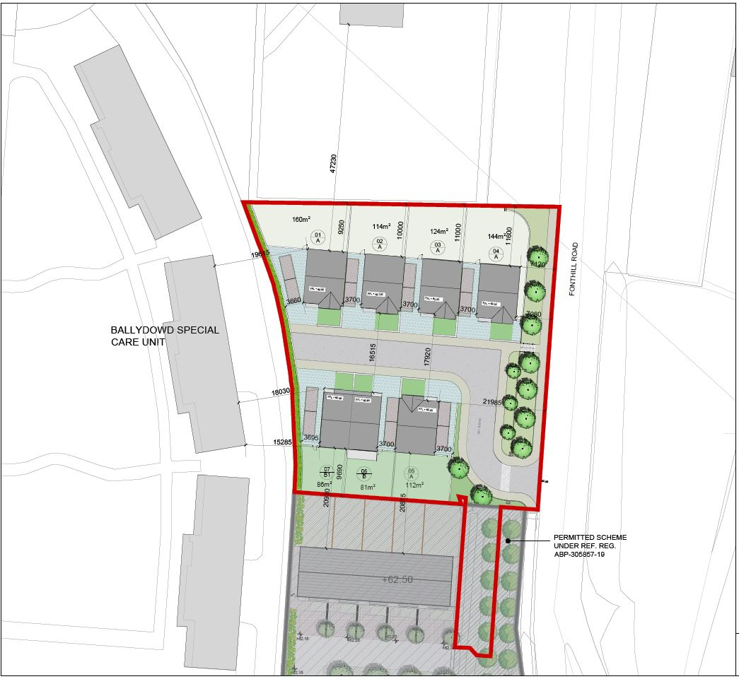  Plan of Proposal  Following the end of the consultation process, and following the final presentation to the Council Chamber, the layout will be reviewed in the light of observations submitted during the public consultation.  The Overall Project Budget is subject to DOHPLG approval.
 | Landscape | Retention of existing healthy mature trees where possible and replaced with supplementary trees where taken down. New planting to be provided to reduce impact on proposed houses of traffic on Slip-road increase amenity on new streetscape and gardens where possible.
 | Ancillary Works to Project: | Re-routing of existing services  Alteration / Upgrading of existing landscaping and open space.
 | Project Partners | Architects & Housing Departments  Department of Housing, Planning and Local Government  Environment Department
 | Site / Services Contraints: | All major existing services runs have been identified for the design. Local alterations to layout are likely when on site investigations establish precise underground service locations.
 | Internal Comments | Water Supply – water supply is adequate  Dainage Report and drawings are included in the submission.  - Foul drainage – requires to be fully scoped to ensure capacity of existing network  - Surface water - requires to be fully scoped to ensure capacity of existing network. Attenuation provision and method to be agreed.  - Ensure floor levels are above 100 year projected floor events.  - A survey, prior to any disturbance of the overall site, is required to fulfil legislative obligations under the EU Habitats Directive.  - Roads access and capacity are within acceptable and safe limits.  - Other comments to be reviewed during consultation period.
 | Surface Water | Surface water - requires to be fully scoped to ensure capacity of existing network. Attenuation provision and method proposed to be finally agreed agreed before construction..
 | Foul Water | Foul drainage – existing system adequate - requires to be fully scoped to ensure capacity of existing network before construction.
 | Roads | Discussed and agreed with SDCC Roads Department.
 | Parks | For Comment
 | Habitats Directive Assessment | Screenings for both Environmental Impact Assessment Report and Appropriate Assessment:  Screening for Environmental Impact Assessment Report Conclusion:  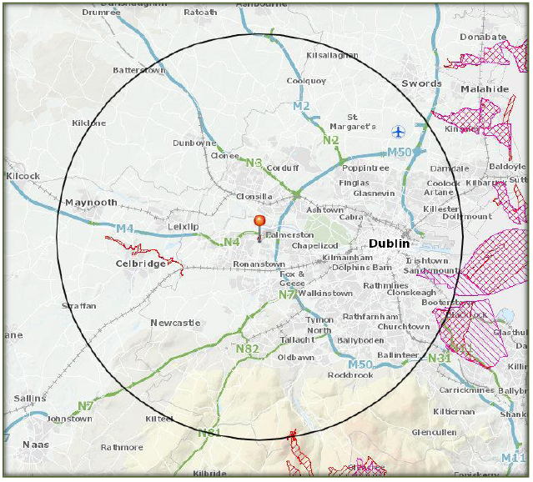  Screening for an Appropriate Assessment:  Identification of Natura 2000 sites within the 15km zone of influence  This screening report has been prepared in relation to a Part 8 residential development on land situated a Slip-road to N4 /Fonthill Road , Lucan , Dublin 22.  In accordance with Article 120 (1) (b) of the Planning & Development Regulations, 2001 as amended, and having regard to the following;  • The location, size and nature of this serviced site located in an established residential area and distance from protected and/or environmentally sensitive sites,  • The proposed development is very considerably below the threshold of a mandatory EIA which would require an Environmental Impact Assessment Report (EIAR),  • The modest scale and quantum of residential development proposed and integration with adjoining land-uses,  • The description of possible effects on the environment are not considered significant and therefore further assessment pursuant to the Planning and Development Regulations 2001 as amended are not considered necessary.  • An Appropriate Assessment Screening has been carried out. It concluded that the proposed development will not cause direct or indirect impacts on any Natura 2000 sites, and that Appropriate Assessment is not required.  It is considered that there is no real likelihood of significant effects on the environment arising from the proposed development, and it is concluded that an EIAR is not required.  Screening for an Appropriate Assessment has been carried out with the following conclusion:  It is concluded that the proposed development will not cause direct or indirect impacts on any Natura 2000 sites, either alone or in combination with other plans or projects, and thus that Appropriate Assessment is not required.
Eddie Conroy FRIAI.
County Architect.
April 2022.

