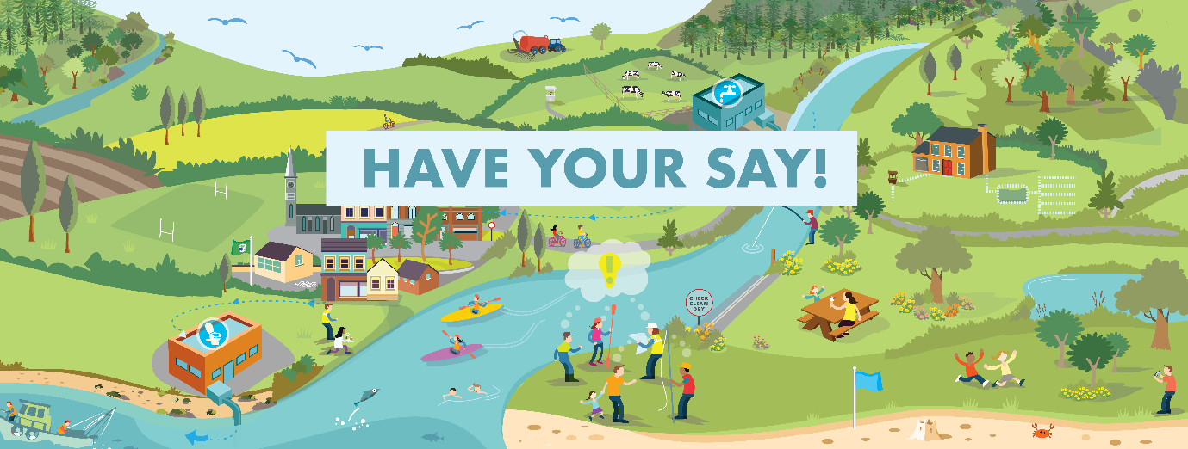
DUBLIN Rivers NEED YOUR HELP!

Come to an online meeting to hear more and have your say

Local Authority | Date & Time | Meeting link to REGISTER
Fingal | 22nd FEB @7pm | https://tinyurl.com/2s43f74a
South Dublin | 23rd FEB @7pm | https://tinyurl.com/y4e5cvbh
Dublin City | 24th FEB @7pm | https://tinyurl.com/yc4xjbp2

Meeting Details:
The draft River Basin Management Plan for Ireland 2022-2027 is the government’s plan to address water quality issues. This meeting will discuss the plan and how you can influence it to improve your local waters.
For more information contact Thomas Carolan, Community Water Officer on 085-871 6896 or tcarolan@lawaters.ie
Online at www.lawaters.ie | Facebook @LAWPROteam | Twitter @watersprogramme
