- Site Location and Description
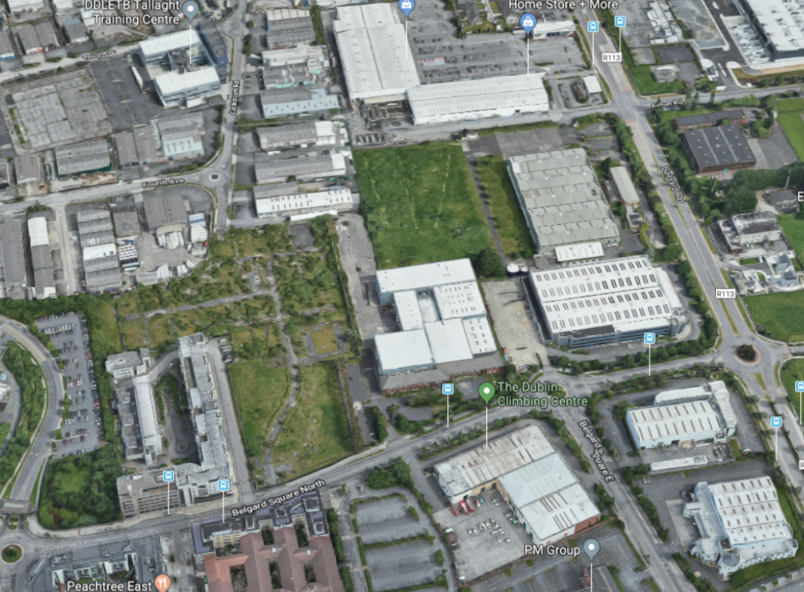
The lands required to deliver the Airton Road extension are located to the west of the existing Airton Road and run through to the Cookstown Road at the junction of the Cookstown Road and Fourth Avenue.

Figure 1.1 – Aerial view of the lands subject to the proposed CPO outlined red

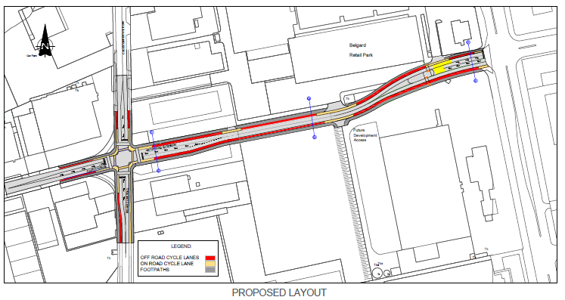
Figure 1.2: Plan showing the lands required to deliver Airton Road extension

