**ENVIRONMENTAL IMPACT ASSESSMENT SCREENING REPORT**

**PROPOSED 2 NO. PLAY SPACES AT NEWCASTLE SOUTH AND BALLYNAKELLY, NEWCASTLE, CO. DUBLIN**

**MAY 2019**

INTRODUCTION

This EIA Screening exercise was undertaken to determine if EIA is required for the proposed

development as set out in the mandatory and discretionary provisions of the Planning and

Development Act, 2000 (as amended) (the Act) and in Schedule 5 of the Planning and Development

Regulations, 2001 as amended (the Regulations).

Certain projects, listed in Schedule 5 of the regulations, due to their always having the potential for significant environmental effects, require mandatory EIA. Others, also listed in the Schedule 5 of the regulations, contain threshold levels and for projects that fall below these thresholds it is the decision of the competent authority to decide if an EIA (and the associated Environmental Impact Assessment Report (EIAR) is required.

Whether a ‘sub threshold’ development should be subject to EIA is determined by the likelihood that

the development would result in significant environmental effects. Significant effects may arise due

to the nature of the development, its scale or extent and its location in relation to the characteristics

of the receiving area, particularly sensitive environments.

This report documents the methodology employed to complete the screening exercise, having

regard to relevant legislation and guidance documents. It also sets out a clear rationale for each

decision made in the process.

STATEMENT OF AUTHORITY

South Dublin County Council is the Planning Authority for the County. The Public Realm Department is responsible for the design and provision of public open spaces and the recreational facilities therein. The Public Realm Section is also charged with management of those open spaces. This Environmental Impact Assessment Screening Report for the development of 2 playspaces at Newcastle, Co. Dublin has been developed by landscape architects within the Public Realm Section of South Dublin County Council and is based on their assessment of the proposed development within the receiving environment. South Dublin County Council are carrying out a Part 8 for the proposed 2 No. playspaces at Newcastle on lands owned by Cairn Homes Ltd. pursuant to a contract with the landowner.

RELEVANT EIA LEGISLATION

EIA requirements derive from EU Directive 85/337/EEC (as amended by Directive 97/11/EC, Directive

2014/52/EU and S.I. 454 of 2011; S.I. 464 of 2011; S.I. 456 of 2011 and S.I. No 296 of 2018).) on the

assessment of the effects of certain public and private projects on the environment. The purpose of

this Environmental Impact Assessment Screening Report is to determine whether this proposed

development will require full Environmental Impact Assessment. The new legislation requires

screening to be undertaken to determine whether or not specified public or private developments

are likely to have significant effects on the environment and, as such, require EIA to be carried out

prior to a decision on a development consent application being made.

The Directive outlines in Article 4 (1) 21 Annex 1 projects that require mandatory EIA. Article 4 (2)

outlines Annex 2 projects that require consideration for EIA further to a case by case examination or

through thresholds and criteria established by Member States. Projects requiring mandatory EIA

are listed in Schedule 5 of the Planning and Development Regulations 2001, as amended. Where

developments are under the relevant EIA threshold, planning authorities are required under Article

103 of the 2001 Regulations, as amended, to request an EIA where it considers the proposed

development is likely to have a significant effect on the environment. In these cases the significant

effects of the project are assessed relative to the criteria contained in Schedule 7a of the regulations,

principally:

• The projects characteristics

• Sensitivity of the project location, and

• Characterisation of potential impacts.

In addition, where the development would be located on or in an area, site etc. set out in Article

103(2), the planning authority shall decide whether the development would or would not be likely to

have significant effects on the environment for such site, area or land etc. the implication being that

if it decides that it would be likely to have significant effects on the environment, it can invoke its

powers to request an EIA.

Article 103(2) sites comprise the following:

a) A European Site;

b) An area the subject of a notice under section 16(2) (b) of the Wildlife (Amendment) Act, 2000;

c) An area designated as a Natural Heritage Area under section 18 of the Wildlife (Amendment) Act,

2000;

d) Land established or recognised as a nature reserve within the meaning of section 15 or 16 of the

Wildlife Act, 1976, as amended by sections 26 and 27 of the Wildlife (Amendment) Act, 2000; or

e) Land designated as a refuge for flora or as a refuge for fauna under section 17 of the Wildlife Act,

1976, as amended by section 28 of the Wildlife (Amendment) Act, 2000.

METHODOLOGY AND GUIDANCE

According to European Commission Guidance (20173)

“*Screening has to implement the Directive’s overall aim, i.e. to determine if a Project listed in Annex II*

*is likely to have significant effects on the environment and, therefore, be made subject to a*

*requirement for Development Consent and an assessment, with regards to its effects on the*

*environment. At the same time, Screening should ensure that an EIA is carried out only for those*

*Projects for which it is thought that a significant impact on the environment is possible, thereby*

*ensuring a more efficient use of both public and private resources. Hence, Screening has to strike the*

*right balance between the above two objectives*.”

As previously stated, this may be considered a sub-threshold EIA development, as EIA is not

mandatory for playspace development.

The key issue for the competent/consent authority in the context of the possible need for EIA of sub-threshold is whether or not such development is likely to have significant effects on the environment.

Consideration of significant effect should not be determined by reference to size only. The nature and location of a project must also be taken into account. This EIA Screening Report is therefore being undertaken to determine in light of the criteria listed in Schedule 7a of the Planning and Development Regulations whether or not this proposed development will require full EIA.

According to the Guidelines for Planning Authorities and An Bord Pleanála on carrying out

Environmental Impact Assessment (2018):

“*For all sub-threshold developments listed in Schedule 5 Part 2, where no EIAR is submitted or EIA*

*determination requested, a screening determination is required to be undertaken by the competent*

*authority unless, on preliminary examination it can be concluded that there is no real likelihood of*

*significant effects on the environment. This is initiated by the competent authority following the*

*receipt of a planning application or appeal. A preliminary examination is undertaken, based on professional expertise and experience, and having regard to the ‘Source – Pathway – Target’ model, where appropriate. The examination should have regard to the criteria set out in Schedule 7 to the 2001 Regulations. Where, based on a preliminary examination of the information submitted with the application and any other supplementary information received, the competent authority concludes that, having considered the nature, size and location of the proposed development, there is no real likelihood of significant effects on the environment, this should be recorded with reasons for this conclusion stated, and no EIA required or formal determination made. The recording of the competent authority’s view should be brief and concise, but adequate to inform the public. In many cases this considered view will be included in the planner’s/inspector’s report on the planning application and this may be cross-referenced in the competent authority’s decision. Normally, this will be published at the time of the decision of the competent authority*.”

A methodology was developed to formally screen the proposed development, which was based on

Environmental Impact Assessment (EIA), Guidance for Consent Authorities regarding Sub-Threshold

Development (EPA, 2003), the recent 2017 EU guidance referenced above, and the 2018 Guidance

issued by the Department of Housing, Planning and Local Government. The screening exercise is

divided into a section on mandatory EIA and another on sub-threshold EIA.

MANDATORY ENVIRONMENT IMPACT ASSESSMENT

Further to the above, Schedule 5 of the Planning & Development Regulations 2001, as amended sets

out a number of classes and scales of development that require EIA.

With regards to the proposed development, the provisions of Schedule 5 do not require an EIA to be undertaken for this class of development (2 No. playspaces).

DESCRIPTION OF THE PROPOSED DEVELOPMENT

Newcastle is a village situated 20 km south of Dublin City Centre. The village supports a range of commercial and social facilities including a church, a national school; a range of local shops; a pharmacy, and a medical centre along the Main Street. Located opposite the recently developed Newcastle Manor is a Service Station which accommodates a post office and convenience store.

The village of Newcastle underwent significant change with extensive new development over the early 2000’s particularly to the east. In this respect, the Newcastle 2012 LAP notes that Newcastle has transformed the area from a rural village to a development village with suburban characteristics. Residential development to the west of the village is predominantly low density, one-off dwellings centred on Main Street while development to the east is characterised by medium density, suburban type housing estates to the north and south of main street.

The proposed development consists of 2 No. proposed play spaces at Newcastle, Co. Dublin. The sites are situated within the Development Boundary of Newcastle as identified in the Newcastle LAP 2012, in particular, in the townlands of Newcastle South and Ballynakelly.

The proposed play spaces are natural type play spaces that incorporate play equipment, surfacing, paving, planting and ancillary items.

SITE LOCATION AND DESCRIPTION

2 play spaces are proposed for development within this predominately residential area of Newcastle located in the eastern section of the village.

The location for the first playspace (at Burgage Green, Newcastle South) contains an existing small pocket park type space that faces onto terraced development across a street with a hoarded off development site to its south. This pocket park is already developed as a local amenity with grass, mounding and trees. This existing area of open space represents half of an area of proposed open space designated within the Newcastle Local Area Plan as Ballynakelly Park and is adjacent to the proposed Local Centre (site currently hoarded off to the south of the proposed playspace No. 1). The second half of the proposed Playspace at Burgage Green, Newcastle South is currently within the hoarded off area and is a brownfield site.

The second proposed playspace is within an existing grassed open space area adjacent to Newcastle Boulevard. This site is a larger triangle shaped open space bounded by roads on two sides and a hedgerow on its northern side.

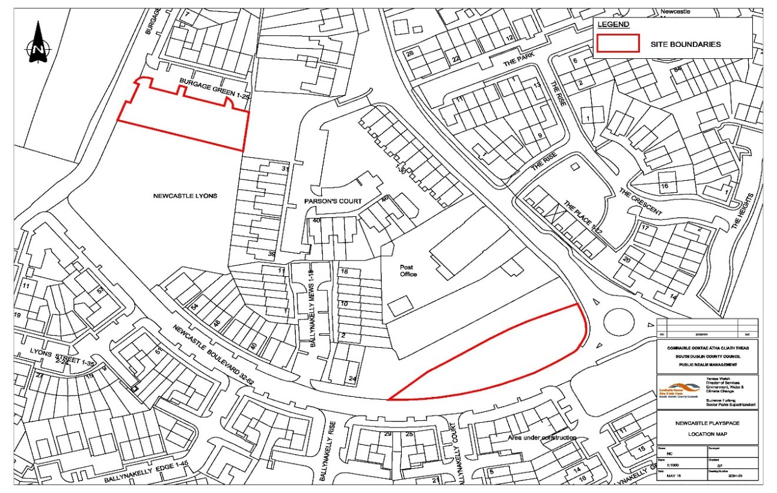

***Figure 1 Lands proposed for the development of 2 No. proposed play spaces at Newcastle, Co. Dublin, outlined in red***

DESCRIPTION OF THE PROPOSED DEVELOPMENT

The development of the playspaces are as depicted on accompanying drawings and described as follows:

• 1 no. playspace at Burgage Green, Newcastle South to incorporate play equipment, surfacing, seating areas, planting, paving. (Drawing No. 17-369-DD-03)

This area is facing a residential area and the northern half of the proposed site is already developed as a small pocket park type area with existing grass trees and planting. It is proposed to locate the new play equipment in the proposed expanded park area to the south of the existing open space to allow the existing open space with the trees etc. to act as a buffer for the adjacent houses and ensure the open space has a multi-generational function and is not solely designed to cater for children. In addition some seats and paths have been added to the existing open space area to improve accessibility and encourage use by a wide variety and demographic of people.

The play area has been designed around natural play principles to incorporate play within a natural setting. The existing area of open space will enhance this affect

• 1 No. play space at Newcastle Boulevard, Ballynakelly to incorporate play equipment, surfacing, seating areas, planting, paving. (Drawing No.: 2093-03)

This proposed play area is located within a larger grassed open space with a mature hedgerow to the north. This play area is designed in the natural playspace style as a ‘dry river bed’ with play equipment set out along a gravel and sand trail. As this area is along a busy route this design will encourage children to exercise on their way to school, shops etc. as parent/ caregivers traverse the adjacent footpaths. For children who want to play longer this natural style play area also encourages imaginative play, the provision of timber bridges allows for informal seating (as well as provide access points) and some of the larger play items (climbing frame etc.) add to the play value, provide seating and encourage longer play and interest in the area. The playspace is located to the back of the open space away from the adjacent roadways and its design will add to the visual amenity of the area.

All ancillary works are also included, providing boundary treatments, planting, site furnishings, drainage etc. as required.

DURATION OF CONSTRUCTION

The Construction period is estimated to be approximately 12-16 weeks.

LANDSCAPING PROPOSALS

The plan for the playground at Burgage Green, Newcastle South retains the existing grass open space, trees and mounding. The expanded open space area (by nearly double) is in line with the open space area depicted within the Local Area pan at this location. The play area surfacing consists of loose impact absorbing play bark, a sand area all of which are permeable to water and allows for natural percolation. The proposals include for new tree planting and new hedge planting (boundary to the south). New footpaths allow for access and increase the accessibility of the site. The proposed play equipment allows for a wide variety of play including swinging, climbing, balancing as well as imaginative play. There are proposals for cycle stands and seating. Seating is provided to the existing open space area as well as to the play area. The play equipment is located to the south of the newly proposed expanded open space area, so it is closer to the planned Local Centre side of the open space and away from the adjacent dwellings to the north.

The plan for the playspace at Newcastle Boulevard, Ballynakelly retains the existing grass open space and hedgerow to the north. The installation of a sand / gravel trail increased the accessibility of the open space and increases the play value and visual amenity of the area. . New tre platning is incorporated into the proposals. The play equipment includes swing bars and a large climbing frame as the formal play equipment but the predominate design is one of natural play with the provision of the ‘dry river bed’ style playspace with meandering gravel/sand trail, scattered boulders, crossing bridges and trees. This natural play area encourages imaginative play which provides increased play value and encourages an increased play time. This form of play provision is particularly beneficial for children with sensory deprivation conditions.

MITIGATION MEASURES

* The expansion of the open space area at Burgage Green, Newcastle South.
* The location of the playground into the proposed newly expanded area.
* The inclusion of 2 playspaces within the area. (Newcastle has until recently had no playground provision. Recent developments are in the process of delivering 1 new area however informal public consultation expressed concern than 1 playspace would be over run with activity. The proposal for 2 different play spaces allows the play activity to be dispersed and the focus for activity will not be centred on one particular area.
* The careful location of the play equipment and play space location in each site.
* The retention of hedgerows and existing trees in each area.
* Additional tree planting to both play areas to increase biodiversity, shade, provide environmental buffers for noise and traffic emissions and provide visual amenity, scale and screening.
* Suitably qualified and experienced competent specialised playground companies will be requested to tender for the works. These companies will be required to have experience of implementation of playgrounds in urban locations and ensure suitable safe-guards and put in place in terms of Health and Safety procedures, hours of working etc.

LANDSCAPE PLAN

These measures inform the landscaping plan as follows:

1. Retention of hedgerow in 2nd playspace site and trees in both sites

2. Additional tree planting within both playspace sites.

OVERVIEW OF EXISTING ENVIRONMENT AND ASSESSMENT OF THE CHARACTERISTICS OF THE PROPSOED DEVELOPMENT UNDER RELEVANT HEADINGS.

POPULATION AND HUMAN HEALTH

According to the 2016 Census, Newcastle has a total population of 3,093 no. persons. The 2016 Census indicates that the population of Newcastle has increased by 16.3% (434 people) between 2011 and 2016.

The age profile of Newcastle is younger than the State average, with 32% of the population of Newcastle aged between 0 and 18 years, in comparison to 26% in the same age group at State level. At 23% of the population, the 35 to 44 year cohort are the largest age group in Newcastle. In comparison, in the State, 16% of the population fall within the 35 to 44 age bracket. Findings from the 2016 Census listed South Dublin as one of the 5 no. youngest county council areas in the Country, with an average age of 35.5 years. In comparison, the average age of the State in 2016 was 37.4 years.

Land use in the vicinity of the proposed development is predominantly residential in nature.

The completed portion of the previously permitted development to the east comprises predominantly 3 no. storey residential blocks.

The locally elected councillors for the area consistently point to the growing young population and the lack of public open space and, particularly, play facilities in the Newcastle area. The Council has a playscape programme underway, delivering playspaces in residential areas across the county; however the Council has a limited amount of public open space available to it in Newcastle and thus cannot provide public play facilities. This agreement with Cairn Homes Ltd for Cairn Homes to provide public play spaces on some of their development land will meet the stated need within the area; in advance of their proposed residential development in the area.

The Council’s Play Space programme was established following the identification of a deficit of play areas for children in this county. This was documented in the policy document ‘Developing Play in South Dublin 2006-2009’ adopted by the Council in June 2006. However the development of play areas / playgrounds did not result in the immediate aftermath, due to the economic downturn and lack of development generally.

In recent years there has been an emphasis on the physical and mental well-being of children. Over the past 20 years there has been a significant rise in levels of obesity, childhood diabetes, high levels of stress and increasing sedentary lifestyles. A report by the National Taskforce on Obesity estimates that 300,000 children in Ireland are now obese.

Due to a variety of factors children are less likely to wander far from their own homes. A study in the UK documented the distance children travelled from home for play; the results showed that the distance children roam from home on their own has shrunk by 90% since the 70s; 43% of adults think a child shouldn't play outdoors unsupervised until the age of 14. Children are increasingly confined to the immediate environs of their homes. This results in children’s activity being dependant on the immediate environment of their homes being conducive to a wide variety of play opportunities and social interaction; which is not so readily available in sterile landscapes of mown grass.

The recent increased access to sedentary activities compounds the problems of inactivity and a recent report from the Kaiser Family Foundation in the US found that the average eight-to-18-year-old American now spends more than 53 hours a week "using entertainment media".

The physical environments in which children grow up have a significant impact on their health, their enjoyment of childhood and their levels of activity. Advice from the NHS in the UK advocates 3 -4 hours per day of strenuous activity for children under 5, and 60 minutes of strenuous activity per day per child over the age of 8. For that to be sustainable; activity needs to be readily available and easily incorporated into the child’s lifestyle; ideally it should be self-directed; (i.e. not dependant on an adult bringing a child to an activity). High levels of play and activity as a child translates nearly directly into higher academic achievement, lower levels of stress, more robust mental health and transmits to healthier activity patterns as an adult.

The proposed development will have a significant positive long-term impact on the existing community by providing play spaces and increased activity for children proximate to their homes and/ or accessible by sustainable modes of transport to the local community.

The proposed development is unlikely to result in any significant adverse impacts on human health and safety considerations once completed and operational.

Environmental impacts of the proposed development (operational phase) and their relationship to human health will be positive.

At construction stage, there is likely to be some slight, temporary negative impacts to local residents. These impacts are likely to result from construction traffic movements to and from the site together with other possible health and safety impacts, such as nuisances associated with construction access requirements, dust, noise and littering.

The construction stage may also result in short term slight positive impacts from the creation of employment opportunities and local spending.

BIODIVERSITY, FLORA AND FAUNA

The application site comprised the following habitats: recolonising bare ground (ED3), with small areas of improved agricultural grassland (GA1). None of the habitats found are listed in Annex I of the Habitats Directive.

The following are present in the area: Rabbits *Oryctolagus cuniculus*, Fox *Vulpes vulpes*. There were no signs of Badger activity and no sett was found within the hedgerows or treelines. Small mammals such as Irish Stoat *Mustela erminea hibernica*, Hedgehog *Erinaceus europaeus* and Pygmy Shrew *Sorex minutus* are considered widespread and can be assumed to be present. Non-protected species such as House Mouse *Mus domesticus*, Wood Mouse *Apodemus sylvaticus* and Brown Rat *Rattus norvegicus* may also be found. It was noted that Common Frog *Rana temporaria* and Common Lizard *Lacerta vivipara* may be present in the area, however none were observed during the survey.

The following bird species are reported in the area; Blackbird *Turdus merula*, Wood Pigeon *Columba palumbus*, Magpie *Pica pica*, Bullfinch *Pyrrhula pyrrhula*, Dunnock *Prunella modularis*, Robin *Erithacus rubecula*, Blue Tit *Parus caeruleus*, Buzzard *Buteo buteo*, and Wren *Troglodytes troglodytes*. These species are listed as ‘low conservation concern’ by BirdWatch Ireland. A single Snipe *Gallinago Gallinago,* which is of ‘medium conservation concern’, has been reported in adjacent development land. No birds of high conservation value were observed during this survey.

Bat surveys in the vicinity of Newcastle report at least 4 no, bat species within the wider Newcastle area including; the common pipistrelle, soprano pipistrelle, Leisler’s bat and a Myotis species. Existing hedgerows in the Newcsatle area are identified as linear habitats for bats. Mitigation measures are proposed in respect of the bat population, including; no proposed lighting, retention of trees, shrubs and principle boundaries, no disturbance of existing trees or hedgerows on site during construction.

The EPA maps service indicates that there are two proposed Natural Heritage Areas within 5 kilometres of the application site; the Grand Canal pNHA that is 2.5 km to the northwest of the site, and the Slade Of Saggart And Crooksling Glen pNHA that is 5 km to the southeast of the site. The closest Natura 2000 sites to the application site comprise the Rye Water Valley/Carton SAC which is 7 kilometres to the north of the site, and the Glenasmole Valley SAC which is 9 kilometres to the southeast.

The South Dublin County Development Plan has a total of four Tree Preservation Orders (TPO’s) registered within the County. None of these occur on or adjoining the application site.

The traditional Burgage plots in the Town are very important to the biodiversity of the area. This development proposed to retain all hedgerows and trees on site and will not have any impact on the existing burgage hedges.

The proposed landscaping of the site retains the existing hedgerow as well as providing areas for additional planting of native species. In this way, the proposed development will provide suitable habitat for the majority of the commonly occurring bird species. It is anticipated that commonly occurring bird species will return to the site once landscaping has been completed.

The construction phase of the development has the potential to generate pollutants such as silt which if discharged to ground or surface waters could indirectly affect watercourses. There are no water courses on the application site, with existing drainage ditches in adjacent sites found to be dry during site surveys. The nearest watercourse is a tributary that is under 100 meters from the application site and appears to arise at the southern boundary of the existing Ballynakelly development. Works at the site will be undertaken prevent discharge to this existing watercourse.

Mitigation measures to be implemented for the operational phases of the development include planting of vegetation which will enhance existing hedgerows and habitats; in addition the proposals do not create many hard standing areas. The majority of the surfacings are permeable and free draining.

Maintenance of the public spaces including the trees and hedgerows incorporated into the development design will be carried out on an ongoing basis as part of the overall management and maintenance of the development. Management will include the monitoring the health and success of the vegetation particularly the replacement planting and retained hedgerows and mature trees.

The Appropriate Assessment Stage 1 Screening Report, concludes that significant effects are not likely to arise, either alone or in combination with other plans or projects that will result in significant effects to the integrity of the Natura 2000 network. A screening statement in support of appropriate assessment accompanies this report.

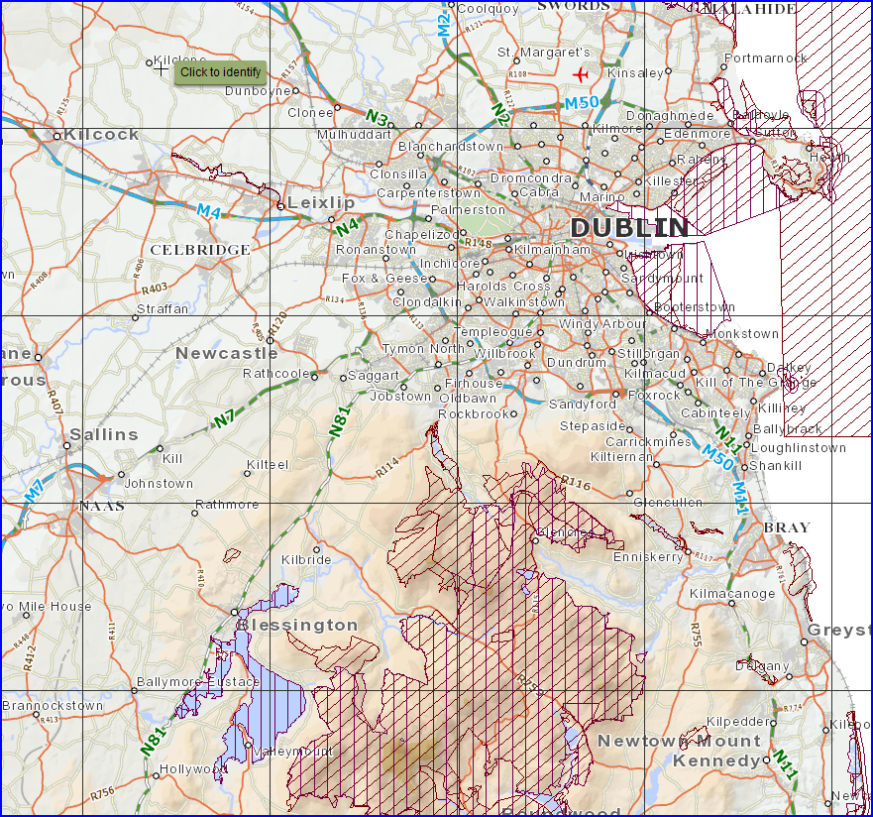

Rye Water Valley/Carton

Ordnance Survey Ireland Licence No. EN 0055916

©Ordnance Survey Ireland/ Government of Ireland

**Approximate location of 2 No. proposed play spaces at Newcastle, Co. Dublin**

Poulaphouca Reservoir SPA

Glenasmole Valley SAC

South Dublin Bay SAC

South Dublin Bay and Tolka Estuary SPA

Red Bog, Kildare

Wicklow Mountains SAC and SPA

***Figure 2: Showing proposed site and Designated Natura 2000 sites***

Water, Drainage, Hydrology and Hydrogeology

There are no major watercourses at the application sites.

Information from the EPA Maps service indicates that the Griffeen River, which is a Tributary of the River Liffey is approximately 1 kilometre southeast of the application site, and a smaller tributary is just under 100 meters from the application site. These waterbodies are stated to be ‘At Risk’ of deteriorating or being at less than Good status in the future.

Geological Survey Ireland ‘Public Data Viewer Series’ found that the groundwater vulnerability at the site is moderate and low. No groundwater wells / springs are shown within the site on the GSI online mapping system. The EPA Maps describes the ground waterbodies described as ‘Not at Risk’ of deteriorating or being at less than Good status in the future.

The OPW CFRAM Fluvial Flood Extents Maps indicate that the application site is in Flood Zone C and is not affected by fluvial flooding.

Potential impacts of the proposed development during the construction phase include the following: Surface water runoff containing increased silt levels or pollutants such as concrete runoff or oils and fuels.

Given the proposed nature and scale of the development the risk of above occurring is deemed to be low. Good site management during construction stage will be required to mitigate against potential impacts that may arise during the construction phase.

The proposed natural play spaces incorporate mainly permeable surfaces so pluvial water will infiltrate as per the green field site condition. There will be no adverse impacts during the operational stage

By utilising best practice design standards it is considered that the impact of the proposed development on water, drainage, hydrology and hydrogeology during the construction and operational phases will not be significant.

GEOLOGY AND SOIL

The development sites existing condition consists of areas of public open space with one section of brown field development within a hoarded off area. The overall topography of the site falls from south to north towards the Main Street.

The proposed development is located within the Local Area Plan lands zoned for new residential development, including open space and recreational facilities therefore the provision of the proposed playscapes uses at this site accords with the planned growth of the Town.

Information from the Environmental Impact Statement (EIS) submitted in support of Reg. Ref. SD05A/0344 (ABP Ref. PL PL06S.217096) found that the bedrock in the vicinity of the site has been mapped by the Geological Survey of Ireland on Geology of Kildare/Wicklow, Sheet 16, Scale 1:100,000 and is identified as the Calp Formation. This formation is of Carboniferous age, approximately 290 - 335 million years old. The Calp Formation comprises varied dark grey to black basinal limestone and shales. No bedrock outcrop was observed during the site walkover survey undertaken in support of the environmental assessment. The overburden is stated to made up of glacial till (boulder clay) which is described as a sandy/gravelly clay with cobbles and boulders.

Geological Survey Ireland ‘Public Data Viewer Series’ found that the application site occurs within Irish Geological Heritage Site Code SD010 ‘Newcastle Buried Channel’. This geological feature is described as “A deep buried channel in the carboniferous limestone bedrock, not seen at surface”.

Site development works will not be intensive and consists of installing play equipment, furniture, fencing and tree planting. This will require some foundation excavation. Where feasible, excavated material will be reused as part of the site development works (e.g. use as fill material).

Potential impacts of the proposed development during the construction phase include the following:

• Some removal of the existing topsoil layer resulting in exposure of the underlying layers to the effects of weather, construction traffic and the generation of sediment-laden runoff.

• Accidental spills and leaks (e.g. storage of oils and fuels on site, use of cement and concrete during construction works).

Given the nature and scale of the development these are considered to be of low likelihood of occurrence. The use of experienced and competent playground companies will mitigate against potential impacts that may arise during the construction phase. Potential impacts of the proposed development on soils and the geological environment do not occur during the construction phase and that any residual impacts will be short term. The primary residual impact is the removal of material unsuitable for reuse as fill material. This impact is unavoidable given the nature of the proposed development but is considered to be minimal due to the small scale and nature of the proposed development.

Noise and Vibration

Existing noise sources audible from the lands include; traffic noise; light construction noise; light aircraft and helicopter noise from Baldonnel Aerodrome (military); occasional noise from dogs barking; and general urban town noises.

EPA Mapping indicates that the loudest daytime and nighttime road noises arise from the N7 Motorway that is approximately 1.7 kilometres from the southern boundary of the site, and the edge of Newcastle Main Street close by both sites. Existing roadways within the site at Ballynakelly experience daytime road noise of between 55 and 59 db.

During the construction phase of the project, there is the potential for some minor impact due to noise emissions from site activities. Some activities during the construction phase will have the potential to generate ground vibrations. The small scale of the proposals and the temporary nature of noise impacts associated with construction activity deem the impact not to be significant and can be appropriately mitigated through the implementation of controlled hours of working during construction stage.

Air, Dust and Climatic Factors

Under the Air Quality Index for Health (AQIH) the application site occurs in ‘Dublin City. As of 5th November 2018, the AQIH for this region is ‘Good’, as shown in the EPA Map Service. The site occurs in a Coal Restricted Area, where the marketing, sale, distribution and burning of bituminous coal has been banned or restricted.

As a small scale, natural playspace project, the proposed development is not expected to cause any likely significant impact on ambient air quality or climate change impacts. However, there may be a minor localised increase in dust levels during certain parts of the construction process associated with excavation work and construction traffic. These increases will be short-term and will remain slight due to the small scale of the project and appropriate management and mitigation measures to be employed on site.

Landscape and Visual Impact

The landscape in the immediate vicinity of the site is largely residential.

The South Dublin County Development Plan does not list any protected views or prospects in the vicinity of the site.

The Landscape Character Assessment of South Dublin County (2015), which informs Section 9.2.0 ‘Landscapes’ of the Development Plan indicates that the site occurs in the ‘Newcastle Lowlands’ character area.

The Landscape Character Assessment describes the key characteristics of this area as;

• Low-lying and gently undulating agricultural lands over limestone

• Established communication corridors include the grand canal and railway corridor traverse east to west and two aerodromes at Weston and Baldonnell.

• Agricultural landuse primarily pasture and tillage

• Increasing influence of urban activities closer to the motorways, national roads and regional roads

• Long history of historic settlement and human activity with medieval landscape complex associated with Newcastle village and surrounds.

• Number of demesnes associated with former country houses and institutions including reuse of older country houses at sites such as Peamount and Baldonnel

The Newcastle Lowlands are stated to have a medium landscape sensitivity, visual sensitivity and overall landscape sensitivity. Landscape capacity is stated to be low as the key characteristics listed above are vulnerable to change. Mitigation measures listed in the Landscape Character Assessment that are relevant to the application site include; designing the site in accordance with the Urban Design Manual, LAP and Development Plan, incorporating trees and screen planting, the use of natural planting as boundary treatments, the planting of native hedgerows, and the retention of agricultural character.

The immediate impact of the development shall be low impact, integrating recreational facilities which area natural playspaces into public open space, in addition the change of one area of brownfield, hoarded-off, derelict land into a larger open space area will be a positive impact.

(The brownfield site is currently hoarded off and had previously been cleared for development, and is currently unused and therefore contributes little to the visual or landscape character of the area.)

The proposed development is located on lands zoned for residential development in the South Dublin County Development, directly adjacent to existing and proposed residential developments. Therefore, the impact of the proposed development on the landscape is considered to be positive as it increases the visual amenity of the public open space.

The proposed development increases the recreational amenity within existing public open space and improves the quality of the public open space. Additional planting of native species will reinforce the retained vegetation and the character and appearance of the development.

The proposed landscaping and trees shall also enhance the biodiversity value of the site, reinforcing the positive visual impact.

Monitoring of effective tree and hedgerow protection measures and the successful establishment of the proposed new planting will ensure continued health and vigour of the existing vegetation on the site and will assist in the sensitive assimilation of the proposed development.

During the construction stage, impacts will vary depending on the stage of construction and the intensity of site activity but they will be short term in duration. The operational phase of the scheme will have a positive impact on the landscape of this area.

Traffic and Transport

The main vehicular and pedestrian/cycle access to the development will be via the existing road and footpath network; consequently, the site will be highly accessible to both pedestrian and cyclists. Public car parking is located adjacent to both sites.

Newcastle is served by the Dublin Bus routes 68, 68x and 69N, and there are existing bus stops for these routes on Newcastle Main street (the R120) to the west and north of the application site. These bus routes connect Newcastle to the Greenogue Business Park to the west, the Red Cow Luas Station, and Dublin City Centre.

The playspaces are small scale and aimed at a younger age cohort; therefore it is felt that the potential to generate detrimental vehicular traffic is low and adverse impact is unlikely to occur in this regard.

Architecture, Archaeology and Cultural Heritage

Newcastle contains a zone of archaeological potential associated with the medieval settlement of Newcastle, identified in the South Dublin County Council Development Plan. This zone is a recorded monument (Ref.: DU020-003). There are no individual recorded monuments located within the proposed development area itself.

The Development Plan identifies 7 no. Protected Structures in Newcastle Town Centre comprising the following:

• RPS Ref. 223 at St. Finian’s Church Of Ireland, Newcastle, comprising a church and cross.

• RPS Ref. 225 at St. Finian’s Church of Ireland Church, Newcastle, comprising a medieval four storey tower house with arched doorway.

• RPS Ref. 226 at the Old Glebe, Newcastle, comprising a house, tower house.

• RPS Ref. 227 on Newcastle Main Street, comprising a detached three bay single storey house

• RPS Ref. 229 at The Loft, Newcastle, comprising a detached five bay two storey house

• RPS Ref. 230 Newcastle National School, Newcastle, comprising a detached two bay two storey former primary school

• RPS Ref. 232 St. Finian’s Roman Catholic Church, Newcastle, comprising a church, graveyard & gates

In addition, there are 2 no. Protected Structure located to the west of the site comprising the following:

• RPS Ref. 238 Newcastle Farm, Newcastle, Detached Five Bay Two Storey Farm House & Range Of Outbuildings

• RPS Ref. 241 Newcastle South Castle, Newcastle, Stone Castle (Ruin), Tower House Possible (RM)

The closest Protected Structure to the application site is RPS Ref. 227, which is approximately 75 metres away. This structure is a traditional single storey residential dwelling that is accessed from Main Street (R120). Protected Structure RPS Ref. 241 is located adjacent to the Athgoe Road approximately 490m to the west of the site. The proposed playspaces are in areas of previously developed land and are not deemed likely to have any impact on protected structures.

The traditional Burgage plots in the Town are very important to the biodiversity and cultural heritage of the area. This development proposes to retain all hedgerows and trees on the 2 sites and will not have any impact on the existing burgage hedges.



***Figure 3: Location of Protected Structures***

MATERIAL ASSETS

Existing access to the sites is via the adjacent street network and this will continue to function

as such with no impact to same

The existing sites both function as public open space and will also remain as such; albeit 1 of the sites will be enlarged to the size proposed within the LAP for the area. In addition the public open space will be enhanced by the provision of footpaths, recreational facilities and planting. This will have a large positive impact. There will be some minor negative imacpt during the construction stage when access to the sites will be precluded, but this impact is temporary, short-term and minor.

Dublin Bus provides public transport within the immediate area and the closest Luas Stop is at the Square Tallaght some 4.5km. There will be no impact to public transport.

Almost all of the waste water in South Dublin is currently treated in Ringsend Wastewater Treatment

Works which discharges into Dublin Bay. The treated waters are treated to a Tertiary standard,

which is in compliance with the Urban Wastewater Treatment Directive. The quality of the

discharged waters is within the requirements of the Urban Waste Water Treatment Directive.

The Greater Dublin Drainage Scheme will represent a significant wastewater infrastructure

development for the Greater Dublin Regional area which will allow for an underground orbital sewer

and two pumping stations, a new wastewater treatment plan at Clonshaugh (in Fingal County) and

an outfall pipe located 6km out to sea from Baldoyle Bay.

The project site is located within the Greater Dublin Water Supply Area (GDWSA). The GDWSA is

served by 5 major water treatment plants, Ballymore Eustace, Srowland, Leixlip, Ballyboden and

Vartry, and a number of smaller sources. There is deemed to be no adverse impact on the waste water infrastructure.

ENVIRONMENTAL IMPACT ASSESSMENT SCREENING EXERCISE

Conclusion

The proposed development does not trigger the threshold for mandatory EIA/EIAR as set in EU

Directive 85/337/EEC (as amended by Directive 97/11/EC, Directive 2014/52/EU and S.I. 454 of

2011; S.I. 464 of 2011; S.I. 456 of 2011 and S.I. No 296 of 2018) and has been assessed as a sub

threshold EIA development. This EIA Screening Assessment has determined that the characteristics

of the proposed development are considered not significant due to the scale and nature of the

proposed development and its footprint, the characteristics and sensitivities of the receiving environment and design and mitigation measures that will be implemented as part of the construction phase and operation phase of the proposed development.

Given the scale and nature of the project and taking account of all available information, the overall

probability of impacts on the receiving environment arising from the proposed development (during

the construction or operational phases) is considered to be minimal.

No significant environmental impacts will occur once mitigation measures outlined in the Report are implemented.

The information provided in this EIA Screening Report can be used by the competent authority,

South Dublin County Council, to conclude and determine that an EIA is not required for the proposed

development relating to the proposed development as there will be no significant effects.

The overall conclusion for this screening appraisal is that, having considered the appropriate criteria,

Environmental Impact Assessment for the project is not required.

REFERENCES

Environmental Impact Assessment of Projects Guidance on Screening (Directive 2011/92/EU as amended by 2014/52/EU). European Commission 2017

Guidelines for Planning Authorities and An Bord Pleanála on carrying out Environmental Impact Assessment August 2018 Prepared Dept of Housing, Planning and Local Government